XANTHIA VILLAGE FACT SHEET 2017

This “Fact Sheet” provides basic information on population changes and demographics for Xanthia village. Whenever you use this information, please reference it as being obtained from MRC/Wits Rural Public Health and Health Transitions Research Unit (Agincourt).

Villages in the Agincourt Health and Socio-Demographic Surveillance (HDSS) System Research Site in 2017 include:
Agincourt, Belfast, Croquet Lawn, Croquet Lawn B, Cunningmore A, Cunningmore B, Dumphries A, Dumphries B, Dumphries C, Huntington, Ireagh A, Ireagh B, Ireagh C, Justicia, Khaya Lami, Kildare A, Kildare B, Kumani, Lillydale A, Lillydale B, Makaringe, MP Stream, Newington B, Newington C, Rolle C, Somerset, Somerset C, and Xanthia.

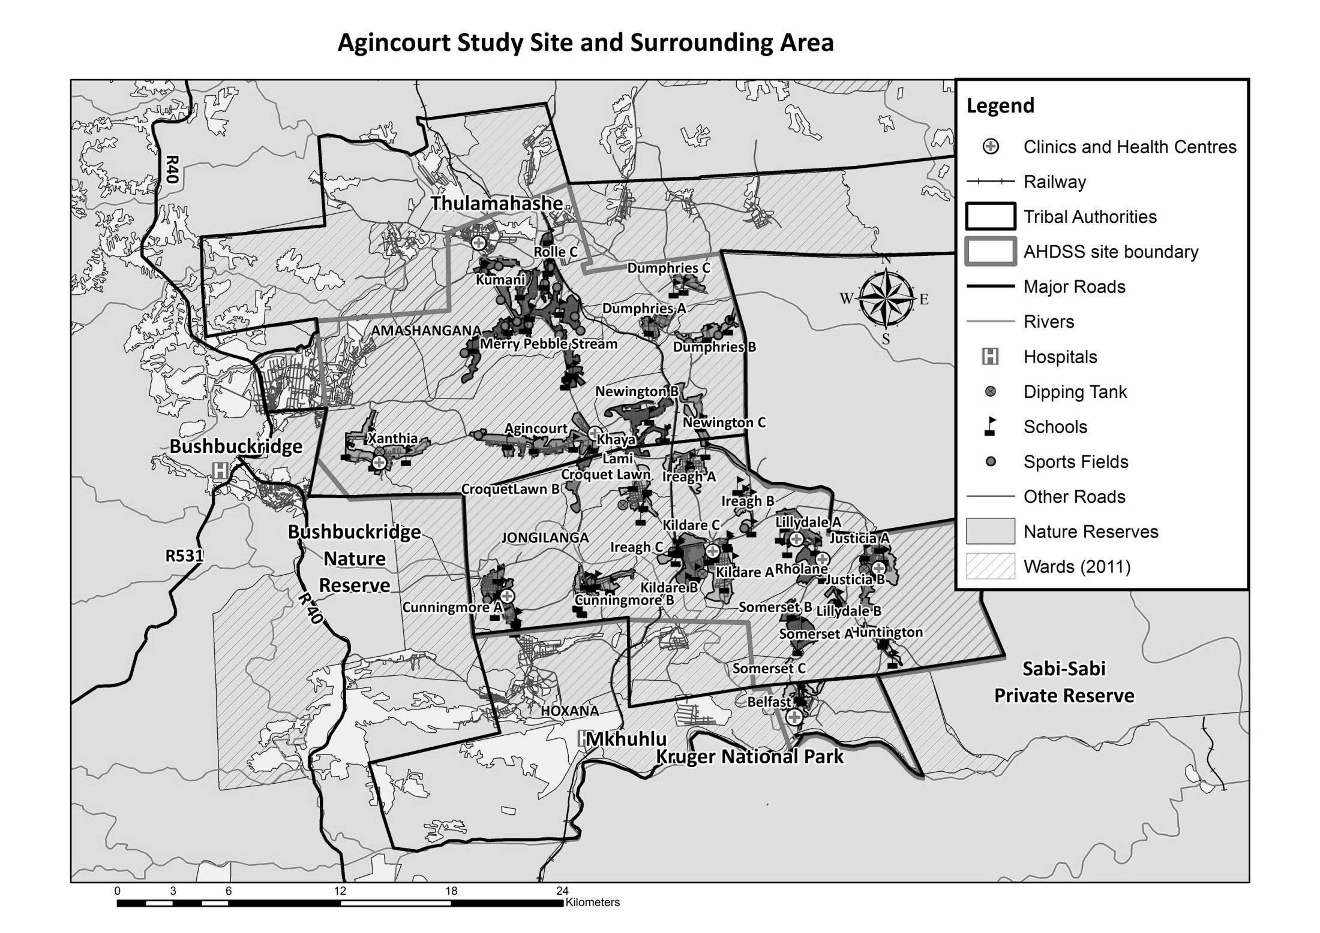
Xanthia

Village Growth and Population over the Period 1994 – 2016
The numbers shown below are calculated according to numbers for the end of June 2016. The numbers are known as mid-year population figures.

Mid-year Figures of Xanthia, 1994 and 2016
 |  |  | 1994 | 2016
Households |  |  | 629 | 912
Population |  |  | 3 953 | 4 681
Male |  |  | 1 893 | 2 301
Female |  |  | 2 060 | 2 380
Children under 5 |  |  | 522 | 476
Children of school-going age (5-19) |  |  | 1 582 | 1 386

Below you can see how many people were living in Xanthia village of different ages in June 2016.

Mid-Year Population of Xanthia village, 2016
Age Group | 2016
 | Male | Female | Total
0-4 | 242 | 234 | 476
5-9 | 280 | 256 | 536
10-14 | 226 | 222 | 448
15-19 | 202 | 200 | 402
20-24 | 215 | 249 | 464
25-29 | 233 | 234 | 467
30-34 | 222 | 224 | 446
35-39 | 183 | 167 | 350
40-44 | 150 | 129 | 279
45-49 | 99 | 90 | 189
50-54 | 81 | 83 | 164
55-59 | 34 | 62 | 96
60-64 | 42 | 70 | 112
65-69 | 43 | 65 | 108
70-74 | 20 | 33 | 53
75-79 | 18 | 24 | 42
80-84 | 5 | 15 | 20
85-89 | 2 | 13 | 15
90-94 | 2 | 6 | 8
95+ | 2 | 4 | 6
Total | 2 301 | 2 380 | 4 681

You can compare the population structure between Xanthia village and the Agincourt HDSS research site (1994 and 2016) by looking at the population pyramids below.

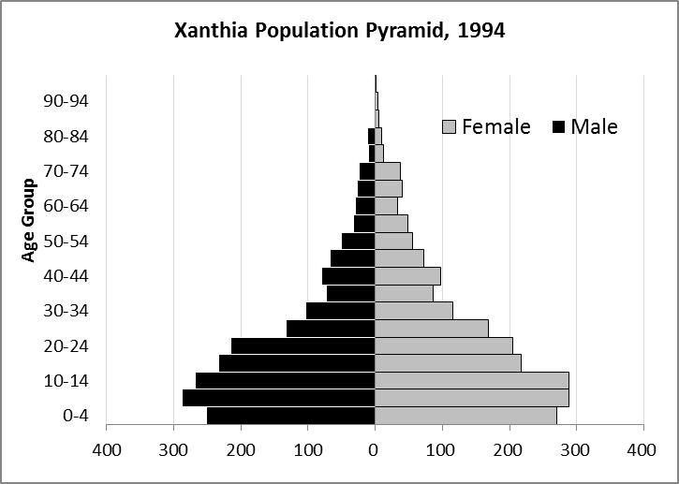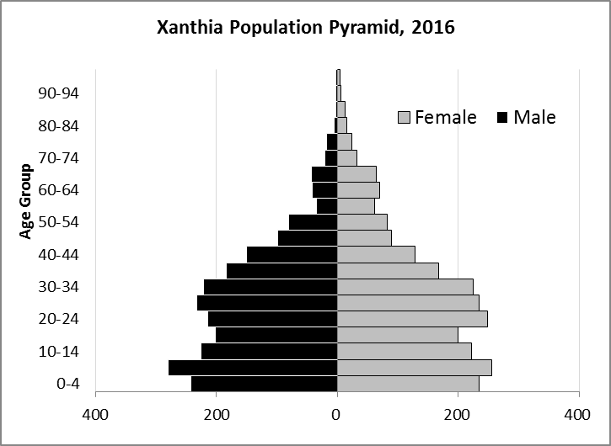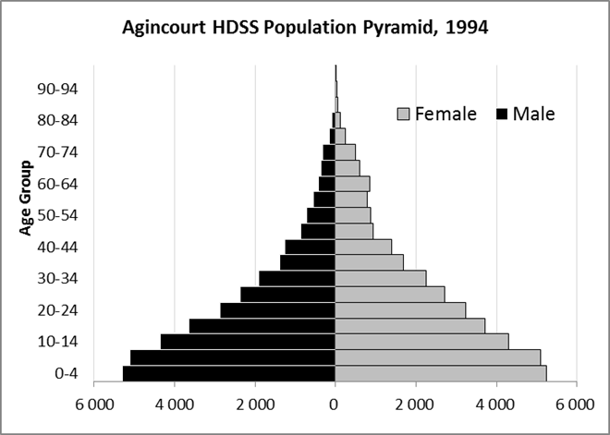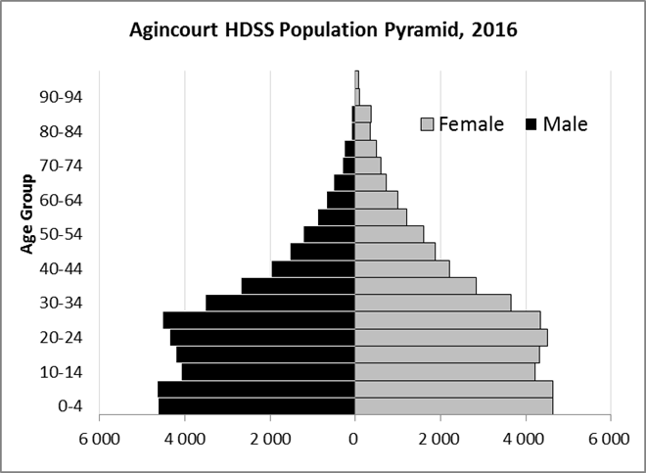

Take home message: The number of households in Xanthia village has increased since 1994. The population has also grown between the years of 1994 and 2016. The population structure of Xanthia village somewhat follows the structure of the Agincourt HDSS research site.

Births

Number of Births by Sex
The number of births recorded in Xanthia village is shown below. We can only provide data to the end of 2015.

Births by Sex in Xanthia Village, 1994 and 2015
 | 1994 | 2015
Male Births | 52 | 41
Female Births | 49 | 32
Total Births | 101 | 73

The numbers of births show an upward trend in Xanthia village. In 2015 there was an increase in the number of births.

Crude Birth Rate (how many babies born for every one thousand people)
We compared the birth trends in Belfast village with the rest of the Agincourt HDSS research site in the graphs below.

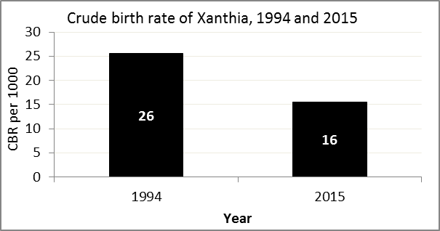
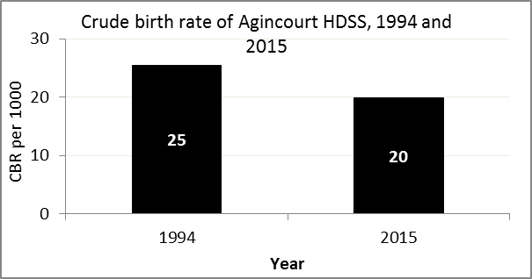

The crude birth rate is found by comparing the number of babies born to the total population. For example, above, for every 1 000 people living in Xanthia village in the year 2015, 16 babies were born.
When you compare the crude birth rates in Xanthia village with the crude birth rate for the whole of the Agincourt HDSS research site, they are relatively similar. One difference is that Xanthia had a greater decrease in births than Agincourt HDSS.

Births by Mother’s Age and Age Specific Fertility Rates
Research within the Agincourt HDSS research site continues to look closely at fertility. You can see the number of babies born to mothers of different ages in Xanthia below.

Births by Age group in Xanthia, 1994 and 2015
Age Groups | 1994 | 2015
10-14 | 1 | 1
15 -19 | 31 | 5
20-24 | 25 | 14
25-29 | 19 | 19
30-34 | 7 | 23
35-39 | 12 | 9
40-44 | 5 | 2
45-49 | 1 | 0
Total Births | 101 | 73

We can also look at trends in birth rates in different age groups across the whole site and compare them with Belfast village.

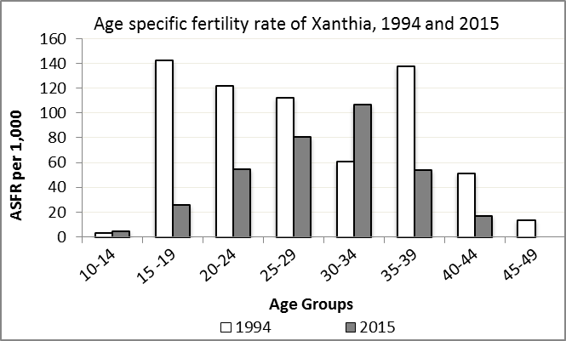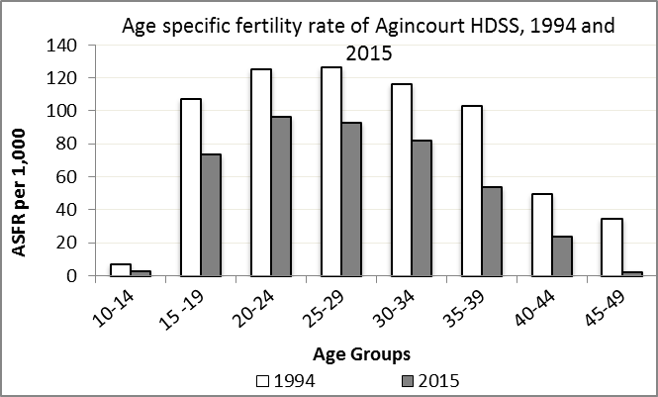

We find the age specific fertility rate by looking at how many women in a certain age group have had babies in a certain year. For example, we can see that in the year 2015 in Xanthia village, for every 1 000 women ages 15-19, about 26 of them gave birth.

Take home message: 2015 saw decreases in fertility throughout age groups except for 10-14 and 30-34.

Deaths

Deaths

The MRC/Wits Agincourt Unit only gives numbers of deaths for each age group in each village, not the cause of death. The number of deaths occurring is low and if the cause of death is given, then a person’s confidentiality may be broken. Below you can see the total number of deaths that occurred in Xanthia village in 1994 and in 2015.

Deaths by Sex in Xanthia, 1994 and 2015
 | 1994 | 2015
Male Deaths | 10 | 18
Female Deaths | 13 | 11
Total Deaths | 23 | 29

Below you can compare the crude death rates over the same period in Xanthia village and across the Agincourt HDSS research site.

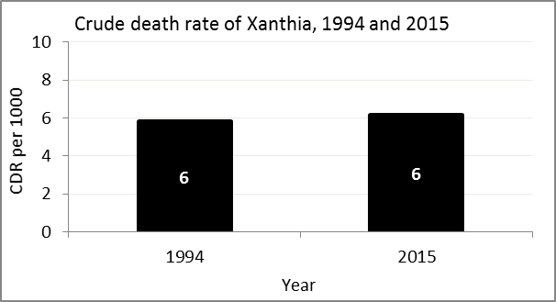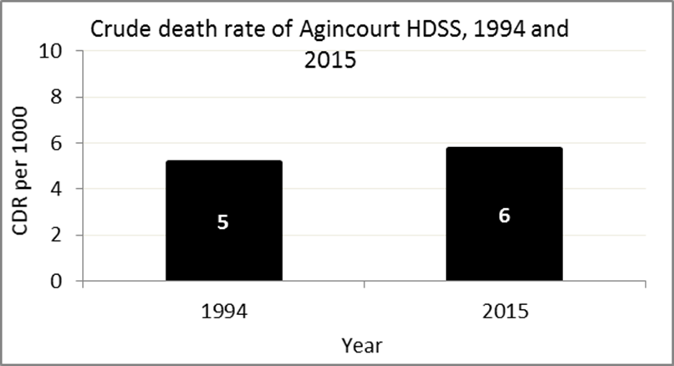
The crude death rate is found by looking at how many people died for every 1 000 people living in the population. For example, in 2015, for every 1 000 people in the population of Xanthia village, 6 died.

The data shows that the crude death is at about the same level as it was in 1994. In addition, the good news is that the death rate across the whole population of the Agincourt HDSS research site is closer to the death rate before HIV became prominent in South Africa.

MIGRATION

Permanent migration patterns

Below you can see how many people have moved into and out of Xanthia village permanently.

In-Migrants by Sex in Xanthia village, 1994 and 2015
 | 1994 | 2015
Male In-Migrants | 118 | 71
Female In-Migrants | 152 | 99
Total | 270 | 170

Out-Migrants by Sex in Xanthia village,1994 and 2015
 | 1994 | 2015
Male Out-Migrants | 127 | 86
Female Out-Migrants | 169 | 94
Total Out-Migrants | 296 | 180

Take home message: The number of people permanently moving into and out of Xanthia village is decreasing.

