SOMERSET C VILLAGE FACT SHEET 2017

This “Fact Sheet” provides basic information on population changes and demographics for Somerset C village. Whenever you use this information, please reference it as being obtained from MRC/Wits Rural Public Health and Health Transitions Research Unit (Agincourt).

Villages in the Agincourt Health and Socio-Demographic Surveillance (HDSS) System Research Site in 2017 include:
Agincourt, Belfast, Croquet Lawn, Croquet Lawn B, Cunningmore A, Cunningmore B, Dumphries A, Dumphries B, Dumphries C, Huntington, Ireagh A, Ireagh B, Ireagh C, Justicia, Khaya Lami, Kildare A, Kildare B, Kumani, Lillydale A, Lillydale B, Makaringe, MP Stream, Newington B, Newington C, Rolle C, Somerset, Somerset C, and Xanthia.

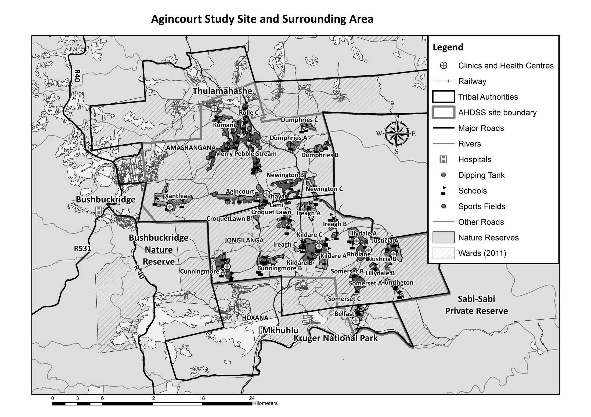
Somerset C

Village Growth and Population over the Period 2010 – 2016
The numbers shown below are calculated according to numbers for the end of June 2016. The numbers are known as mid-year population figures.

Mid-year Figures of Somerset C, 2010 and 2016
 |  |  | 2010 | 2016
Households |  |  | 46 | 57
Population |  |  | 154 | 225
Male |  |  | 54 | 95
Female |  |  | 100 | 130
Children under 5 |  |  | 25 | 28
Children of school-going age (5-19) |  |  | 57 | 87

Below you can see how many people were living in Somerset C village of different ages in June 2016.

Mid-Year Population of Somerset C village, 2016
Age Group | 2016
 | Male | Female | Total
0-4 | 15 | 13 | 28
5-9 | 15 | 17 | 32
10-14 | 12 | 12 | 24
15-19 | 16 | 15 | 31
20-24 | 8 | 14 | 22
25-29 | 6 | 11 | 17
30-34 | 5 | 13 | 18
35-39 | 9 | 17 | 26
40-44 | 1 | 10 | 11
45-49 | 3 | 3 | 6
50-54 | 2 | 3 | 5
55-59 | 2 | 1 | 3
60-64 | 0 | 1 | 1
65-69 | 1 | 0 | 1
70-74 | 0 | 0 | 0
75-79 | 0 | 0 | 0
80-84 | 0 | 0 | 0
85-89 | 0 | 0 | 0
90-94 | 0 | 0 | 0
95+ | 0 | 0 | 0
Total | 95 | 130 | 225

You can compare the population structure between Somerset C village and the Agincourt HDSS research site (2010 and 2016) by looking at the population pyramids below.

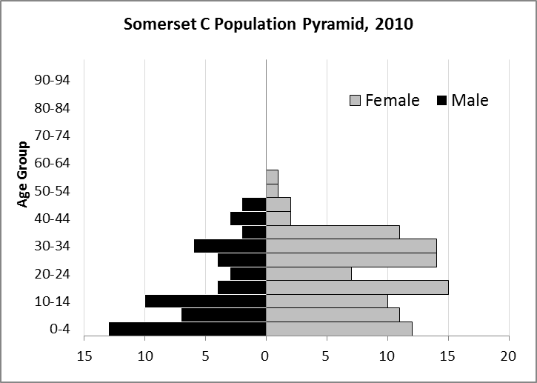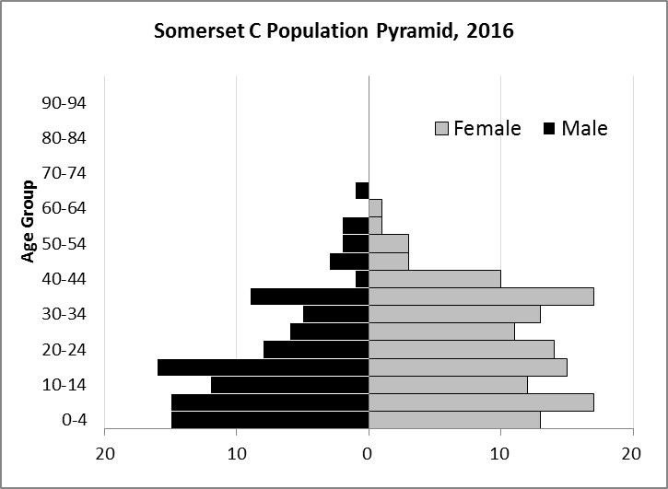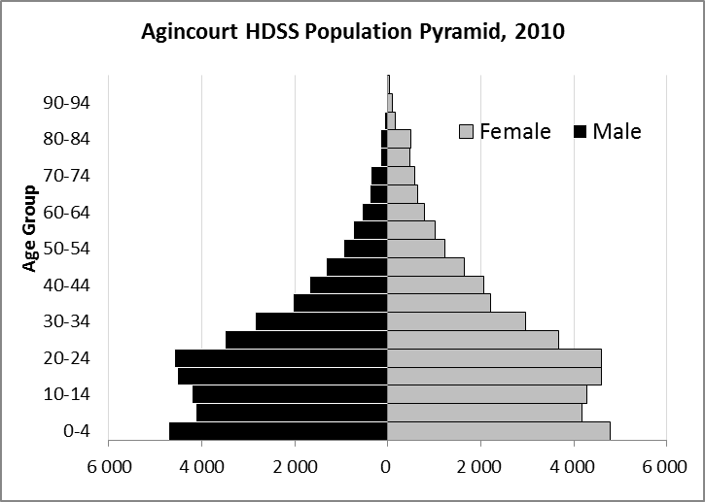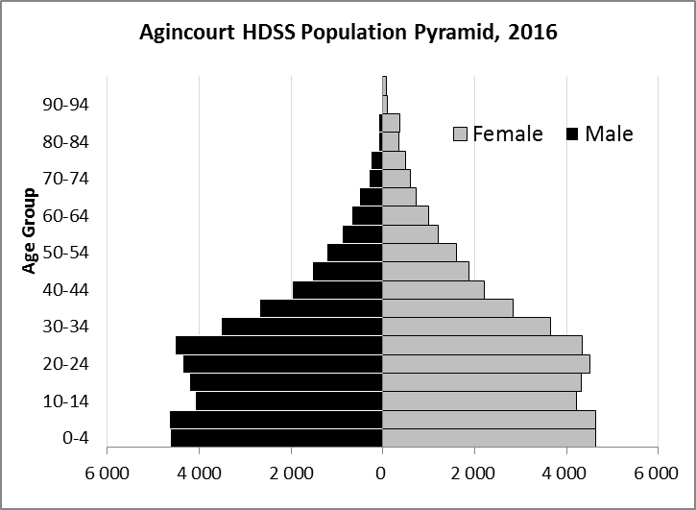

Take home message: The number of households in Somerset C village has increased since 2010. The population has also grown between the years of 2010 and 2016. Since 2010, more males entered the population, and the Somerset C population pyramid has become more similar to the Agincourt HDSS population pyramid. However, Somerset C has a very small above-50 population in comparison to Agincourt HDSS.

Births

Number of Births by Sex
The number of births recorded in Somerset village are shown below. We can only provide data to the end of 2015.

Births by Sex in Somerset C village, 2010 and 2015
 | 2010 | 2015
Male Births | 2 | 2
Female Births | 2 | 1
Total Births | 4 | 3

The numbers of births show an upward trend in Somerset C village. In 2015 there was an increase in the number of births.

Crude Birth Rate (how many babies born for every one thousand people)
We compared the birth trends in Somerset C village with the rest of the Agincourt HDSS research site in the graphs below.

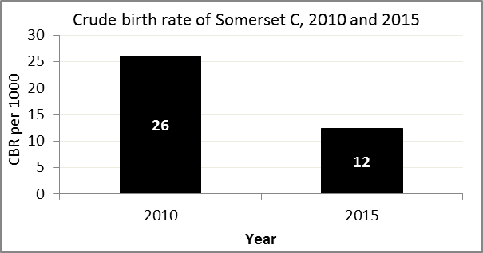
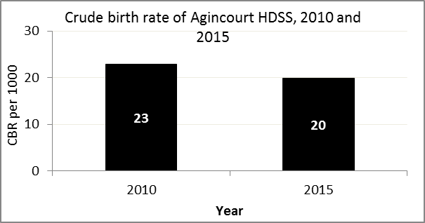

The crude birth rate is found by comparing the number of babies born to the total population. For example, above, for every 1 000 people living in Somerset C village in the year 2015, 12 babies were born.
When you compare the crude birth rates in Somerset C village with the crude birth rate for the whole of the Agincourt HDSS research site, they are relatively similar. One difference is that Somerset C had a greater decrease in births in 2015 than Agincourt HDSS.

Births by Mother’s Age and Age Specific Fertility Rates
Research within the Agincourt HDSS research site continues to look closely at fertility. You can see the number of babies born to mothers of different ages in Somerset C village below.

Births by Age group in Somerset C, 2010 and 2015
Age Groups | 2010 | 2015
10-14 | 0 | 0
15 -19 | 1 | 0
20-24 | 1 | 0
25-29 | 1 | 1
30-34 | 0 | 0
35-39 | 1 | 1
40-44 | 0 | 1
45-49 | 0 | 0
Total Births | 4 | 3

We can also look at trends across the whole site and compare them with Somerset C village.

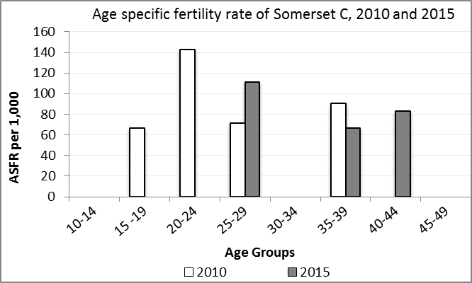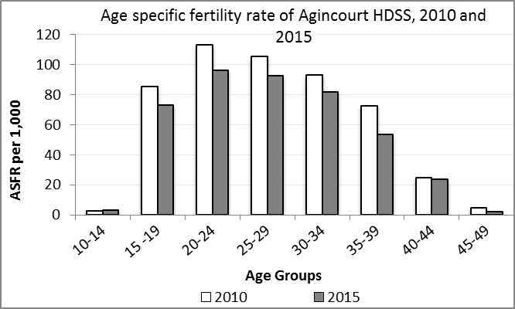

We find the age specific fertility rate by looking at how many women in a certain age group have had babies in a certain year. For example, above, we can see that in the year 2015 in Somerset C village, for every 1 000 women ages 25-29, about 111 of them gave birth.

Take home message: 2015 saw an increase in fertility in age groups 25-29 and 40-44. Age groups 15-24 and 35-39 had decreases in fertility.

Deaths

Deaths

The MRC/Wits Agincourt Unit only gives numbers of deaths for each age group in each village, not the cause of death. The number of deaths occurring is low and if the cause of death is given, then a person’s confidentiality may be broken. Below you can see the total number of deaths that occurred in Somerset C village in 2010 and in 2015.

Deaths by Sex in Somerset C, 2010 and 2015
 | 2010 | 2015
Male Deaths | 1 | 0
Female Deaths | 0 | 0
Total Deaths | 1 | 0

Below you can compare the crude death rates over the same period in Somerset C village and across the Agincourt HDSS research site.

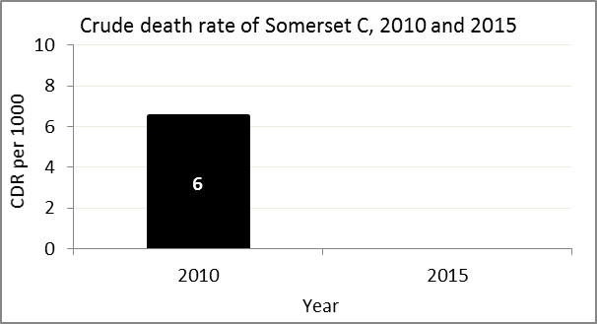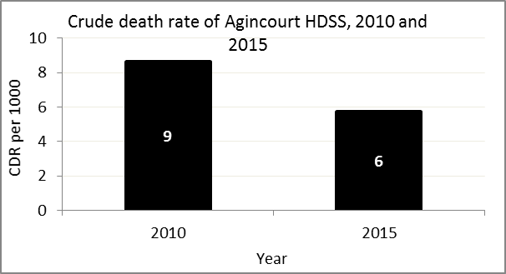
The crude death rate is found by looking at how many people died for every 1 000 people living in the population. For example, in 2010, for every 1 000 people in the population of Somerset C village, 6 died.

The data shows that the crude death rate has dropped to 0 from the levels seen in 2010. This is lower than the death measured across the whole population of the Agincourt HDSS research site, which has fallen closer to the death rate before HIV became prominent in South Africa.

MIGRATION

Permanent migration patterns

Below you can see how many people have moved into and out of Somerset C village permanently.

Out-Migrants by Sex in Somerset C village, 2010 and 2015
 | 2010 | 2015
Male Out-Migrants | 5 | 11
Female Out-Migrants | 16 | 12
Total Out-Migrants | 21 | 23

In-Migrants by Sex in Somerset C village, 2010 and 2015
 | 2010 | 2015
Male In-Migrants | 13 | 6
Female In-Migrants | 25 | 5
Total | 38 | 11

Take home message: The number of people permanently moving into Somerset C village is decreasing, but the number moving out of the village is increasing.

