ROLLE C VILLAGE FACT SHEET 2017

This “Fact Sheet” provides basic information on population changes and demographics for Rolle C village. Whenever you use this information, please reference it as being obtained from MRC/Wits Rural Public Health and Health Transitions Research Unit (Agincourt).

Villages in the Agincourt Health and Socio-Demographic Surveillance (HDSS) System Research Site in 2017 include:
Agincourt, Belfast, Croquet Lawn, Croquet Lawn B, Cunningmore A, Cunningmore B, Dumphries A, Dumphries B, Dumphries C, Huntington, Ireagh A, Ireagh B, Ireagh C, Justicia, Khaya Lami, Kildare A, Kildare B, Kumani, Lillydale A, Lillydale B, Makaringe, MP Stream, Newington B, Newington C, Rolle C, Somerset, Somerset C, and Xanthia.

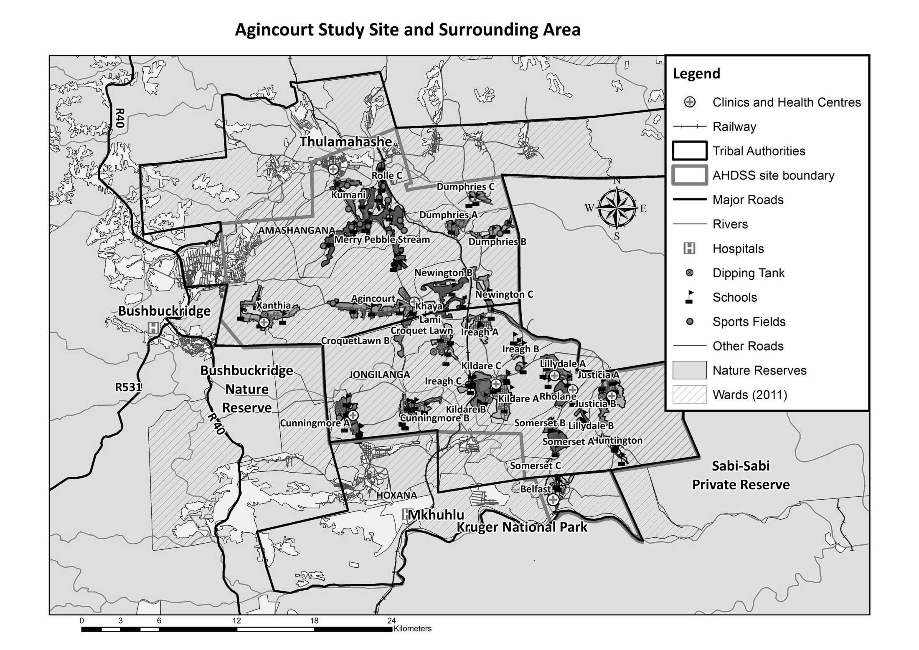
Rolle C

Village Growth and Population over the Period 2013 – 2016
The numbers shown in below are calculated according to numbers for the end of June 2016. The numbers are known as mid-year population figures.

Mid-year Figures of Rolle C, 2013 and 2016
 |  |  | 2013 | 2016
Households |  |  | 385 | 392
Population |  |  | 2 273 | 2 330
Male |  |  | 1 092 | 1 129
Female |  |  | 1 181 | 1 201
Children under 5 |  |  | 258 | 222
Children of school-going age (5-19) |  |  | 726 | 714

Below you can see how many people were living in Rolle C village of different ages in June 2016.

Mid-Year Population of Rolle C village, 2016
Age Group | 2016
 | Male | Female | Total
0-4 | 119 | 103 | 222
5-9 | 129 | 100 | 229
10-14 | 121 | 124 | 245
15-19 | 118 | 130 | 248
20-24 | 117 | 118 | 235
25-29 | 100 | 104 | 204
30-34 | 89 | 97 | 186
35-39 | 49 | 64 | 113
40-44 | 49 | 44 | 93
45-49 | 124 | 116 | 240
50-54 | 30 | 45 | 75
55-59 | 25 | 55 | 80
60-64 | 20 | 36 | 56
65-69 | 21 | 29 | 50
70-74 | 2 | 14 | 16
75-79 | 12 | 9 | 21
80-84 | 1 | 3 | 4
85-89 | 3 | 7 | 10
90-94 | 0 | 3 | 3
95+ | 0 | 0 | 0
Total | 1 129 | 1 201 | 2 330

You can compare the population structure between Rolle C village and the Agincourt HDSS research site (2013 and 2016) by looking at the population pyramids below.

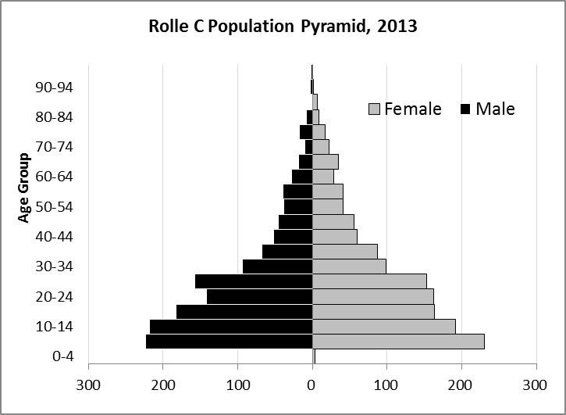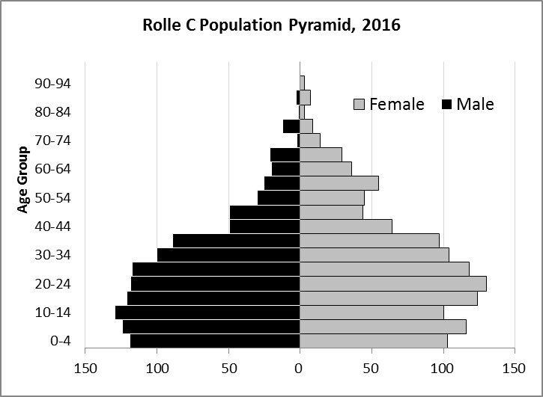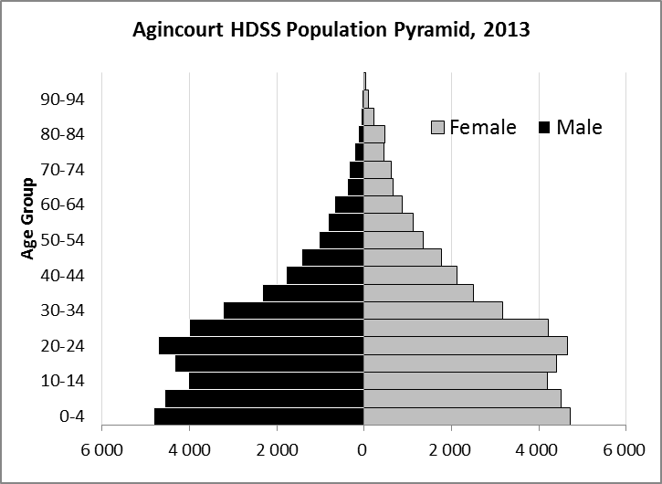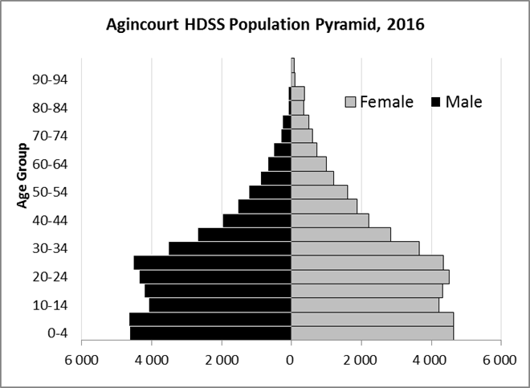

Take home message: The number of households in Rolle C village has increased since 2013. The population has also grown between the years of 2013 and 2016. The population structure of Rolle C village strongly follows the structure of the Agincourt HDSS research site.

Births

Number of Births by Sex
The number of births recorded in Rolle C village are shown in below. We can only provide data to the end of 2015.
Births by Sex in Rolle C Village, 2013 and 2015
 | 2013 | 2015
Male Births | 11 | 20
Female Births | 21 | 19
Total Births | 32 | 39

With the increase in the number of births in 2015, the table shows an upward trend in Rolle C village.

Crude Birth Rate (how many babies born for every one thousand people)
We compared the birth trends in Rolle C village from 2013 to 2015 with the rest of the Agincourt HDSS research site in the graphs below.

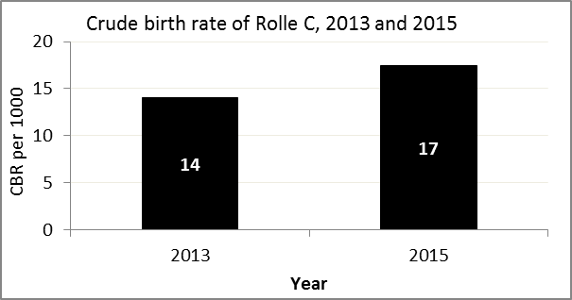
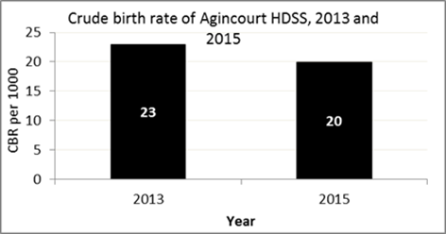

The crude birth rate is found by comparing the number of babies born to the total population. For example, for every 1 000 people living in Rolle C village in the year 2015, 17 babies were born.
When you compare the crude birth rates in Rolle C village with the crude birth rate for the whole of the Agincourt HDSS research site, you will see that as of now, they are relatively similar. One difference is that Rolle C had an increase in births, but Agincourt HDSS did not.

Births by Mother’s Age and Age Specific Fertility Rates
Research within the Agincourt HDSS research site continues to look closely at fertility. You can see the number of babies born to mothers of different ages in Rolle C village below.
Births by Age group in Rolle C, 2013 and 2015
Age Groups | 2013 | 2015
10-14 | 0 | 0
15 -19 | 5 | 14
20-24 | 11 | 10
25-29 | 6 | 6
30-34 | 9 | 5
35-39 | 0 | 4
40-44 | 1 | 1
45-49 | 0 | 0
Total Births | 32 | 40

We can also look at trends across the whole site and compare them with Rolle C village.

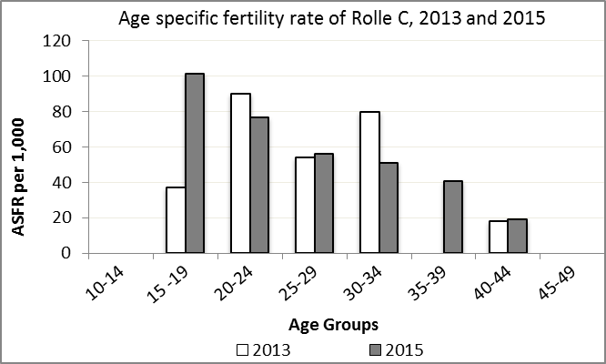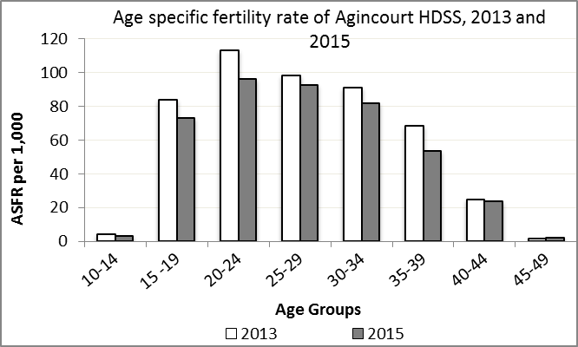
We find the age specific fertility rate by looking at how many women in a certain age group have had babies in a certain year. For example, we can see that in the year 2015 in Rolle C village, for every 1 000 women ages 15-19, about 101 of them gave birth.

Take home message: 2015 saw increases in fertility throughout all age groups except ages 20-24 and 30-34.

Deaths

Deaths

The MRC/Wits Agincourt Unit only gives numbers of deaths for each age group in each village, not the cause of death. The number of deaths occurring is low and if the cause of death is given, then a person’s confidentiality may be broken. Below you can see the total number of deaths that occurred in Rolle C village 2013 and in 2015.

Deaths by Sex in Rolle C, 2013 and 2015
 | 2013 | 2015
Male Deaths | 6 | 9
Female Deaths | 6 | 5
Total Deaths | 12 | 14

Below you can compare the crude death rates over the same period in Rolle C village and across the Agincourt HDSS research site.

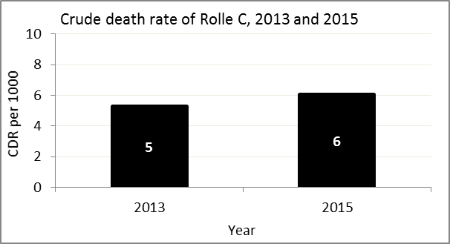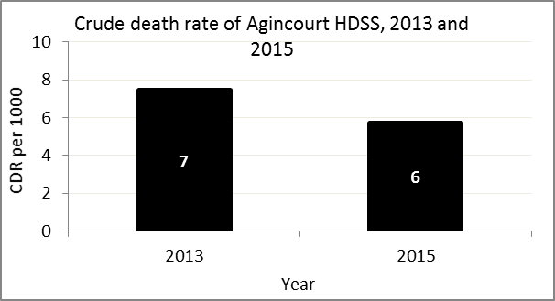
The crude death rate is found by looking at how many people died for every 1 000 people living in the population. For example, in 2015, for every 1 000 people in the population of Rolle C village, 6 died.

The data shows that the crude death rate has increased from the levels seen in 1994. However, the good news is that the death rate across the whole population of the Agincourt HDSS research site is closer to the death rate before HIV became prominent in South Africa.

MIGRATION

Permanent migration patterns

Below you can see how many people have moved into and out of Belfast village permanently.

In-Migrants by Sex in Rolle C village, 2013 and 2015
 | 2013 | 2015
Male In-Migrants | 27 | 30
Female In-Migrants | 57 | 45
Total | 84 | 75

Out-Migrants by Sex in Rolle C village, 2013 and 2015
 | 2013 | 2015
Male Out-Migrants | 41 | 39
Female Out-Migrants | 81 | 43
Total Out-Migrants | 122 | 82

Take home message: The number of people permanently moving into and out of Rolle C village is decreasing.

