MP STREAM VILLAGE FACT SHEET 2017

This “Fact Sheet” provides basic information on population changes and demographics for MP Stream village. Whenever you use this information, please reference it as being obtained from MRC/Wits Rural Public Health and Health Transitions Research Unit (Agincourt).

Villages in the Agincourt Health and Socio-Demographic Surveillance (HDSS) System Research Site in 2017 include:
Agincourt, Belfast, Croquet Lawn, Croquet Lawn B, Cunningmore A, Cunningmore B, Dumphries A, Dumphries B, Dumphries C, Huntington, Ireagh A, Ireagh B, Ireagh C, Justicia, Khaya Lami, Kildare A, Kildare B, Kumani, Lillydale A, Lillydale B, Makaringe, MP Stream, Newington B, Newington C, Rolle C, Somerset, Somerset C, and Xanthia.

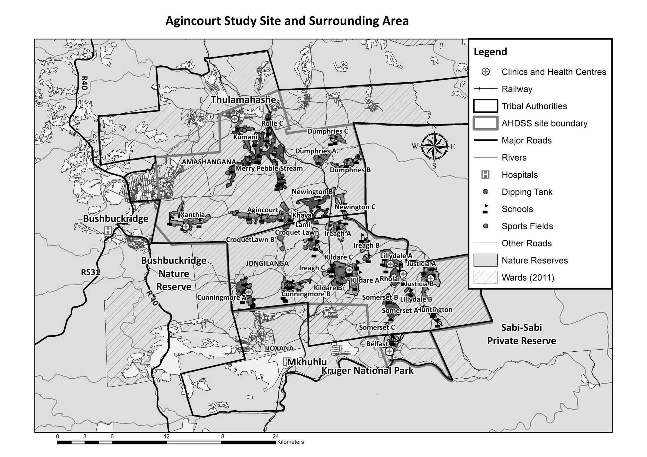
MP Stream

Village Growth and Population over the Period 2013 – 2016
The numbers shown below are calculated according to numbers for the end of June 2016. The numbers are known as mid-year population figures.

Mid-year Figures of MP Stream, 2013 and 2016
 |  |  | 2013 | 2016
Households |  |  | 1 595 | 1 727
Population |  |  | 9 343 | 9 704
Male |  |  | 4 485 | 4 669
Female |  |  | 4 858 | 5 035
Children under 5 |  |  | 1 088 | 978
Children of school-going age (5-19) |  |  | 2 961 | 3 023

Below you can see how many people were living in MP Stream village of different ages in June 2016.

Mid-Year Population of MP Stream village, 2016
Age Group | 2016
 | Male | Female | Total
0-4 | 513 | 505 | 1 018
5-9 | 477 | 494 | 971
10-14 | 498 | 469 | 967
15-19 | 488 | 488 | 976
20-24 | 459 | 521 | 980
25-29 | 411 | 427 | 838
30-34 | 334 | 366 | 700
35-39 | 245 | 235 | 480
40-44 | 178 | 220 | 398
45-49 | 533 | 555 | 1 088
50-54 | 137 | 167 | 304
55-59 | 131 | 159 | 290
60-64 | 79 | 125 | 204
65-69 | 57 | 83 | 140
70-74 | 23 | 63 | 86
75-79 | 25 | 42 | 67
80-84 | 9 | 46 | 55
85-89 | 16 | 42 | 58
90-94 | 8 | 10 | 18
95+ | 2 | 6 | 8
Total | 4 623 | 5 023 | 9 646

You can compare the population structure between MP Stream village and the Agincourt HDSS research site (2013 and 2016) by looking at the population pyramids below.
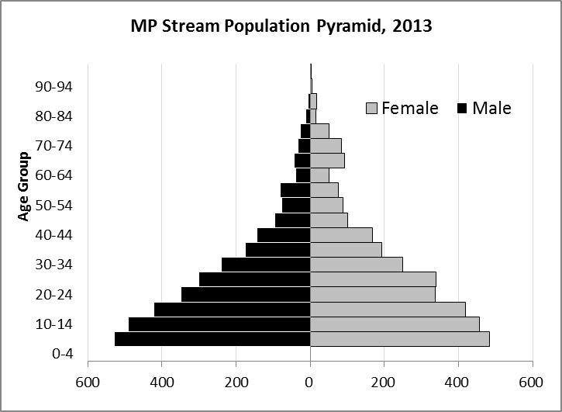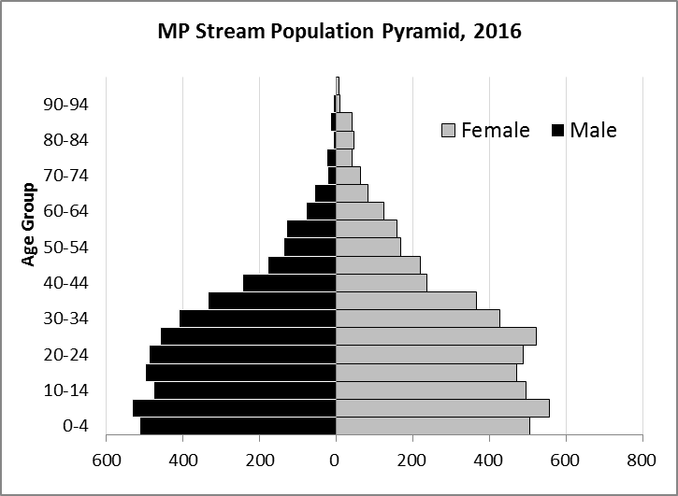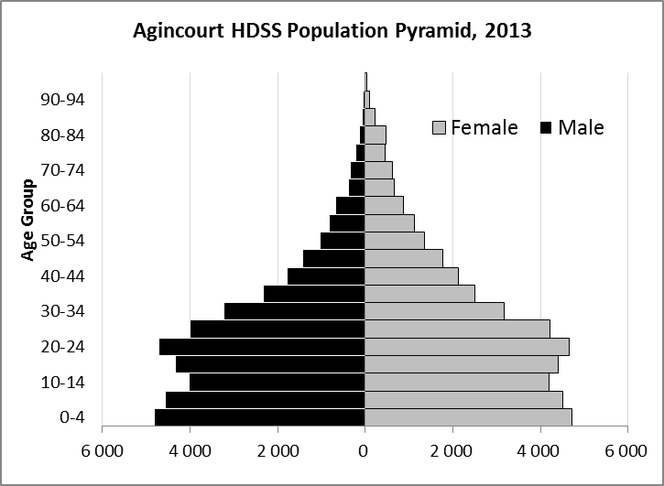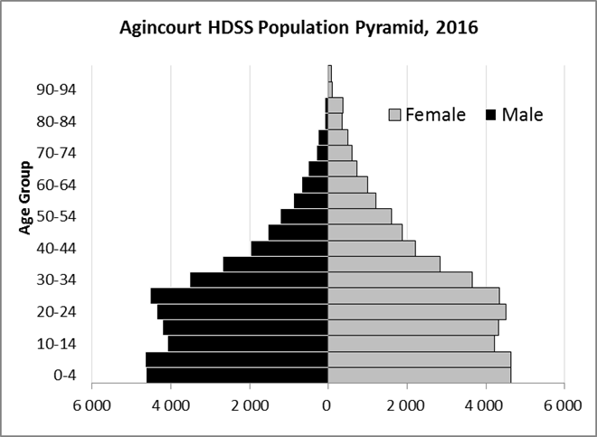

Take home message: The number of households in MP Stream village has increased since 2013. The population has also grown between the years of 2013 and 2015. The population structure of MP Stream village strongly follows the structure of the Agincourt HDSS research site.

Births

Number of Births by Sex
The number of births recorded in MP Stream village are shown below. We can only provide data to the end of 2015.
Births by Sex in MP Stream Village, 2013 and 2015
 | 2013 | 2015
Male Births | 83 | 78
Female Births | 62 | 77
Total Births | 145 | 156

The numbers of births show an upward trend in MP Stream village. In 2015 there was an increase in the number of births.

Crude Birth Rate (how many babies born for every one thousand people)
The graphs below show the crude birth rate in MP stream village from 2013 to 2015. The second graph shows the crude birth rates in the Agincourt HDSS research site from 2013 to 2015.

We compared the birth trends in MP Stream village with the rest of the Agincourt HDSS research site in the graphs below.
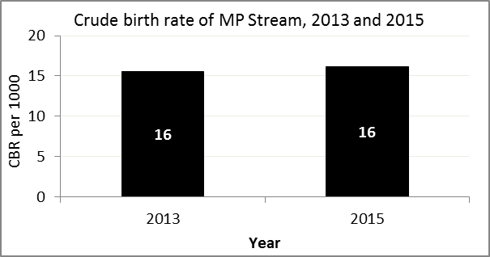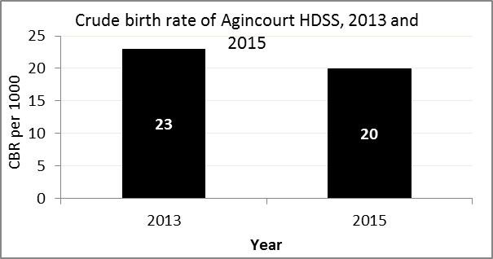

The crude birth rate is found by comparing the number of babies born to the total population. For example, for every 1 000 people living in MP Stream village in the year 2015, 16 babies were born.
When you compare the crude birth rates in MP Stream village with the crude birth rate for the whole of the Agincourt HDSS research site, they are relatively similar. One difference is that MP Stream had a constant birth rate in 2015 while Agincourt HDSS had a decrease.

Births by Mother’s Age and Age Specific Fertility Rates
Research within the Agincourt HDSS research site continues to look closely at fertility. You can see the number of babies born to mothers of different ages in MP Stream village below.

Births by Age group in MP Stream, 2013 and 2015
Age Groups | 2013 | 2015
10-14 | 2 | 2
15 -19 | 22 | 29
20-24 | 46 | 42
25-29 | 31 | 48
30-34 | 28 | 22
35-39 | 13 | 10
40-44 | 3 | 2
45-49 | 0 | 1
Total Births | 145 | 156
We can also look at trends across the whole site and compare them with MP Stream village.

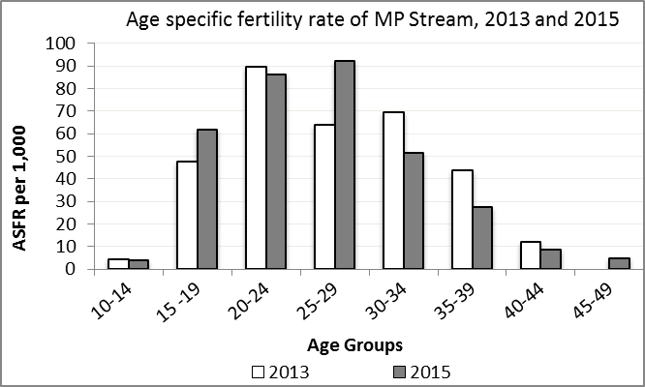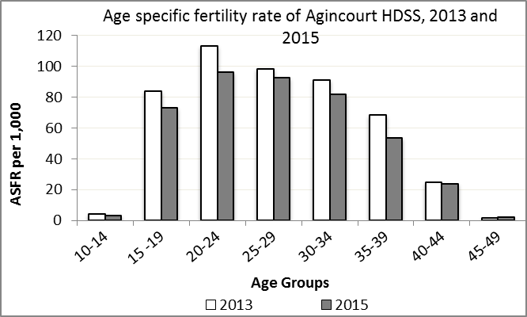

We find the age specific fertility rate by looking at how many women in a certain age group have had babies in a certain year. For example, we can see that in the year 2015 in MP Stream village, for every 1 000 women ages 15-19, about 62 of them gave birth.

Take home message: 2015 saw a decrease in fertility across most groups, while the 10-14 range remained constant and ages 15-19, and 25-29 had increases in fertility.

Deaths

Deaths

The MRC/Wits Agincourt Unit only gives numbers of deaths for each age group in each village, not the cause of death. The number of deaths occurring is low and if the cause of death is given, then a person’s confidentiality may be broken. The table below shows the total number of deaths that occurred in MP Stream village in 2013 and in 2015.

Deaths by Sex in MP Stream, 2013 and 2015
 | 2013 | 2015
Male Deaths | 33 | 42
Female Deaths | 30 | 41
Total Deaths | 63 | 83

The graphs below show the crude death rates over the same period in MP Stream village and across the Agincourt HDSS research site.

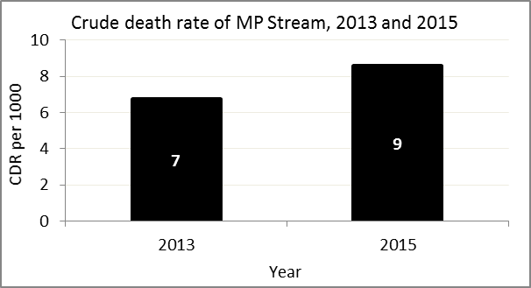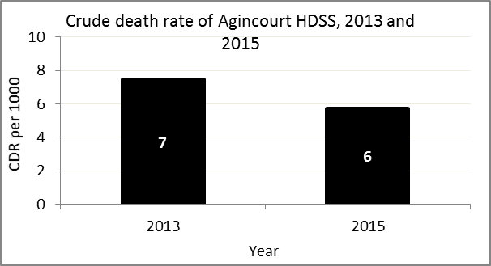
The crude death rate is found by looking at how many people died for every 1 000 people living in the population. For example, in 2015, for every 1 000 people in the population of MP Stream village, 9 died.

The data shows that the crude death rate has increased from the levels seen in 2013. However, the good news is that the death rate across the whole population of the Agincourt HDSS research site is closer to the death rate before HIV became prominent in South Africa.

MIGRATION

Permanent migration patterns

The tables below describe how many people have moved into MP Stream village permanently and out of MP Stream village permanently.

In-Migrants by Sex in MP Stream village, 2013 and 2015
 | 2013 | 2015
Male In-Migrants | 132 | 191
Female In-Migrants | 185 | 244
Total | 317 | 435

Out-Migrants by Sex in MP Stream village, 2013 and 2015
 | 2013 | 2015
Male Out-Migrants | 122 | 174
Female Out-Migrants | 217 | 255
Total Out-Migrants | 339 | 429

Take home message: The number of people permanently moving into and out of MP stream village is increasing.

