KUMANI VILLAGE FACT SHEET 2017

This “Fact Sheet” provides basic information on population changes and demographics for Kumani village. Whenever you use this information, please reference it as being obtained from MRC/Wits Rural Public Health and Health Transitions Research Unit (Agincourt).

Villages in the Agincourt Health and Socio-Demographic Surveillance (HDSS) System Research Site in 2017 include:
Agincourt, Belfast, Croquet Lawn, Croquet Lawn B, Cunningmore A, Cunningmore B, Dumphries A, Dumphries B, Dumphries C, Huntington, Ireagh A, Ireagh B, Ireagh C, Justicia, Khaya Lami, Kildare A, Kildare B, Kumani, Lillydale A, Lillydale B, Makaringe, MP Stream, Newington B, Newington C, Rolle C, Somerset, Somerset C, and Xanthia.

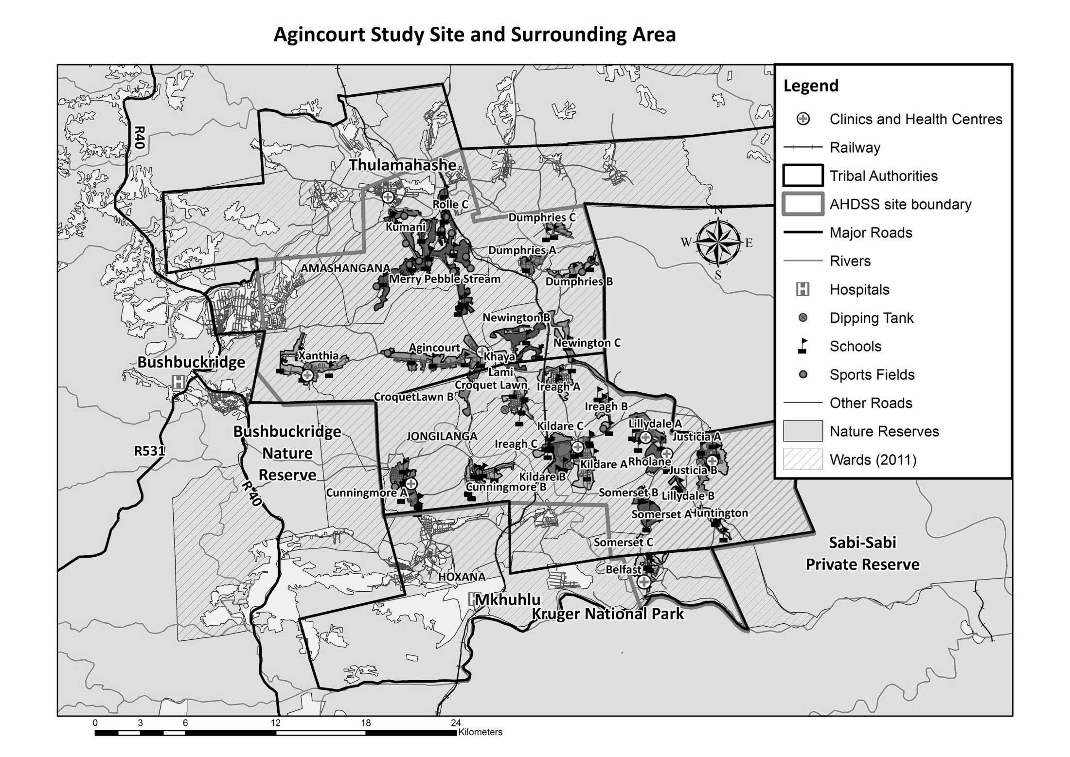
Kumani

Village Growth and Population over the Period 2013 – 2016
The numbers shown below are calculated according to numbers for the end of June 2016. The numbers are known as mid-year population figures.

Mid-year Figures of Kumani, 2013 and 2016
 |  |  | 2013 | 2016
Households |  |  | 1 239 | 1 342
Population |  |  | 6 541 | 6 999
Male |  |  | 3 123 | 3 340
Female |  |  | 3 418 | 3 659
Children under 5 |  |  | 800 | 804
Children of school-going age (5-19) |  |  | 2 013 | 2 121

The numbers of people who were living in Kumani village of different ages in June 2015 are pictured below.

Mid-Year Population of Kumani village, 2016
Age Group | 2016
 | Male | Female | Total
0-4 | 388 | 416 | 804
5-9 | 320 | 333 | 653
10-14 | 358 | 322 | 680
15-19 | 340 | 350 | 690
20-24 | 346 | 425 | 771
25-29 | 339 | 306 | 645
30-34 | 223 | 232 | 455
35-39 | 152 | 201 | 353
40-44 | 134 | 155 | 289
45-49 | 380 | 408 | 788
50-54 | 105 | 133 | 238
55-59 | 92 | 95 | 187
60-64 | 63 | 77 | 140
65-69 | 45 | 69 | 114
70-74 | 32 | 39 | 71
75-79 | 9 | 37 | 46
80-84 | 6 | 23 | 29
85-89 | 6 | 28 | 34
90-94 | 2 | 7 | 9
95+ | 0 | 3 | 3
Total | 3 340 | 3 659 | 6 999

You can compare the population structure between Kumani village and the Agincourt HDSS research site (2013 and 2016) by looking at the population pyramids below.

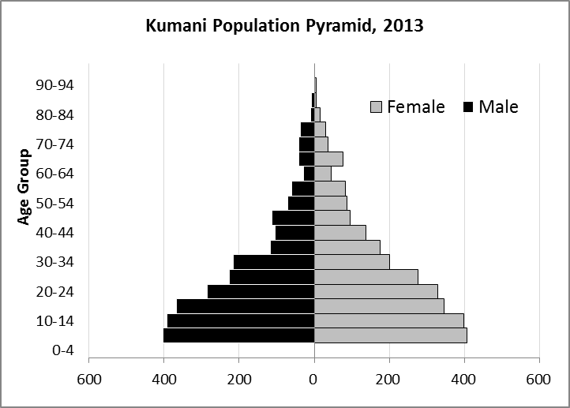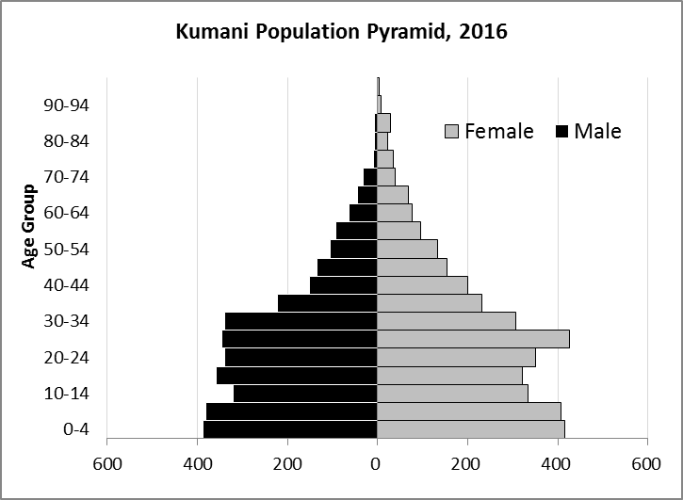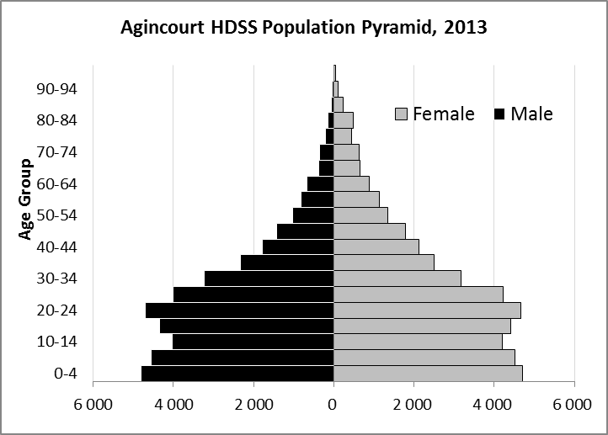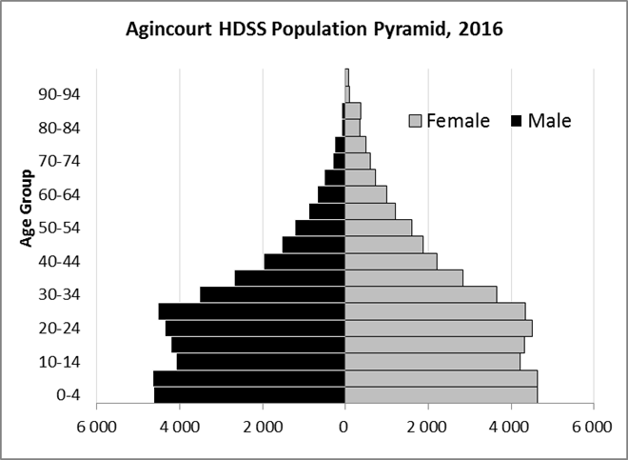

Take home message: The number of households in Kumani village has increased since 2013. The population has also grown between the years of 2013 and 2016. The population structure of Kumani village somewhat follows the structure of the Agincourt HDSS research site.

Births

Number of Births by Sex
The number of births recorded in Kumani village are shown below. We can only provide data to the end of 2015. We compared the birth trends in Kumani village with the rest of the Agincourt HDSS research site.

Births by Sex in Kumani Village, 2013 and 2015
 | 2013 | 2015
Male Births | 53 | 74
Female Births | 61 | 76
Total Births | 114 | 150

The numbers of births show an upward trend in Kumani village. In 2015 there was an increase in the number of births.

Crude Birth Rate (how many babies born for every one thousand people)
The graphs below show a comparison of the birth trends in Kumani village with the rest of the Agincourt HDSS research.

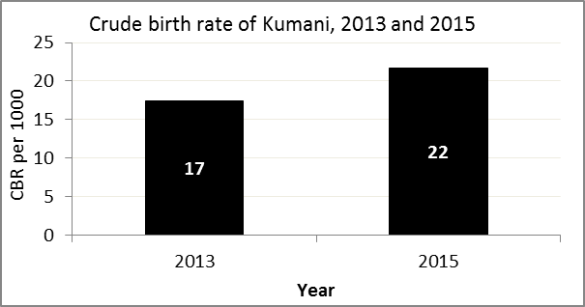
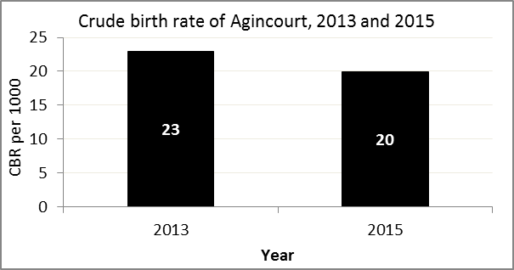

The crude birth rate is found by comparing the number of babies born to the total population. For example, for every 1 000 people living in Kumani village in the year 2015, 22 babies were born.
When you compare the crude birth rates in Kumani village with the crude birth rate for the whole of the Agincourt HDSS research site, they are relatively similar. One difference is that Kumani had an increase in births in 2015 and Agincourt HDSS did not.

Births by Mother’s Age and Age Specific Fertility Rates
Research within the Agincourt HDSS research site continues to look closely at fertility. You can see the number of babies born to mothers of different ages in Kumani village below.

Births by Age group in Kumani, 2013 and 2015
Age Groups | 2013 | 2015
10-14 | 0 | 1
15 -19 | 23 | 23
20-24 | 32 | 36
25-29 | 24 | 36
30-34 | 15 | 29
35-39 | 17 | 15
40-44 | 3 | 10
45-49 | 0 | 0
Total Births | 114 | 150

We can also look at trends in birth rates among different groups across the whole site and compare them with the Kumani village.

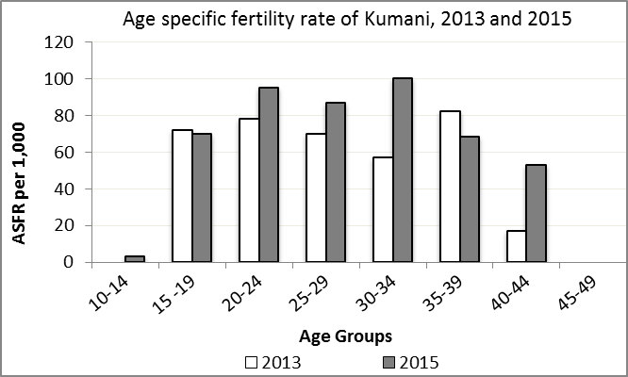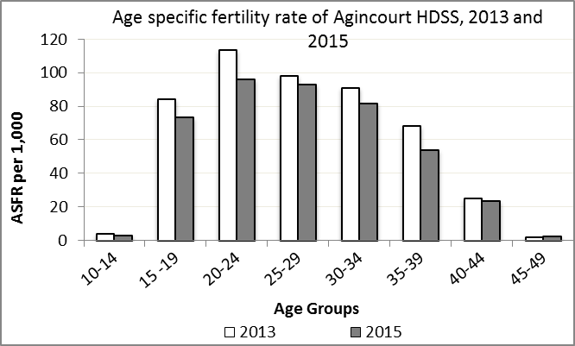

We find the age specific fertility rate by looking at how many women in a certain age group have had babies in a certain year. For example, we can see that in the year 2015 in Kumani village, for every 1 000 women ages 15-19, about 70 of them gave birth.

Take home message: 2015 increases in fertility throughout all age groups except for ages 15-19 and 35-39.

Deaths

Deaths

The MRC/Wits Agincourt Unit only gives numbers of deaths for each age group in each village, not the cause of death. The number of deaths occurring is low and if the cause of death is given, then a person’s confidentiality may be broken. Below you can see the total number of deaths that occurred in Kumani village in 2013 and in 2015.

Deaths by Sex in Kumani, 2013 and 2015
 | 2013 | 2015
Male Deaths | 19 | 25
Female Deaths | 17 | 27
Total Deaths | 36 | 52

Below you can compare the crude death rates over the same period in Kumani village and across the Agincourt HDSS research site.

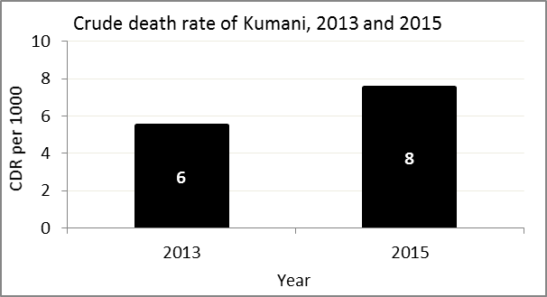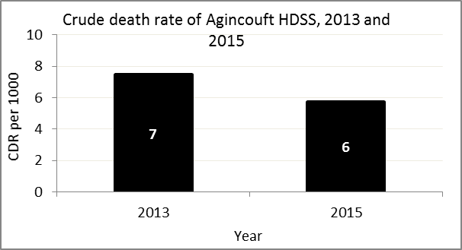
The crude death rate is found by looking at how many people died for every 1 000 people living in the population. For example, in 2015, for every 1 000 people in the population of Kumani village, 8 died.

The data shows that the crude death rate has increased from the levels seen in 2013. However, the good news is that the death rate across the whole population of the Agincourt HDSS research site is closer to the death rate before HIV became prominent in South Africa.

MIGRATION

Permanent migration patterns

Below you can see how many people have moved into Kumani village permanently and out of Kumani village permanently.

In-Migrants by Sex in Kumani village, 2013 and 2015
 | 2013 | 2015
Male In-Migrants | 108 | 136
Female In-Migrants | 204 | 204
Total | 312 | 340

Out-Migrants by Sex in Kumani village, 2013 and 2015
 | 2013 | 2015
Male Out-Migrants | 116 | 135
Female Out-Migrants | 205 | 221
Total Out-Migrants | 321 | 356

Take home message: The number of people permanently moving into and out of Kumani village is increasing.

