KILDARE A VILLAGE FACT SHEET 2017

This “Fact Sheet” provides basic information on population changes and demographics for Kildare A village. Whenever you use this information, please reference it as being obtained from MRC/Wits Rural Public Health and Health Transitions Research Unit (Agincourt).

Villages in the Agincourt Health and Socio-Demographic Surveillance (HDSS) System Research Site in 2017 include:
Agincourt, Belfast, Croquet Lawn, Croquet Lawn B, Cunningmore A, Cunningmore B, Dumphries A, Dumphries B, Dumphries C, Huntington, Ireagh A, Ireagh B, Ireagh C, Justicia, Khaya Lami, Kildare A, Kildare B, Kumani, Lillydale A, Lillydale B, Makaringe, MP Stream, Newington B, Newington C, Rolle C, Somerset, Somerset C, and Xanthia.

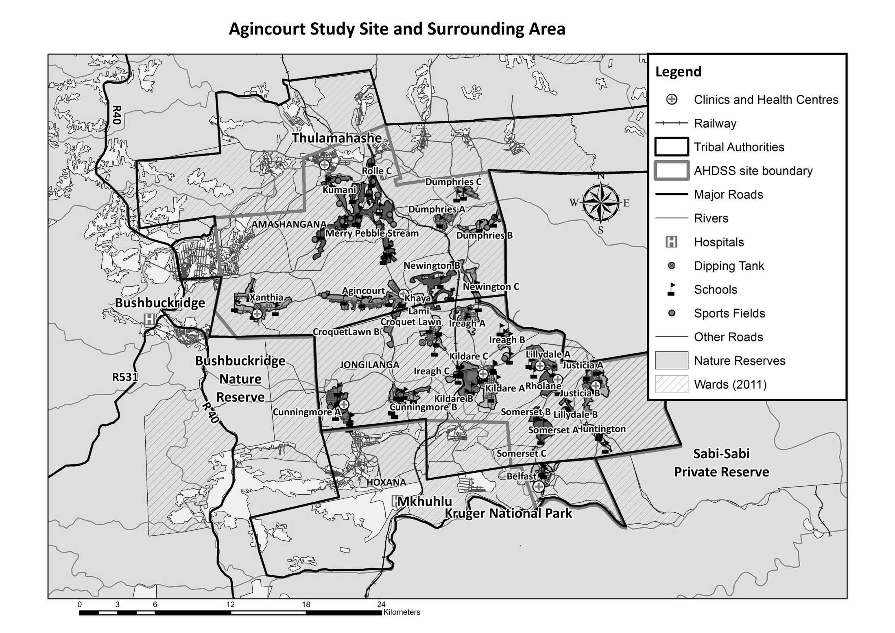
Kildare A

Village Growth and Population over the Period 1994 – 2016
The numbers shown below are calculated according to numbers for the end of June 2016. The numbers are known as mid-year population figures.

Mid-year Figures of Kildare A, 1994 and 2016
 |  |  | 1994 | 2016
Households |  |  | 717 | 974
Population |  |  | 4 378 | 4 925
Male |  |  | 2 094 | 2 363
Female |  |  | 2 284 | 2 562
Children under 5 |  |  | 631 | 413
Children of school-going age (5-19) |  |  | 1 727 | 1 382

Below you can see how many people were living in Kildare village of different ages in June 2016.

Mid-Year Population of Kildare A village, 2016
Age Group | 2016
 | Male | Female | Total
0-4 | 263 | 251 | 514
5-9 | 224 | 263 | 487
10-14 | 211 | 203 | 414
15-19 | 246 | 239 | 485
20-24 | 246 | 263 | 509
25-29 | 280 | 277 | 557
30-34 | 216 | 220 | 436
35-39 | 151 | 162 | 313
40-44 | 113 | 124 | 237
45-49 | 102 | 109 | 211
50-54 | 82 | 108 | 190
55-59 | 83 | 98 | 181
60-64 | 50 | 63 | 113
65-69 | 34 | 54 | 88
70-74 | 25 | 37 | 62
75-79 | 18 | 27 | 45
80-84 | 2 | 19 | 21
85-89 | 10 | 30 | 40
90-94 | 0 | 10 | 10
95+ | 6 | 6 | 12
Total | 2 362 | 2 563 | 4 925

You can compare the population structure between Kildare A village and the Agincourt HDSS research site (1994 and 2016) by looking at the population pyramids below.

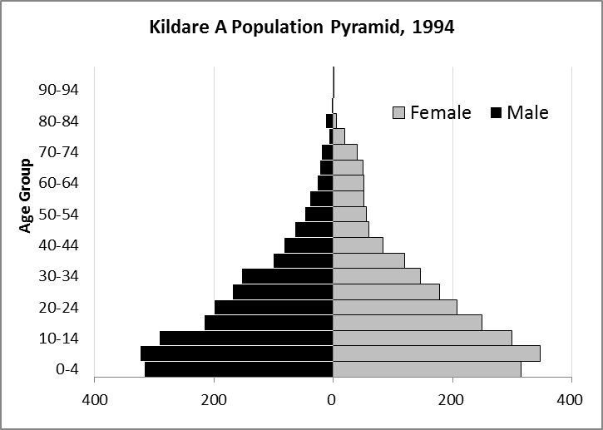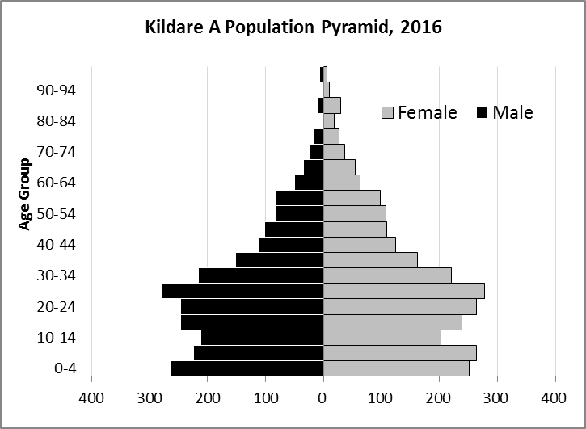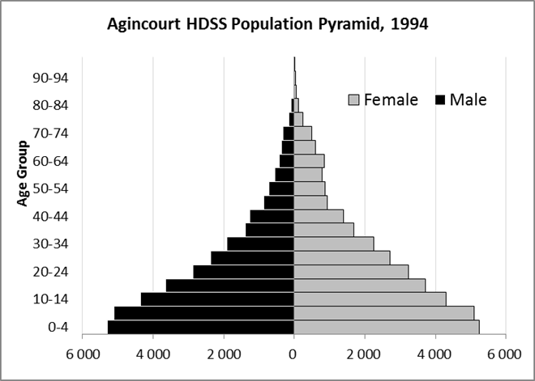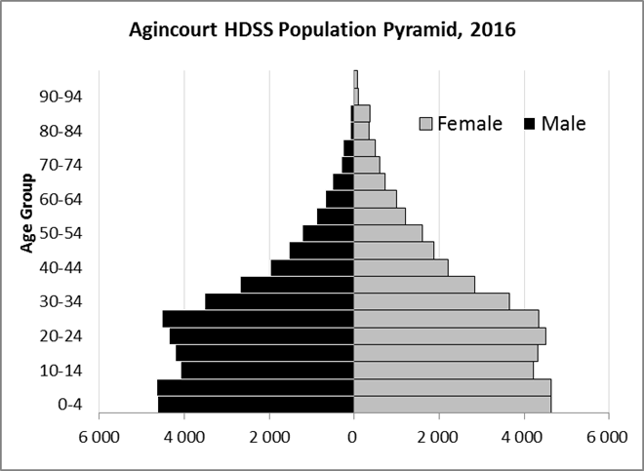

Take home message: The number of households in Kildare A village has increased since 1994. The population has also grown between the years of 1994 and 2016. The population structure of Kildare A village strongly follows the structure of the Agincourt HDSS research site.

Births

Number of Births by Sex
The number of births recorded in Kildare A village are shown below. We can only provide data to the end of 2015.

Births by Sex in Kildare A Village, 1994 and 2015
 | 1994 | 2015
Male Births | 33 | 45
Female Births | 54 | 52
Total Births | 87 | 97

The numbers of births show an upward trend in Kildare A village. In 2015 there was an increase in the number of births.

Crude Birth Rate (how many babies born for every one thousand people)
We compared the birth trends in Kidare A village with the rest of the Agincourt HDSS research site in the graphs below.

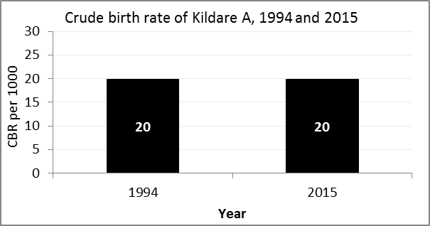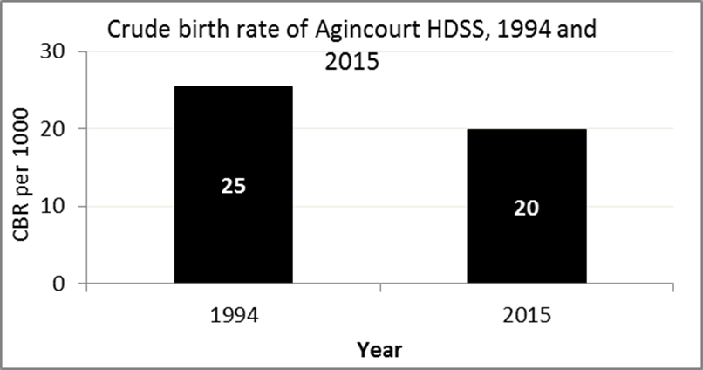

The crude birth rate is found by comparing the number of babies born to the total population. For example, above, for every 1 000 people living in Kildare A village in the year 2015, 20 babies were born.
When you compare the crude birth rates in Kildare A village with the crude birth rate for the whole of the Agincourt HDSS research site, they are relatively similar. One difference is that the birth rate in Kildare A did not change, but Agincourt HDSS saw a decrease in births.

Births by Mother’s Age and Age Specific Fertility Rates
Research within the Agincourt HDSS research site continues to look closely at fertility. You can see the number of babies born to mothers of different ages in Kidare A village below.

Births by Age group in Kildare A, 1994 and 2015
Age Groups | 1994 | 2015
10-14 | 2 | 0
15 -19 | 23 | 18
20-24 | 15 | 28
25-29 | 16 | 23
30-34 | 19 | 19
35-39 | 7 | 8
40-44 | 3 | 1
45-49 | 2 | 0
Total Births | 87 | 97

We can also look at trends across the whole site and compare them with Kildare A village.

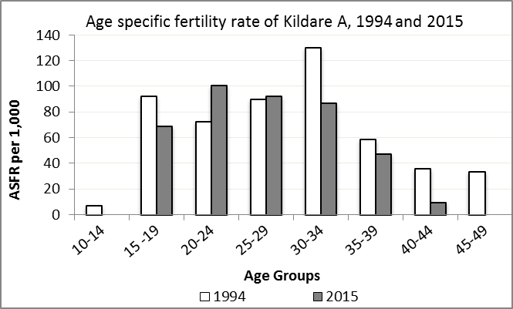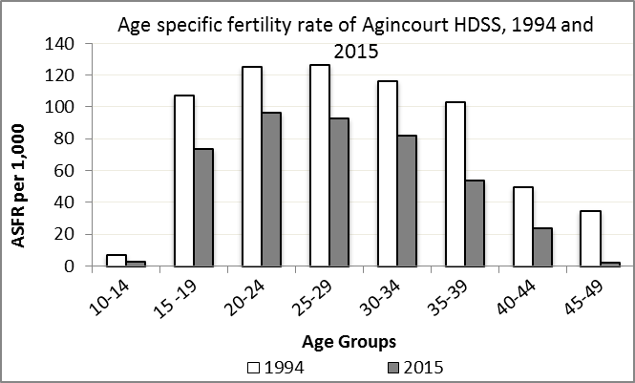

We find the age specific fertility rate by looking at how many women in a certain age group have had babies in a certain year. For example, we can see that in the year 2015 in Kildare A village, for every 1 000 women ages 15-19, about 69 of them gave birth.

Take home message: 2015 saw decreases in fertility throughout all ages except ages 20-24 and 25-29.

Deaths

Deaths

The MRC/Wits Agincourt Unit only gives numbers of deaths for each age group in each village, not the cause of death. The number of deaths occurring is low and if the cause of death is given, then a person’s confidentiality may be broken. shows the total number of deaths that occurred in Kildare A village in 1994 and in 2015.

Deaths by Sex in Kildare A, 1994 and 2015
 | 1994 | 2015
Male Deaths | 13 | 22
Female Deaths | 8 | 22
Total Deaths | 21 | 44

Below you can compare the crude death rates over the same period in Kildare A village and across the Agincort HDSS research site.

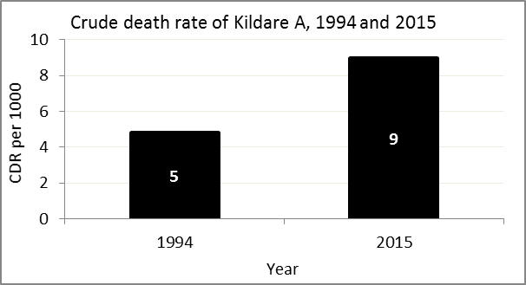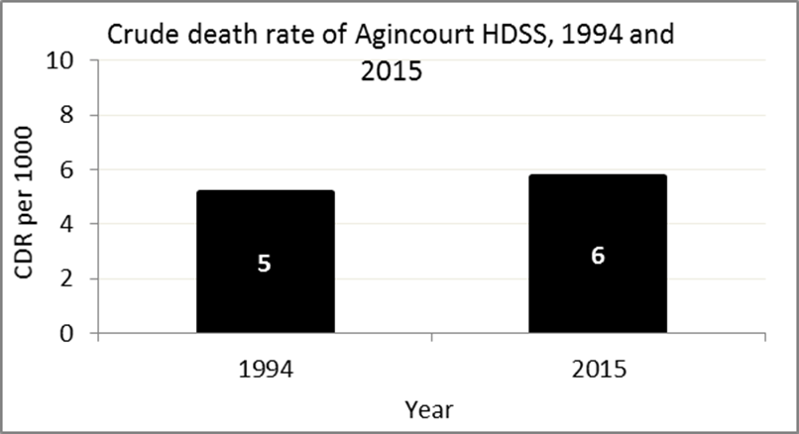
The crude death rate is found by looking at how many people died for every 1 000 people living in the population. For example, in 2015, for every 1 000 people in the population of Kildare A village, 9 died.

The data shows that the crude death rate has increased from the levels seen in 1994. However, the good news is that the death rate across the whole population of the Agincourt HDSS research site is closer to the death rate before HIV became prominent in South Africa.

MIGRATION

Permanent migration patterns

Below you can see how many people moved into and out of Belfast village permanently.

Out-Migrants by Sex in Kildare A village,1994 and 2015
 | 1994 | 2015
Male Out-Migrants | 87 | 104
Female Out-Migrants | 119 | 144
Total Out-Migrants | 206 | 248

In-Migrants by Sex in Kildare A village, 1994 and 2015
 | 1994 | 2015
Male In-Migrants | 90 | 95
Female In-Migrants | 139 | 152
Total | 229 | 247

Take home message: The number of people permanently moving into and out of Kildare A village is increasing.

