KHAYA LAMI VILLAGE FACT SHEET 2017

This “Fact Sheet” provides basic information on population changes and demographics for Khaya Lami village. Whenever you use this information, please reference it as being obtained from MRC/Wits Rural Public Health and Health Transitions Research Unit (Agincourt).

Villages in the Agincourt Health and Socio-Demographic Surveillance (HDSS) System Research Site in 2017 include:
Agincourt, Belfast, Croquet Lawn, Croquet Lawn B, Cunningmore A, Cunningmore B, Dumphries A, Dumphries B, Dumphries C, Huntington, Ireagh A, Ireagh B, Ireagh C, Justicia, Khaya Lami, Kildare A, Kildare B, Kumani, Lillydale A, Lillydale B, Makaringe, MP Stream, Newington B, Newington C, Rolle C, Somerset, Somerset C, and Xanthia.

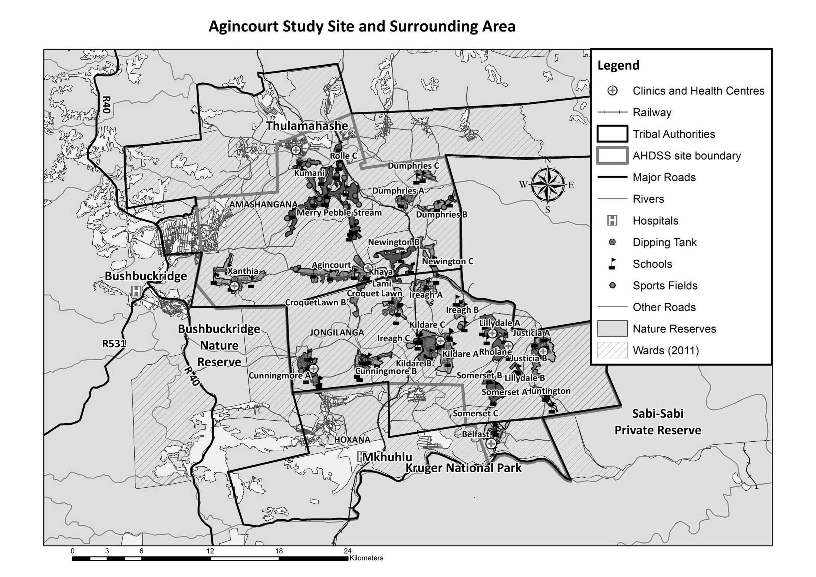
Khaya Lami

Village Growth and Population over the Period 2000 – 2016
The numbers shown in below are calculated according to numbers for the end of June 2016. The numbers are known as mid-year population figures.

Mid-year Figures of Khaya Lami, 2000 and 2016
 |  |  | 2000 | 2016
Households |  |  | 388 | 709
Population |  |  | 1 042 | 2 646
Male |  |  | 477 | 1 210
Female |  |  | 565 | 1 436
Children under 5 |  |  | 142 | 336
Children of school-going age (5-19) |  |  | 347 | 920

Below you can see how many people were living in Khaya Lami village of different ages in June 2016.

Mid-Year Population of Khaya Lami village, 2016
Age Group | 2016
 | Male | Female | Total
0-4 | 179 | 157 | 336
5-9 | 171 | 171 | 342
10-14 | 150 | 161 | 311
15-19 | 128 | 139 | 267
20-24 | 114 | 133 | 247
25-29 | 110 | 126 | 236
30-34 | 68 | 122 | 190
35-39 | 87 | 128 | 215
40-44 | 78 | 130 | 208
45-49 | 68 | 83 | 151
50-54 | 29 | 36 | 65
55-59 | 13 | 19 | 32
60-64 | 5 | 10 | 15
65-69 | 5 | 5 | 10
70-74 | 1 | 3 | 4
75-79 | 3 | 5 | 8
80-84 | 0 | 1 | 1
85-89 | 0 | 5 | 5
90-94 | 1 | 2 | 3
95+ | 0 | 0 | 0
Total | 1 210 | 1 436 | 2 646

You can compare the population structure between Khaya Lami village and the Agincourt HDSS research site (2000 and 2016) by looking at the population pyramids below.

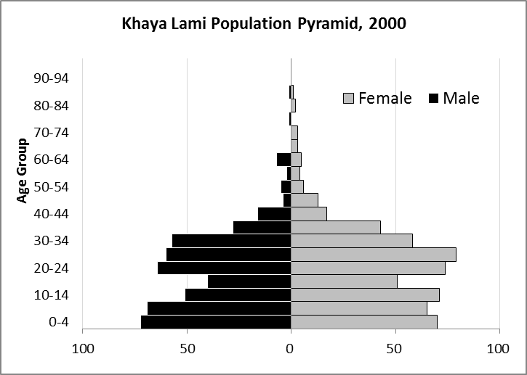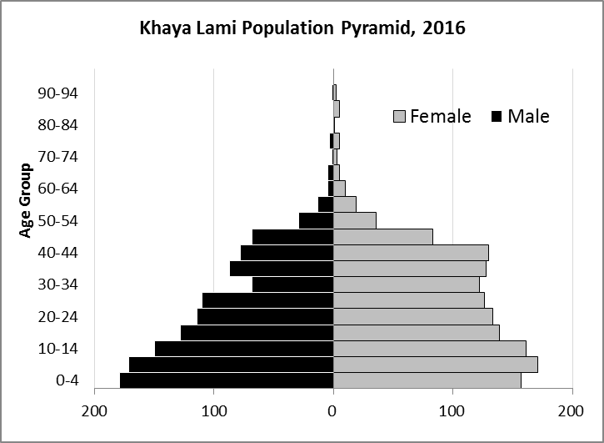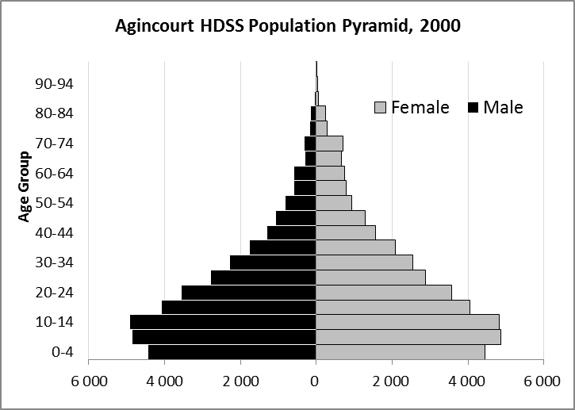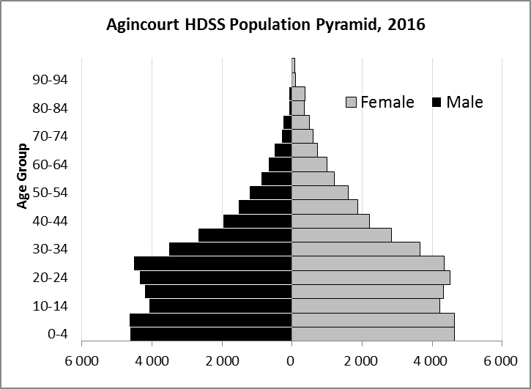

Take home message: The number of households in Khaya Lami village has increased since 2000. The population has also grown between the years of 2000 and 2016. The population structure of Khaya Lami village strongly follows the structure of the Agincourt HDSS research site.

Births

Number of Births by Sex
The number of births recorded in Khaya Lami village are shown below. We can only provide data to the end of 2015.
Births by Sex in Khaya Lami Village, 2000 and 2015
 | 2000 | 2015
Male Births | 16 | 33
Female Births | 15 | 29
Total Births | 31 | 62

The numbers of births show an upward trend in Khaya Lami village. In 2015 there was an increase in the number of births.

Crude Birth Rate (how many babies born for every one thousand people)
We compared the birth trends in Khaya Lami village with the rest of the Agincourt HDSS research site in the graphs below.

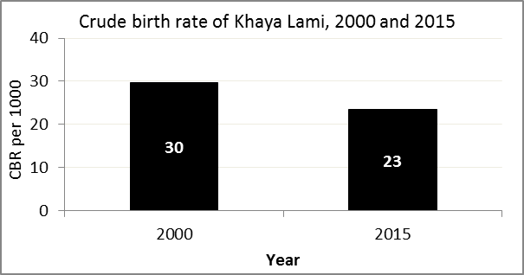
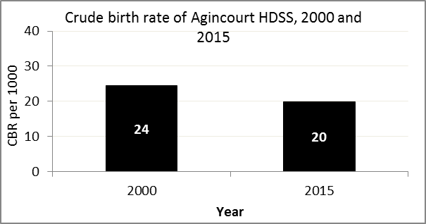

The crude birth rate is found by comparing the number of babies born to the total population. For example, above, for every 1 000 people living in Khaya Lami village in the year 2015, 23 babies were born.
When you compare the crude birth rates in Khaya Lami village with the crude birth rate for the whole of the Agincourt HDSS research site, they are relatively similar. The primary difference is that Khaya Lami had a greater decrease in births than Agincourt HDSS.

Births by Mother’s Age and Age Specific Fertility Rates
Research within the Agincourt HDSS research site continues to look closely at fertility. You can see the number of babies born to mothers of different ages in Khaya Lami village below.

Births by Age group in Khaya Lami, 2000 and 2015
Age Groups | 2000 | 2015
10-14 | 1 | 0
15 -19 | 5 | 16
20-24 | 7 | 8
25-29 | 15 | 14
30-34 | 3 | 11
35-39 | 0 | 11
40-44 | 0 | 2
45-49 | 0 | 0
Total Births | 31 | 62

We can also look at trends in birth rates in different age groups across the whole site and compare them with Khaya Lami village.

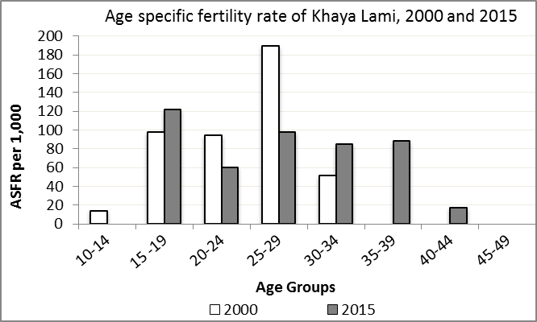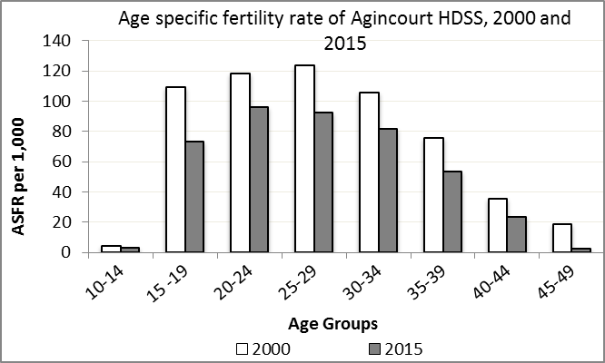

We find the age specific fertility rate by looking at how many women in a certain age group have had babies in a certain year. For example, we can see that in the year 2015 in Khaya Lami village, for every 1 000 women ages 15-19, about 122 of them gave birth.

Take home message: 2015 saw a mix of increases and decreases in fertility across age groups. Ages 15-19 and 30-44 saw increases in fertility, while ages 10-14 and 20-29 saw decreases in fertility.

Deaths

Deaths

The MRC/Wits Agincourt Unit only gives numbers of deaths for each age group in each village, not the cause of death. The number of deaths occurring is low and if the cause of death is given, then a person’s confidentiality may be broken. Below you can see the total number of deaths that occurred in Khaya Lami village in 2000 and in 2015.

Deaths by Sex in Khaya Lami, 2000 and 2015
 | 2000 | 2015
Male Deaths | 4 | 7
Female Deaths | 2 | 4
Total Deaths | 6 | 11

Below you can compare the crude death rates over the same period in Khaya Lami village and across the Agincourt HDSS research site.

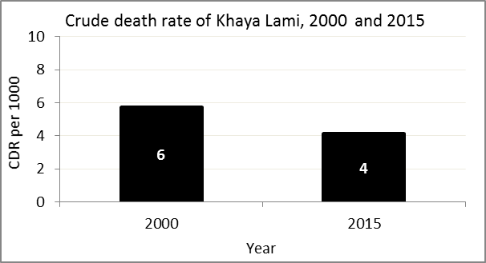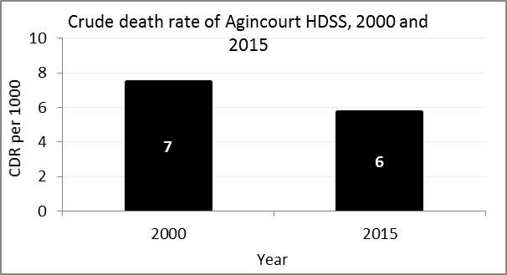
The crude death rate is found by looking at how many people died for every 1 000 people living in the population. For example, in 2015, for every 1 000 people in the population of Khaya Lami village, 4 died.

The data shows that the crude death rate has decreased from the levels seen in 2000. In addition, the death rate across the whole population of the Agincourt HDSS research site is closer to the death rate before HIV became prominent in South Africa.

MIGRATION

Permanent migration patterns

Below you can see how many people have moved into and out of Khaya Lami village permanently.

Out-Migrants by Sex in Khaya Lami village, 2000 and 2015
 | 2000 | 2015
Male Out-Migrants | 67 | 136
Female Out-Migrants | 88 | 149
Total Out-Migrants | 155 | 285

In-Migrants by Sex in Khaya Lami village, 2000 and 2015
 | 2000 | 2015
Male In-Migrants | 316 | 114
Female In-Migrants | 368 | 112
Total | 684 | 226

Take home message: The number of people permanently moving into Khaya Lami village is decreasing, but the number of people moving out of Khaya Lami is increasing.

