JUSTICIA VILLAGE FACT SHEET 2017

This “Fact Sheet” provides basic information on population changes and demographics for Justicia village. Whenever you use this information, please reference it as being obtained from MRC/Wits Rural Public Health and Health Transitions Research Unit (Agincourt).

Villages in the Agincourt Health and Socio-Demographic Surveillance (HDSS) System Research Site in 2017 include:
Agincourt, Belfast, Croquet Lawn, Croquet Lawn B, Cunningmore A, Cunningmore B, Dumphries A, Dumphries B, Dumphries C, Huntington, Ireagh A, Ireagh B, Ireagh C, Justicia, Khaya Lami, Kildare A, Kildare B, Kumani, Lillydale A, Lillydale B, Makaringe, MP Stream, Newington B, Newington C, Rolle C, Somerset, Somerset C, and Xanthia.

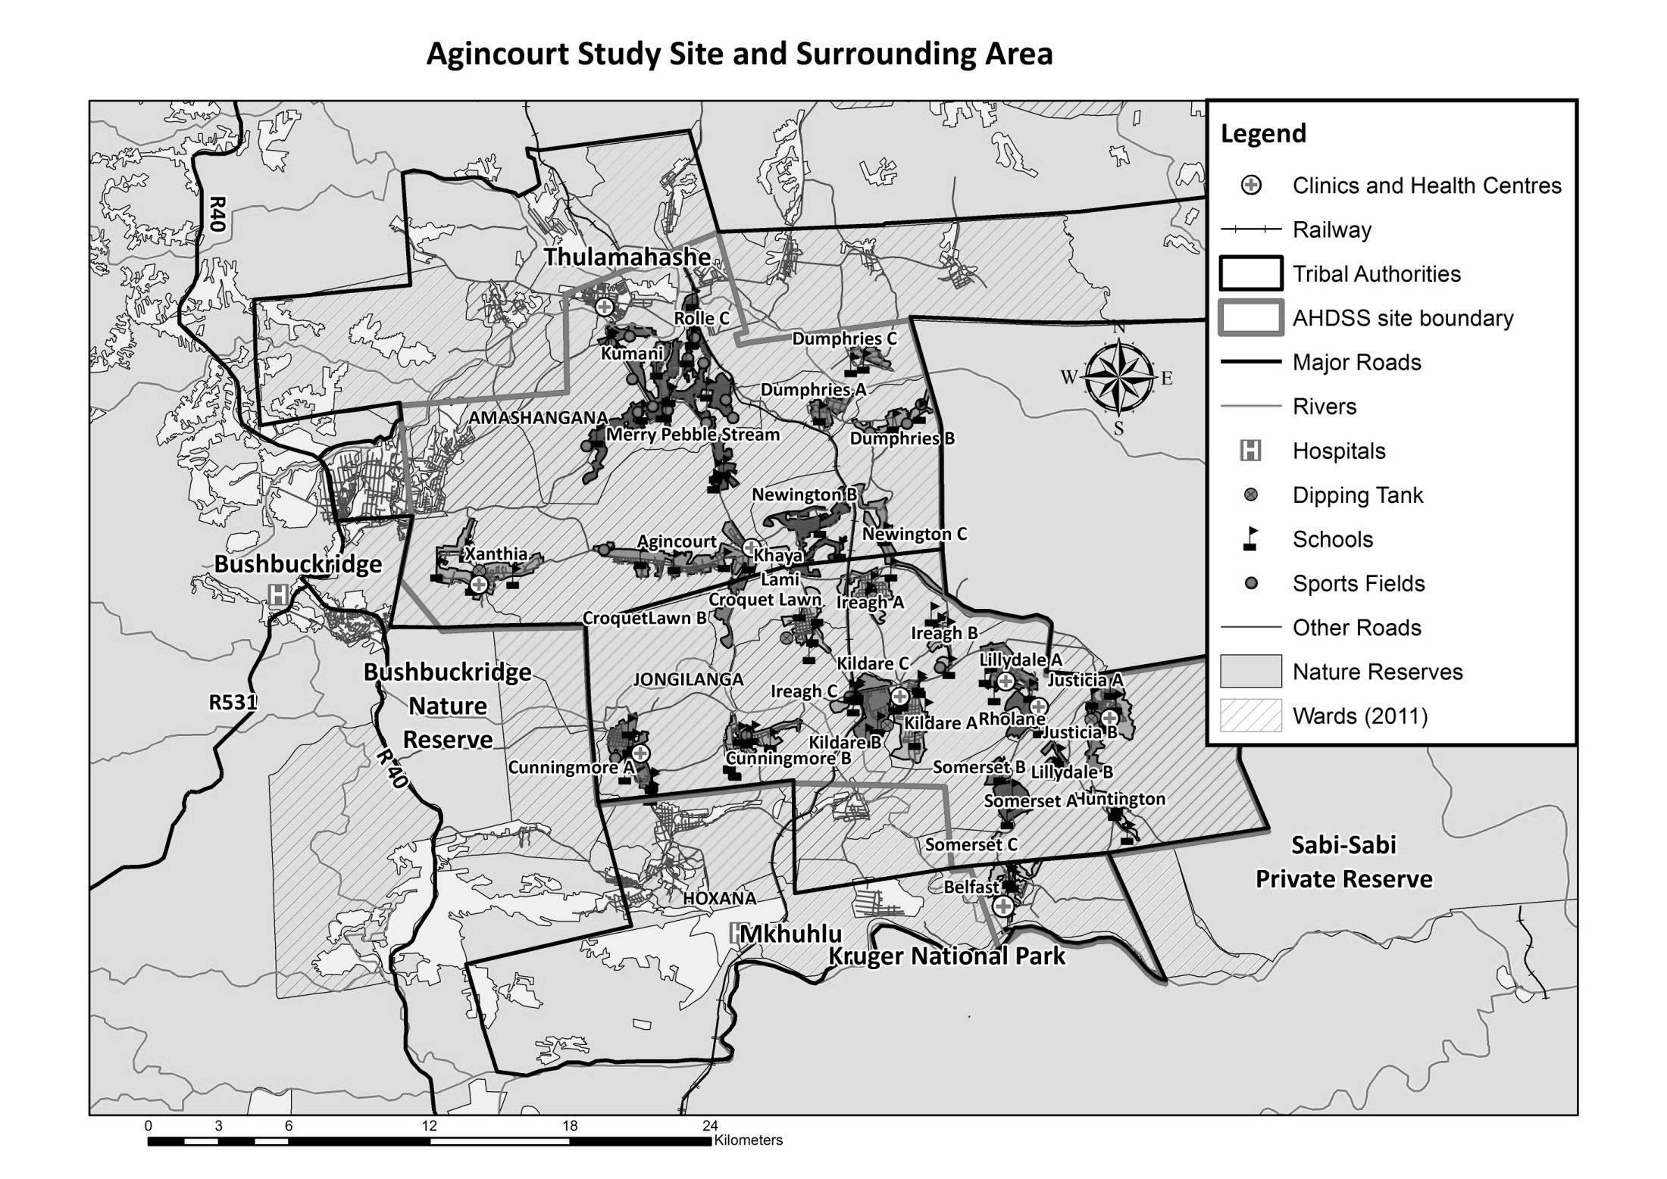
Justicia

Village Growth and Population over the Period 1994 – 2016
The numbers shown in below are calculated according to numbers for the end of June 2016. The numbers are known as mid-year population figures.

Mid-year Figures of Justicia, 1994 and 2016
 |  |  | 1994 | 2016
Households |  |  | 963 | 1 503
Population |  |  | 6 253 | 7 313
Male |  |  | 2 959 | 3 390
Female |  |  | 3 294 | 3 923
Children under 5 |  |  | 1 070 | 853
Children of school-going age (5-19) |  |  | 2 417 | 2 335

Below you can see how many people were living in Justicia village of different ages in June 2016.

Mid-Year Population of Justicia village, 2016
Age Group | 2016
 | Male | Female | Total
0-4 | 438 | 415 | 853
5-9 | 379 | 414 | 793
10-14 | 357 | 416 | 773
15-19 | 347 | 422 | 769
20-24 | 375 | 418 | 793
25-29 | 357 | 372 | 729
30-34 | 301 | 315 | 616
35-39 | 232 | 235 | 467
40-44 | 169 | 196 | 365
45-49 | 128 | 163 | 291
50-54 | 90 | 120 | 210
55-59 | 77 | 108 | 185
60-64 | 48 | 102 | 150
65-69 | 33 | 53 | 86
70-74 | 24 | 53 | 77
75-79 | 16 | 44 | 60
80-84 | 5 | 31 | 36
85-89 | 9 | 32 | 41
90-94 | 4 | 8 | 12
95+ | 1 | 6 | 7
Total | 3 390 | 3 923 | 7 313

You can compare the population structure between Justicia village and the Agincourt HDSS research site (1994 and 2016) by looking at the population pyramids below.

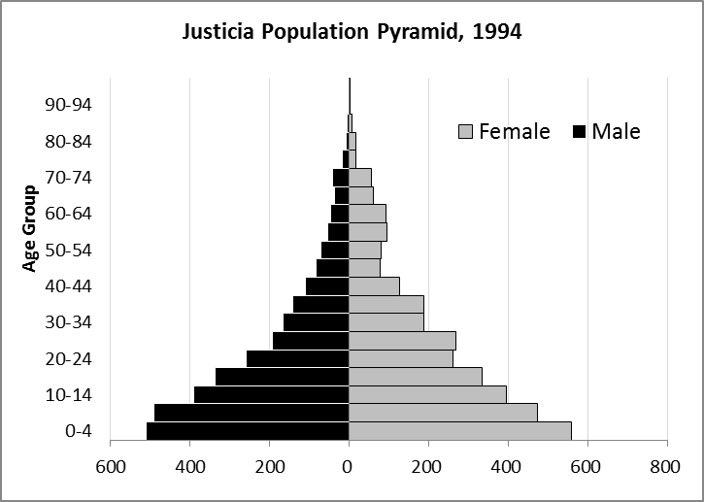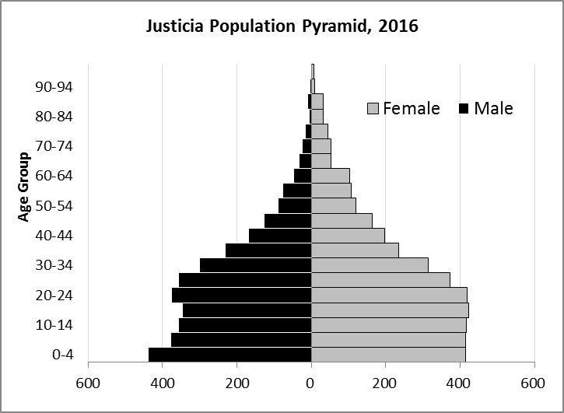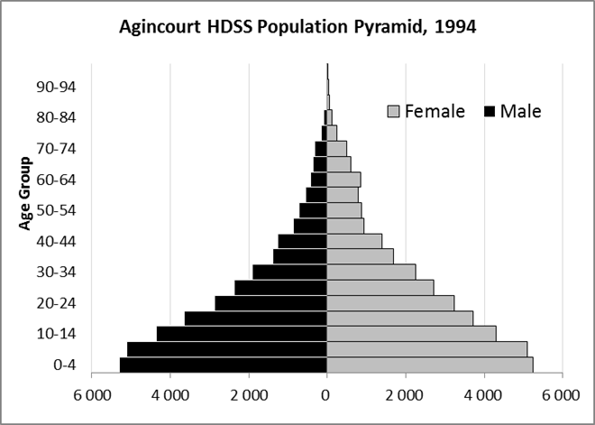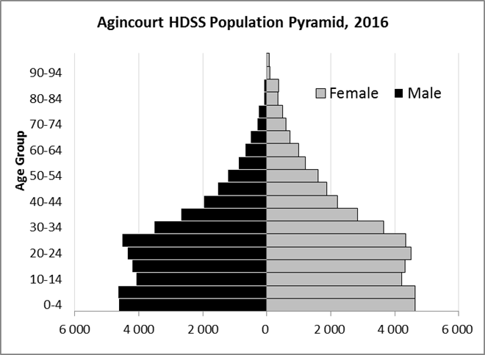

Take home message: The number of households in Justicia village has increased since 1994. The population has also grown between the years of 1994 and 2016. The population structure of Justicia village strongly follows the structure of the Agincourt HDSS research site.

Births

Number of Births by Sex
The number of births recorded in Justicia village is shown below. We can only provide data to the end of 2015.

Births by Sex in Justicia Village, 1994 and 2015
 | 1994 | 2015
Male Births | 100 | 70
Female Births | 96 | 76
Total Births | 196 | 147

The numbers of births show an upward trend in Justicia village. In 2015 there was an increase in the number of births.

Crude Birth Rate (how many babies born for every one thousand people)
We compared the birth trends in Justicia village with the rest of the Agincourt HDSS research site in the graphs below.

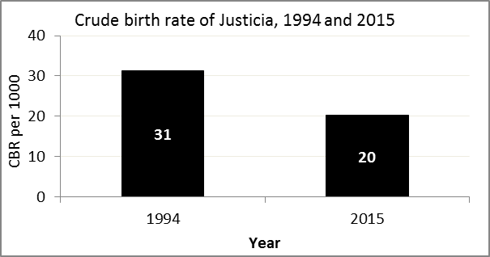
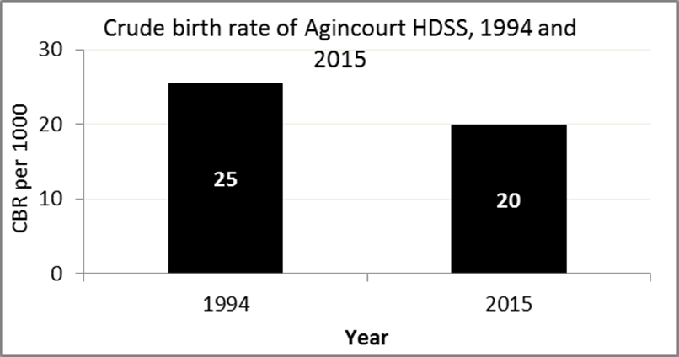

The crude birth rate is found by comparing the number of babies born to the total population. For example, above, for every 1 000 people living in Justicia village in the year 2015, 20 babies were born.
When you compare the crude birth rates in Justicia village with the crude birth rate for the whole of the Agincourt HDSS research site, they are relatively similar. One difference is that Justicia had an increase in births in 2015 and Agincourt HDSS did not.

Births by Mother’s Age and Age Specific Fertility Rates
Research within the Agincourt HDSS research site continues to look closely at fertility. You can see the number of babies born to mothers of different ages in Justicia village below.

Births by Age group in Justicia, 1994 and 2015
Age Groups | 1994 | 2015
10-14 | 2 | 1
15 -19 | 55 | 21
20-24 | 40 | 43
25-29 | 39 | 39
30-34 | 21 | 28
35-39 | 19 | 11
40-44 | 12 | 3
45-49 | 5 | 0
Total Births | 193 | 146

We can also look at trends across the whole site and compare them with Justicia village.

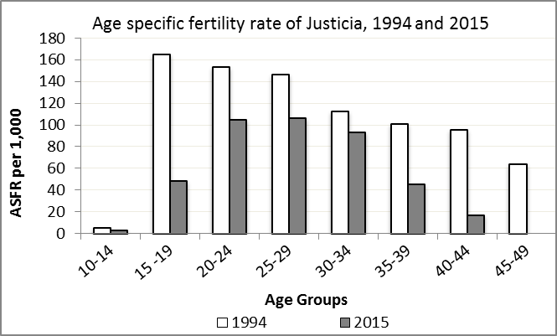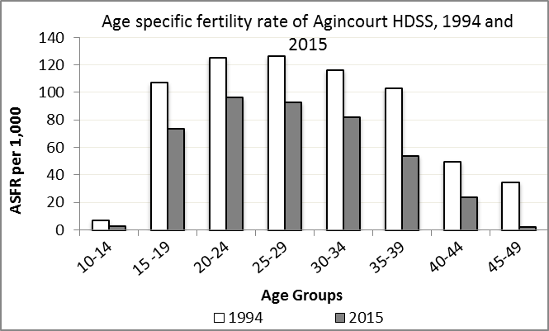

We find the age specific fertility rate by looking at how many women in a certain age group have had babies in a certain year. For example, we can see that in the year 2015 in Justicia village, for every 1 000 women ages 15-19, about 48 of them gave birth.

Take home message: 2015 saw decreases in fertility across all age groups.

Deaths

Deaths

The MRC/Wits Agincourt Unit only gives numbers of deaths for each age group in each village, not the cause of death. The number of deaths occurring is low and if the cause of death is given, then a person’s confidentiality may be broken. Below you can see the total number of deaths that occurred in Justicia village in 1994 and in 2015.

Deaths by Sex in Justicia, 1994 and 2015
 | 1994 | 2015
Male Deaths | 26 | 27
Female Deaths | 15 | 25
Total Deaths | 41 | 52

Below you can compare the crude death rates over the same period in Justicia village and across the Agincourt HDSS research site.

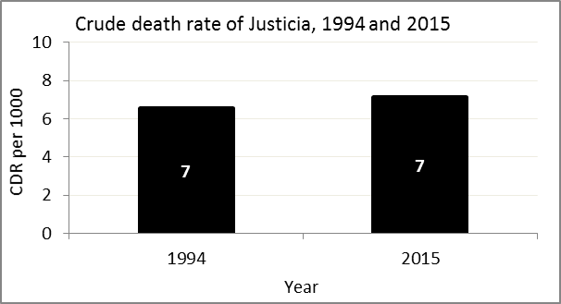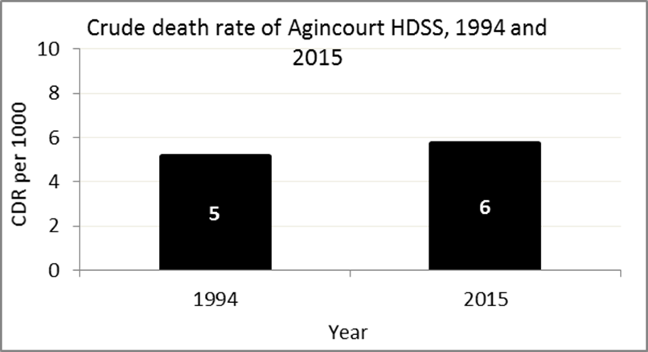
The crude death rate is found by looking at how many people died for every 1 000 people living in the population. For example, in 2015, for every 1 000 people in the population of Justicia village, 7 died.

The data shows that the crude death rate has not changed much from the levels seen in 1994. However, the good news is that the death rate across the whole population of the Agincourt HDSS research site is closer to the death rate before HIV became prominent in South Africa.

MIGRATION

Permanent migration patterns

Below you can see how many people have moved into and out of Justicia village permanently.

Out-Migrants by Sex in Justicia village,1994 and 2015
 | 1994 | 2015
Male Out-Migrants | 274 | 127
Female Out-Migrants | 408 | 184
Total Out-Migrants | 682 | 311

In-Migrants by Sex in Justicia village, 1994 and 2015
 | 1994 | 2015
Male In-Migrants | 203 | 98
Female In-Migrants | 315 | 146
Total | 518 | 244

Take home message: The number of people permanently moving into and out of Justicia village is decreasing.

