IREAGH C VILLAGE FACT SHEET 2017

This “Fact Sheet” provides basic information on population changes and demographics for Ireagh C village. Whenever you use this information, please reference it as being obtained from MRC/Wits Rural Public Health and Health Transitions Research Unit (Agincourt).

Villages in the Agincourt Health and Socio-Demographic Surveillance (HDSS) System Research Site in 2017 include:
Agincourt, Belfast, Croquet Lawn, Croquet Lawn B, Cunningmore A, Cunningmore B, Dumphries A, Dumphries B, Dumphries C, Huntington, Ireagh A, Ireagh B, Ireagh C, Justicia, Khaya Lami, Kildare A, Kildare B, Kumani, Lillydale A, Lillydale B, Makaringe, MP Stream, Newington B, Newington C, Rolle C, Somerset, Somerset C, and Xanthia.

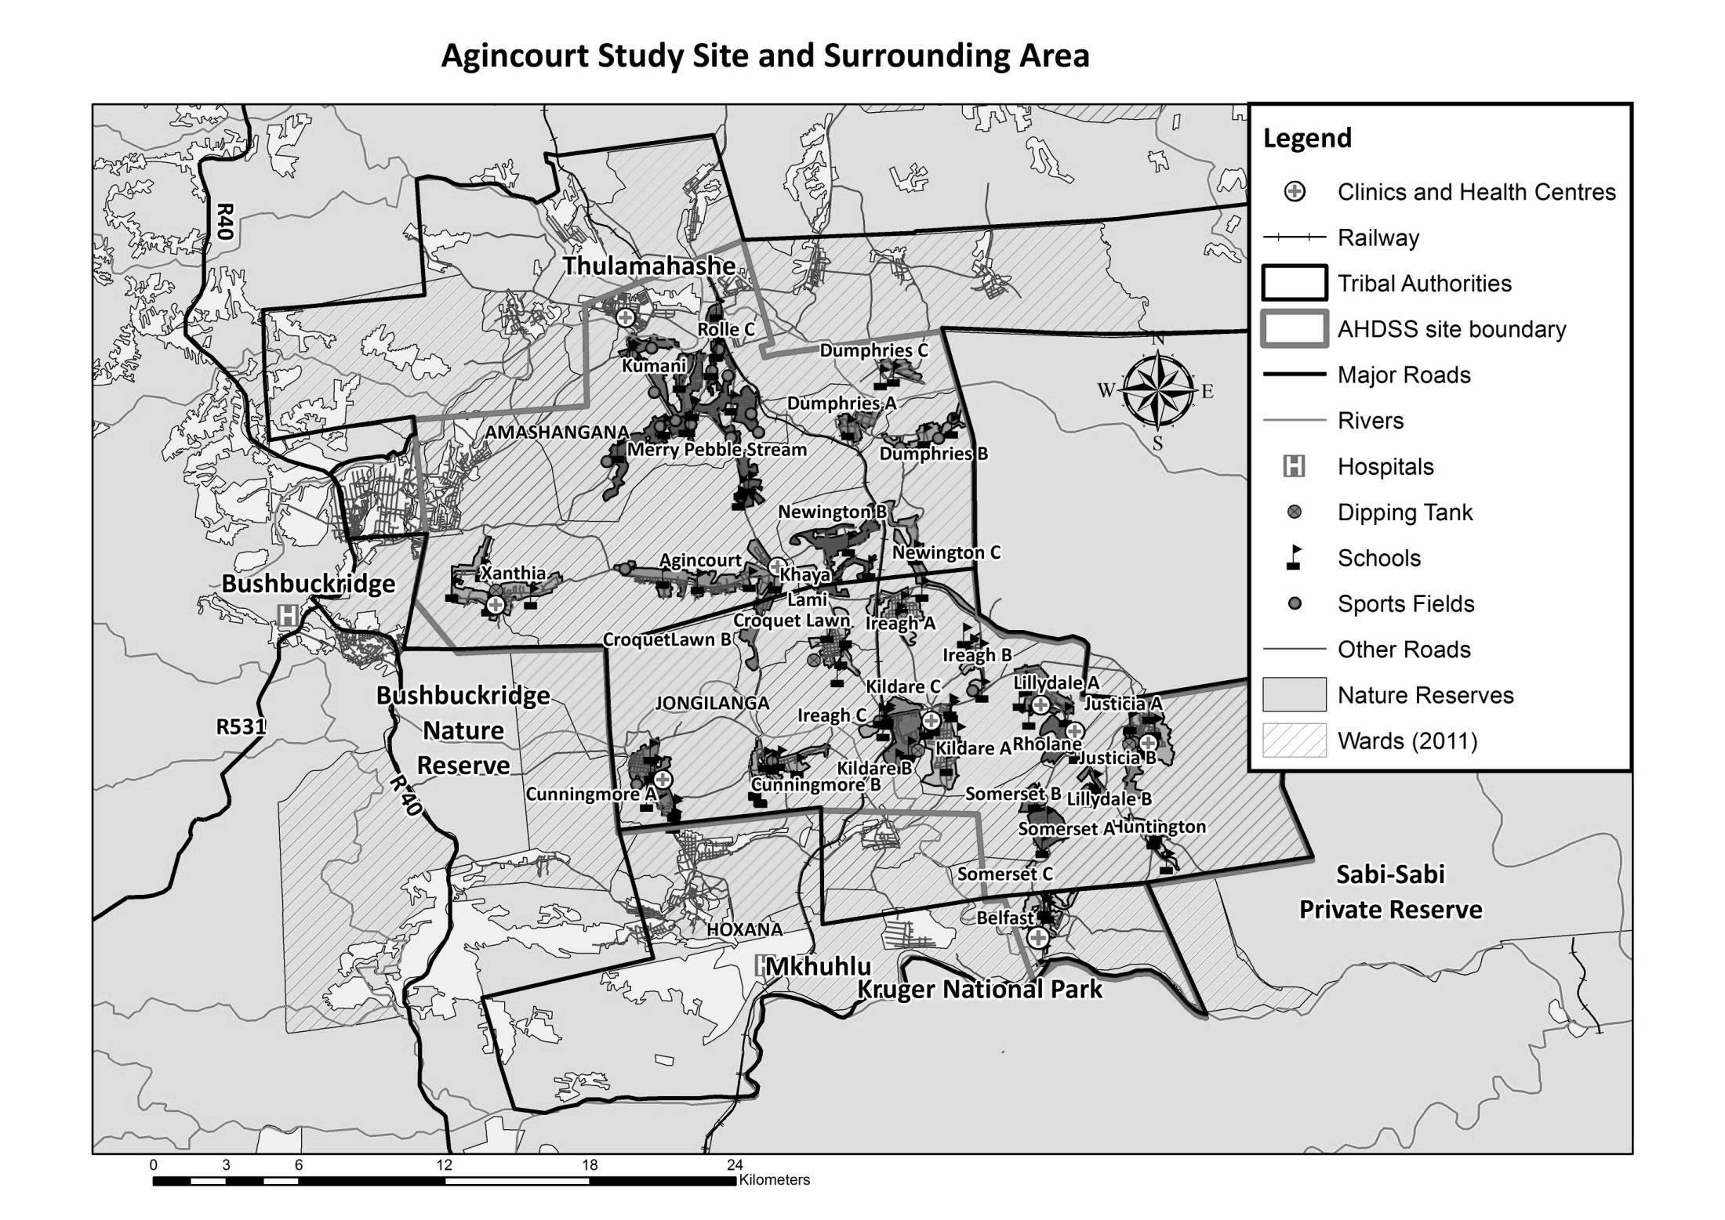
Ireagh C

Village Growth and Population over the Period 2010 – 2016
The numbers below are calculated according to numbers for the end of June 2016. The numbers are known as mid-year population figures.

Mid-year Figures of Ireagh C, 2010 and 2016
 |  |  | 2010 | 2016
Households |  |  | 211 | 258
Population |  |  | 537 | 879
Male |  |  | 235 | 385
Female |  |  | 302 | 494
Children under 5 |  |  | 81 | 139
Children of school-going age (5-19) |  |  | 155 | 280

Below you can see how many people were living in Ireagh C village of different ages in June 2016.

Mid-Year Population of Ireagh C village, 2016
Age Group | 2016
 | Male | Female | Total
0-4 | 64 | 75 | 139
5-9 | 52 | 67 | 119
10-14 | 35 | 42 | 77
15-19 | 42 | 42 | 84
20-24 | 27 | 42 | 69
25-29 | 32 | 34 | 66
30-34 | 41 | 72 | 113
35-39 | 38 | 57 | 95
40-44 | 31 | 26 | 57
45-49 | 13 | 22 | 35
50-54 | 4 | 10 | 14
55-59 | 2 | 1 | 3
60-64 | 1 | 1 | 2
65-69 | 0 | 2 | 2
70-74 | 3 | 0 | 3
75-79 | 0 | 0 | 0
80-84 | 0 | 0 | 0
85-89 | 0 | 1 | 1
90-94 | 0 | 0 | 0
95+ | 0 | 0 | 0
Total | 385 | 494 | 879

You can compare the population structure between Ireagh C village and the Agincourt HDSS research site (2010 and 2016) by looking at the population pyramids below.
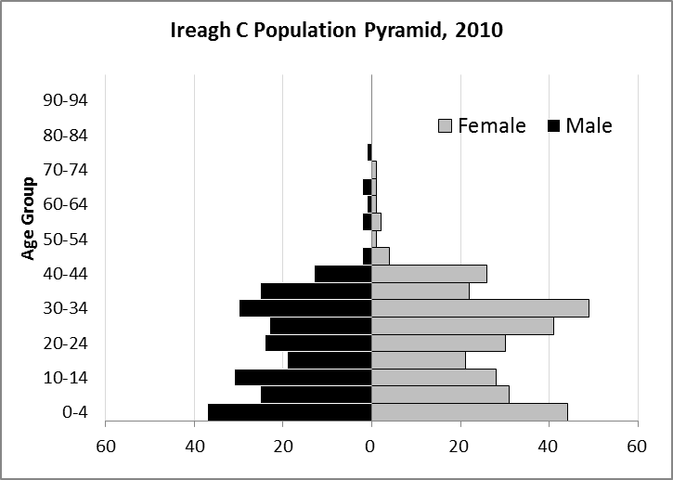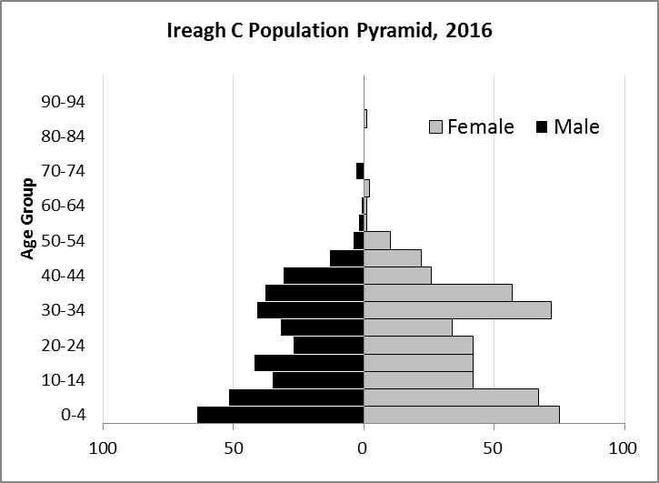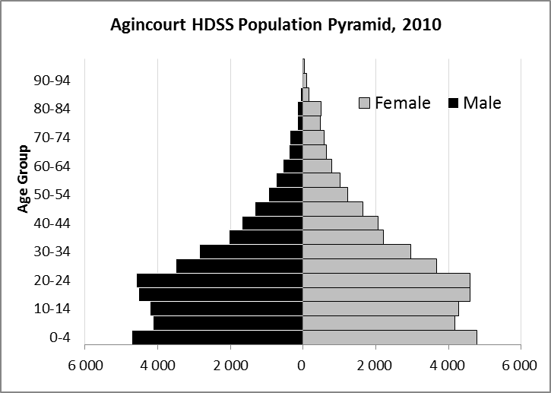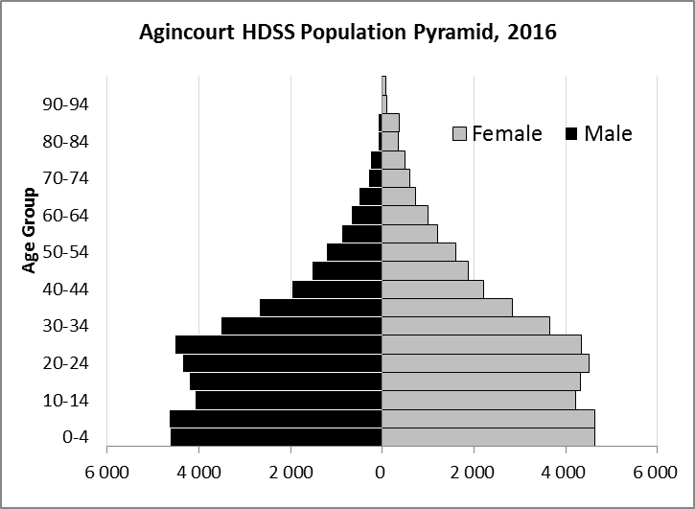

Take home message: The number of households in Ireagh C village has increased since 2010. The population has also grown between the years of 2010 and 2016. The population structure of Ireagh C is quite different from Agincourt HDSS. The female population outnumbers the male population in Ireagh C, and the above-50 population is much smaller than Agincourt HDSS.

Births

Number of Births by Sex
The number of births recorded in Ireagh C village is shown below. We can only provide data to the end of 2015.
Births by Sex in Ireagh C Village, 2010 and 2015
 | 2010 | 2015
Male Births | 9 | 11
Female Births | 11 | 17
Total Births | 20 | 28

The numbers of births show an upward trend in Ireagh C village. In 2015 there was an increase in the number of births.

Crude Birth Rate (how many babies born for every one thousand people)
We compared the birth trends in Ireagh C village with the rest of the Agincourt HDSS research site in the graphs below.

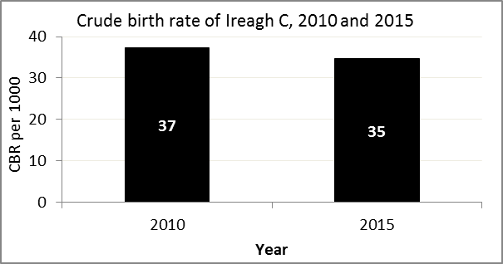
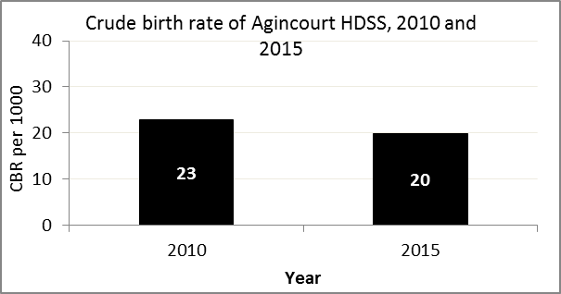

The crude birth rate is found by comparing the number of babies born to the total population. For example, above, for every 1 000 people living in Ireagh C village in the year 2015, 35 babies were born.
When you compare the crude birth rates in Ireagh C village with the crude birth rate for the whole of the Agincourt HDSS research site, they are relatively similar.

Births by Mother’s Age and Age Specific Fertility Rates
Research within the Agincourt HDSS research site continues to look closely at fertility. You can see the number of babies born to mothers of different ages in Ireagh C village.
Births by Age group in Ireagh C, 2010 and 2015
Age Groups | 2010 | 2015
10-14 | 0 | 2
15 -19 | 2 | 1
20-24 | 2 | 7
25-29 | 8 | 2
30-34 | 5 | 5
35-39 | 3 | 11
40-44 | 0 | 0
45-49 | 0 | 0
Total Births | 20 | 28

We can also look at trends across the whole site and compare them with Ireagh C village.

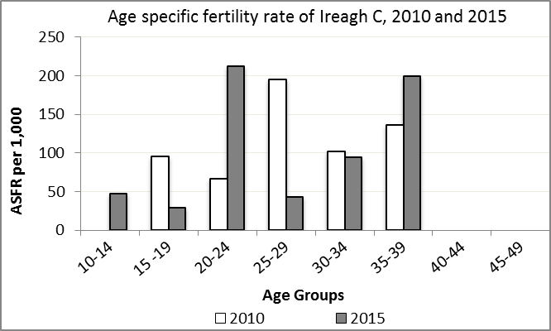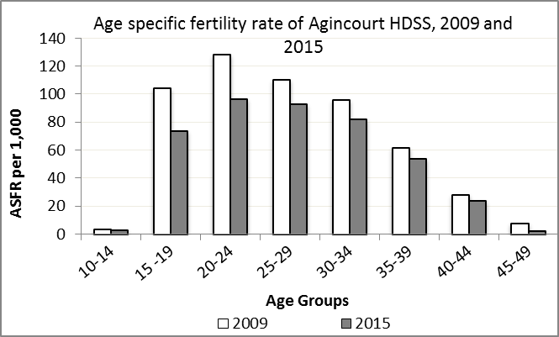

We find the age specific fertility rate by looking at how many women in a certain age group have had babies in a certain year. For example, we can see that in the year 2015 in Ireagh C village, for every 1 000 women ages 15-19, about 29 of them gave birth.

Take home message: 2015 saw a mix of increases and decreases in fertility. Ages 10-14, 20-24 and 35-39 saw increases in fertility, while ages 15-19 and 25-34 saw decreases in fertility.

Deaths

Deaths

The MRC/Wits Agincourt Unit only gives numbers of deaths for each age group in each village, not the cause of death. The number of deaths occurring is low and if the cause of death is given, then a person’s confidentiality may be broken. Below you can see the total number of deaths that occurred in Ireagh C village in 2010 and in 2015.

Deaths by Sex in Ireagh C, 2010 and 2015
 | 2010 | 2015
Male Deaths | 1 | 3
Female Deaths | 1 | 3
Total Deaths | 2 | 6

Below you can compare the crude death rates over the same period in Ireagh C village and across the Agincourt HDSS research site.

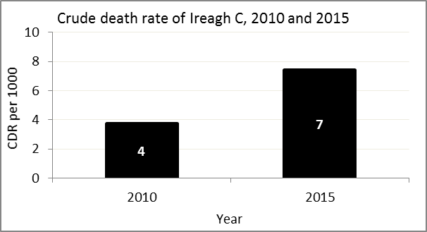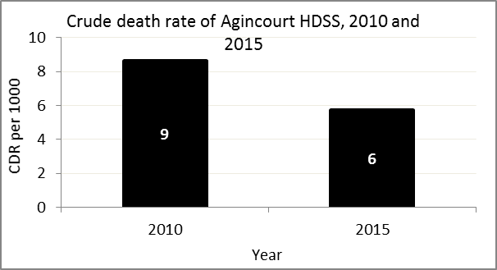
The crude death rate is found by looking at how many people died for every 1 000 people living in the population. For example, in 2015, for every 1 000 people in the population of Ireagh C village, 7 died.

The data shows that the crude death rate has increased from the levels seen in 2010. However, the good news is that the death rate across the whole population of the Agincourt HDSS research site is closer to the death rate before HIV became prominent in South Africa.

MIGRATION

Permanent migration patterns

Below you can see how many people have moved into and out of Ireagh C village permanently.

Out-Migrants by Sex in Ireagh C village, 2010 and 2015
 | 2010 | 2015
Male Out-Migrants | 26 | 34
Female Out-Migrants | 48 | 41
Total Out-Migrants | 74 | 75

In-Migrants by Sex in Ireagh C village, 2010 and 2015
 | 2010 | 2015
Male In-Migrants | 105 | 26
Female In-Migrants | 137 | 26
Total | 242 | 52

Take home message: The number of people permanently moving into Ireagh C village is decreasing, but the number of people moving out of the village is increasing.

