HUNTINGTON VILLAGE FACT SHEET 2017

This “Fact Sheet” provides basic information on population changes and demographics for Huntington village. Whenever you use this information, please reference it as being obtained from MRC/Wits Rural Public Health and Health Transitions Research Unit (Agincourt).

Villages in the Agincourt Health and Socio-Demographic Surveillance (HDSS) System Research Site in 2017 include:
Agincourt, Belfast, Croquet Lawn, Croquet Lawn B, Cunningmore A, Cunningmore B, Dumphries A, Dumphries B, Dumphries C, Huntington, Ireagh A, Ireagh B, Ireagh C, Justicia, Khaya Lami, Kildare A, Kildare B, Kumani, Lillydale A, Lillydale B, Makaringe, MP Stream, Newington B, Newington C, Rolle C, Somerset, Somerset C, and Xanthia.

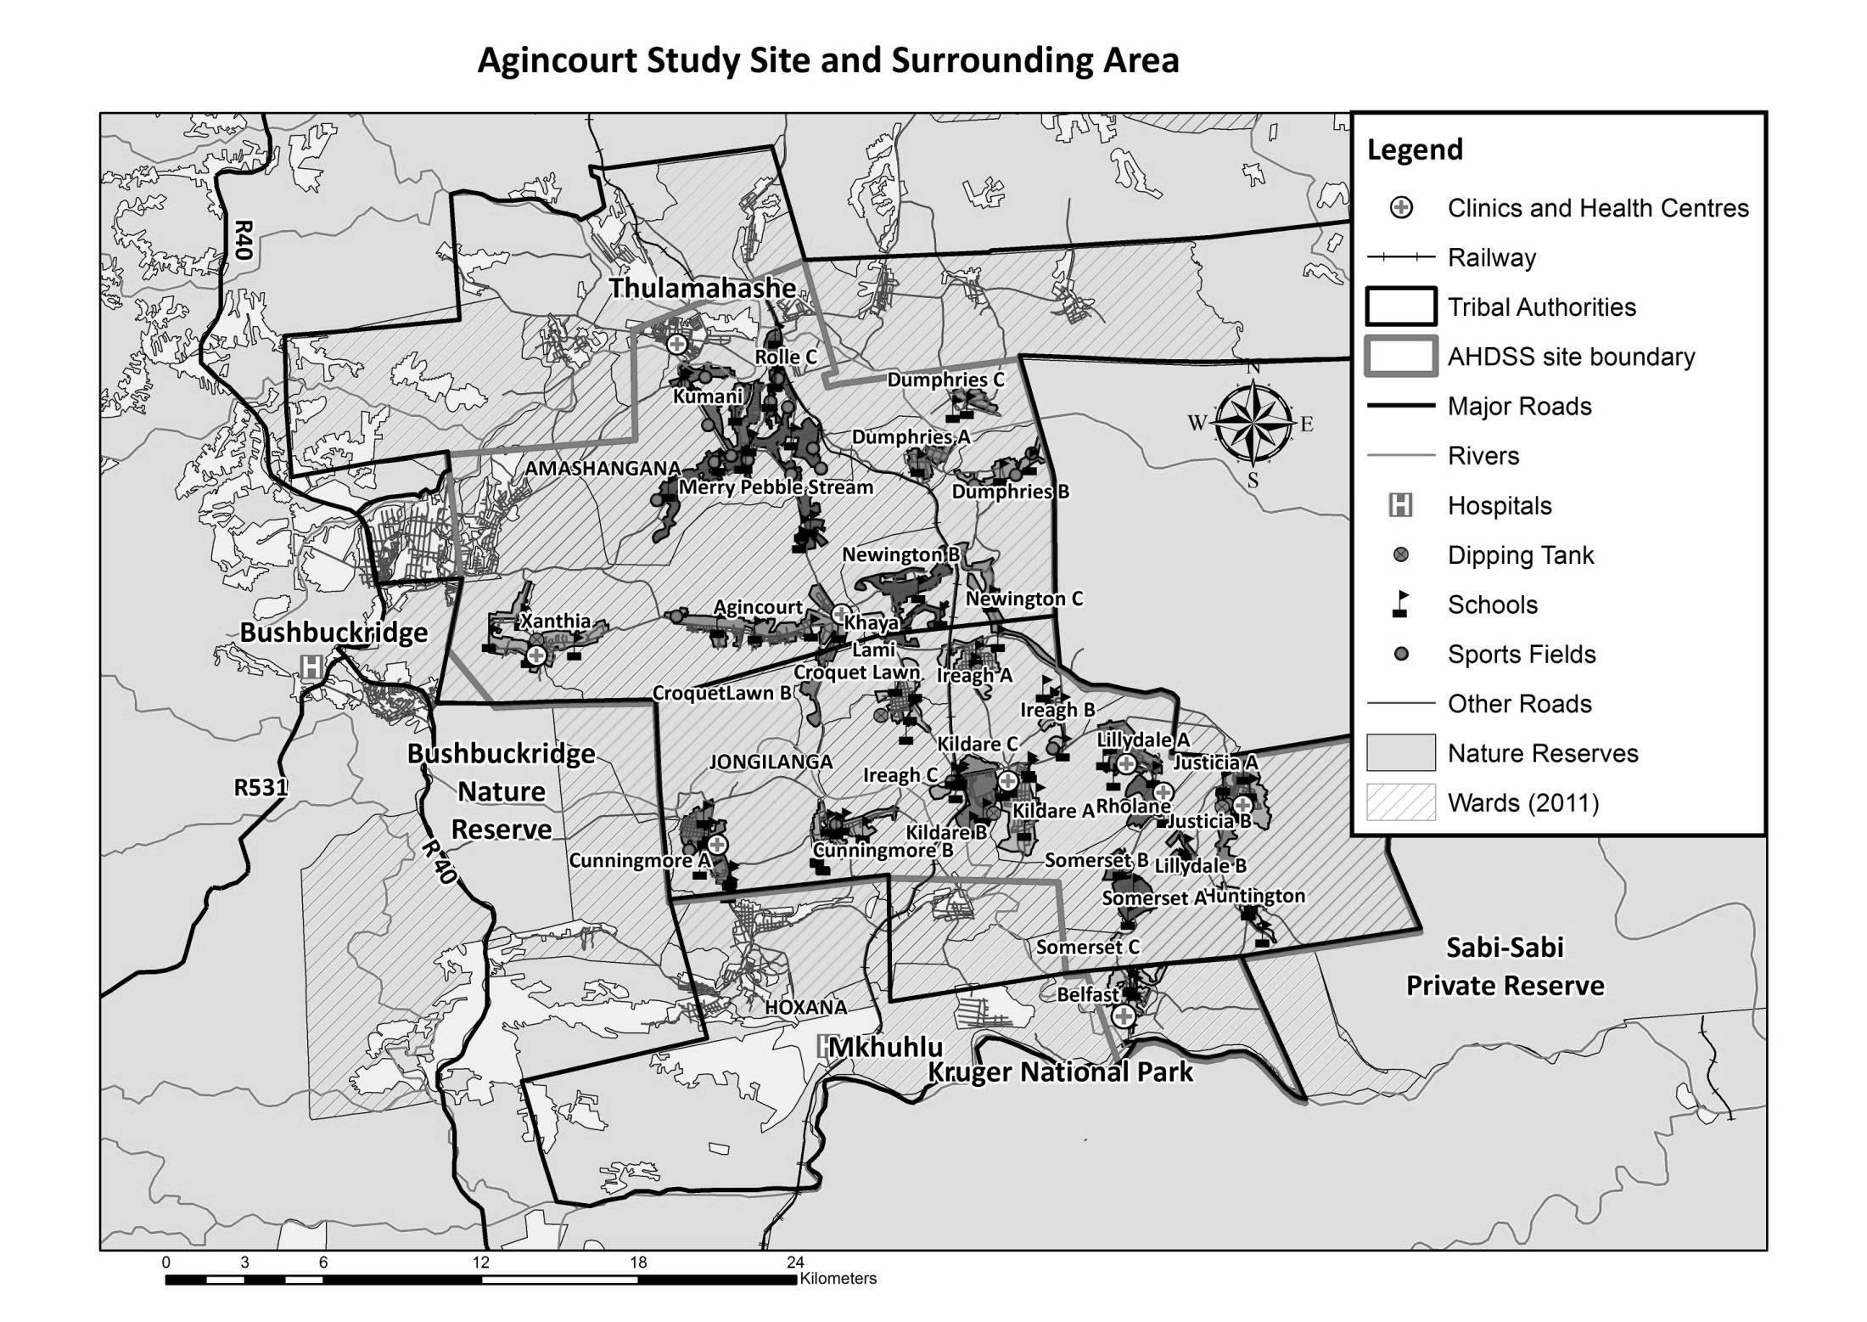
Huntington

Village Growth and Population over the Period 1994 – 2016
The numbers shown below are calculated according to numbers for the end of June 2016. The numbers are known as mid-year population figures.

Mid-year Figures of Huntington, 1994 and 2016
 |  |  | 1994 | 2016
Households |  |  | 400 | 789
Population |  |  | 2 605 | 3 509
Male |  |  | 1 265 | 1 685
Female |  |  | 1 340 | 1 824
Children under 5 |  |  | 460 | 439
Children of school-going age (5-19) |  |  | 1 001 | 1 096

Below you can see how many people were living in Huntington village of different ages in June 2016.

Mid-Year Population of Huntington village, 2016
Age Group | 2016
 | Male | Female | Total
0-4 | 231 | 208 | 439
5-9 | 190 | 203 | 393
10-14 | 163 | 169 | 332
15-19 | 195 | 176 | 371
20-24 | 166 | 179 | 345
25-29 | 182 | 174 | 356
30-34 | 143 | 157 | 300
35-39 | 113 | 132 | 245
40-44 | 80 | 114 | 194
45-49 | 70 | 74 | 144
50-54 | 54 | 58 | 112
55-59 | 25 | 46 | 71
60-64 | 24 | 33 | 57
65-69 | 16 | 26 | 42
70-74 | 14 | 26 | 40
75-79 | 9 | 21 | 30
80-84 | 3 | 12 | 15
85-89 | 5 | 11 | 16
90-94 | 1 | 2 | 3
95+ | 1 | 3 | 4
Total | 1 685 | 1 824 | 3 509

You can compare the population structure between Huntington village and the Agincourt HDSS research site (1994 and 2016) by looking at the population pyramids below.

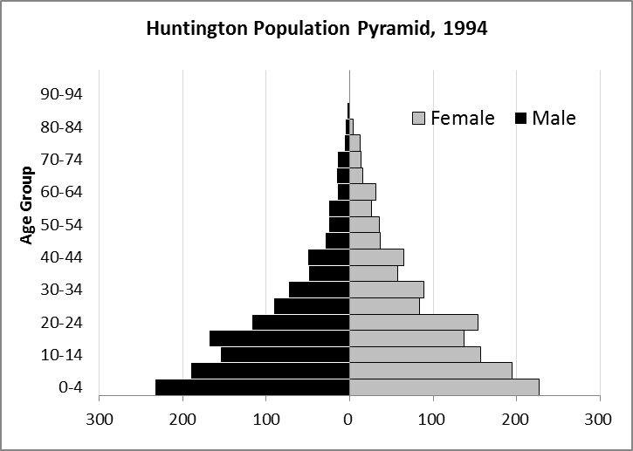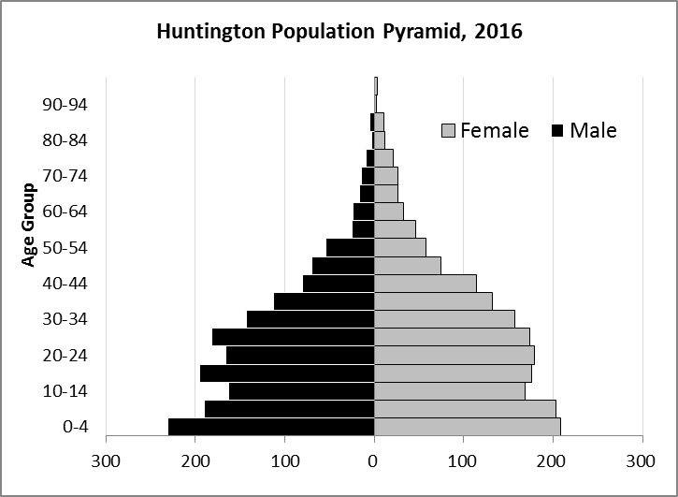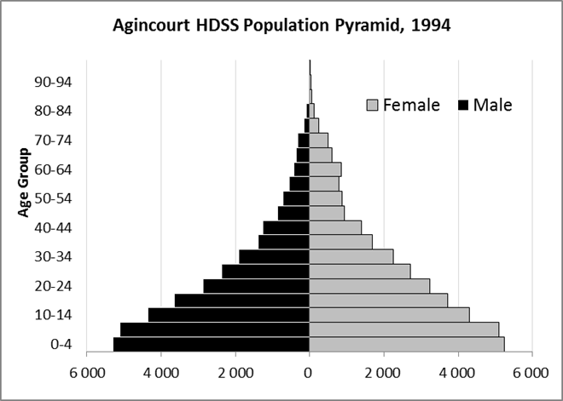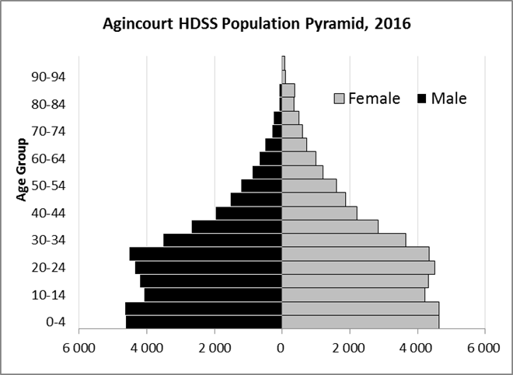

Take home message: The number of households in Huntington village has increased since 1994. The population has also grown between the years of 1994 and 2016. The population structure of Huntington village strongly follows the structure of the Agincourt HDSS research site.

Births

Number of Births by Sex
The number of births recorded in Huntington village is shown below. We can only provide data to the end of 2015.

Births by Sex in Huntington Village, 1994 and 2015
 | 1994 | 2015
Male Births | 29 | 52
Female Births | 28 | 34
Total Births | 57 | 86

The numbers of births show an upward trend in Huntington village. In 2015 there was an increase in the number of births.

Crude Birth Rate (how many babies born for every one thousand people)
We compared the birth trends in Huntington village with the rest of the Agincourt HDSS research site in the graphs below.

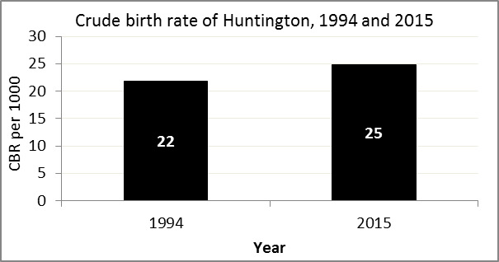
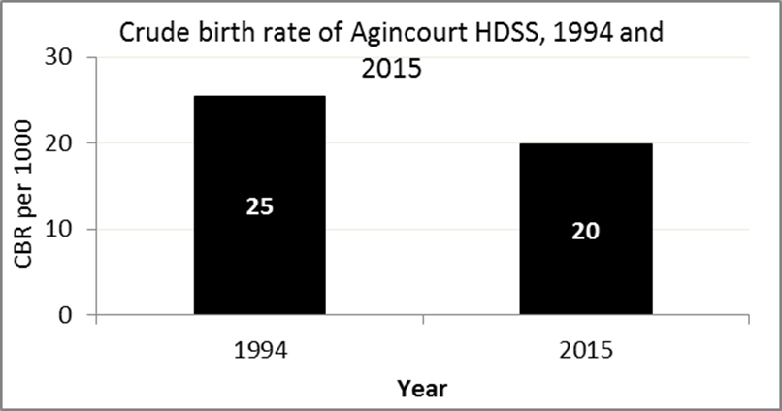

The crude birth rate is found by comparing the number of babies born to the total population. For example, above, for every 1 000 people living in Huntington village in the year 2015, 25 babies were born.
When you compare the crude birth rates in Huntington village with the crude birth rate for the whole of the Agincourt HDSS research site, they are relatively similar. One difference is that Huntington had an increase in births in 2015 and Agincourt HDSS had a decrease.

Births by Mother’s Age and Age Specific Fertility Rates
Research within the Agincourt HDSS research site continues to look closely at fertility. You can see the number of babies born to mothers of different ages in Huntington village below.

Births by Age group in Huntington, 1994 and 2015
Age Groups | 1994 | 2015
10-14 | 0 | 1
15 -19 | 10 | 20
20-24 | 23 | 20
25-29 | 7 | 17
30-34 | 6 | 15
35-39 | 6 | 7
40-44 | 2 | 6
45-49 | 3 | 0
Total Births | 57 | 86

We can also look at trends across the whole site and compare them with Huntington village.

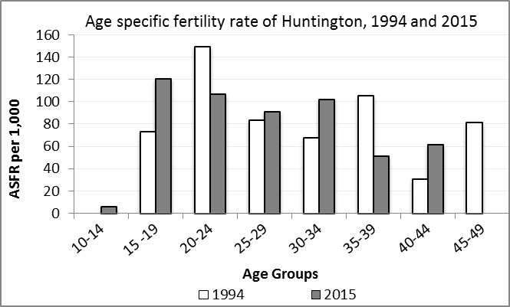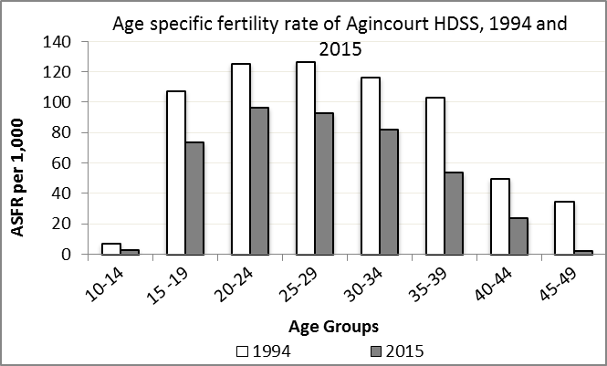

We find the age specific fertility rate by looking at how many women in a certain age group have had babies in a certain year. For example, we can see that in the year 2015 in Huntington village, for every 1 000 women ages 15-19, about 120 of them gave birth.

Take home message: 2015 saw a mix of increases and decreases in fertility across age groups. Ages 10-19, 25-34, and 40-44 saw increases in fertility, and ages 20-24, 35-39 and 45-49 saw decreases in fertility.

Deaths

Deaths

The MRC/Wits Agincourt Unit only gives numbers of deaths for each age group in each village, not the cause of death. The number of deaths occurring is low and if the cause of death is given, then a person’s confidentiality may be broken. Below you can see the total number of deaths that occurred in Huntington village in 1994 and in 2015.

Deaths by Sex in Huntington, 1994 and 2015
 | 1994 | 2015
Male Deaths | 0 | 9
Female Deaths | 4 | 11
Total Deaths | 4 | 20

Below you can compare the crude death rates over the same period in Huntington village and across the Agincourt HDSS research site.

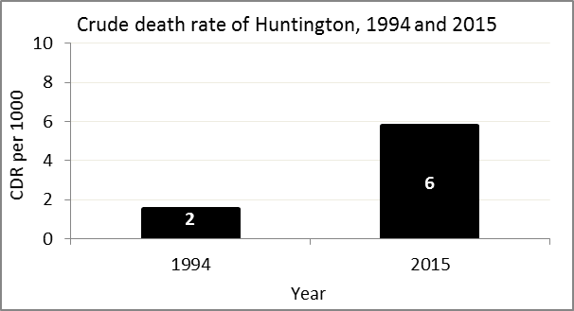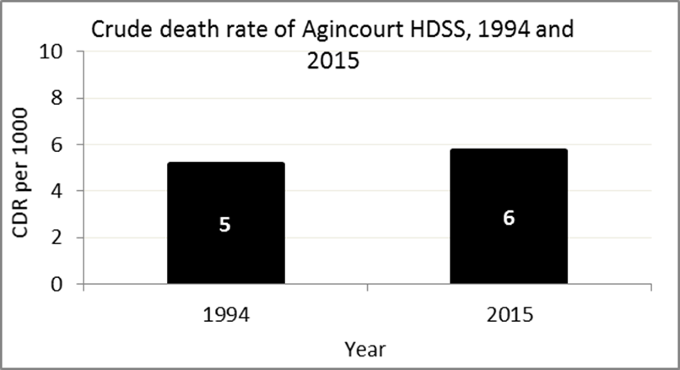
The crude death rate is found by looking at how many people died for every 1 000 people living in the population. For example, in 2015, for every 1 000 people in the population of Huntington village, 6 died.

The data shows that the crude death rate has increased from the levels seen in 1994. However, the good news is that the death rate across the whole population of the Agincourt HDSS research site is closer to the death rate before HIV became prominent in South Africa.

MIGRATION

Permanent migration patterns

Below you can see how many people have moved into and out of Huntington village permanently.

Out-Migrants by Sex in Huntington village,1994 and 2015
 | 1994 | 2015
Male Out-Migrants | 114 | 90
Female Out-Migrants | 135 | 123
Total Out-Migrants | 249 | 213

In-Migrants by Sex in Huntington village, 1994 and 2015
 | 1994 | 2015
Male In-Migrants | 53 | 74
Female In-Migrants | 78 | 97
Total | 131 | 171

Take home message: The number of people permanently moving into Huntington village is increasing, but the number of people moving out is decreasing.

