DUMPHRIES B VILLAGE FACT SHEET 2017

This “Fact Sheet” provides basic information on population changes and demographics for Dumphries B village. Whenever you use this information, please reference it as being obtained from MRC/Wits Rural Public Health and Health Transitions Research Unit (Agincourt).

Villages in the Agincourt Health and Socio-Demographic Surveillance (HDSS) System Research Site in 2017 include:
Agincourt, Belfast, Croquet Lawn, Croquet Lawn B, Cunningmore A, Cunningmore B, Dumphries A, Dumphries B, Dumphries C, Huntington, Ireagh A, Ireagh B, Ireagh C, Justicia, Khaya Lami, Kildare A, Kildare B, Kumani, Lillydale A, Lillydale B, Makaringe, MP Stream, Newington B, Newington C, Rolle C, Somerset, Somerset C, and Xanthia.

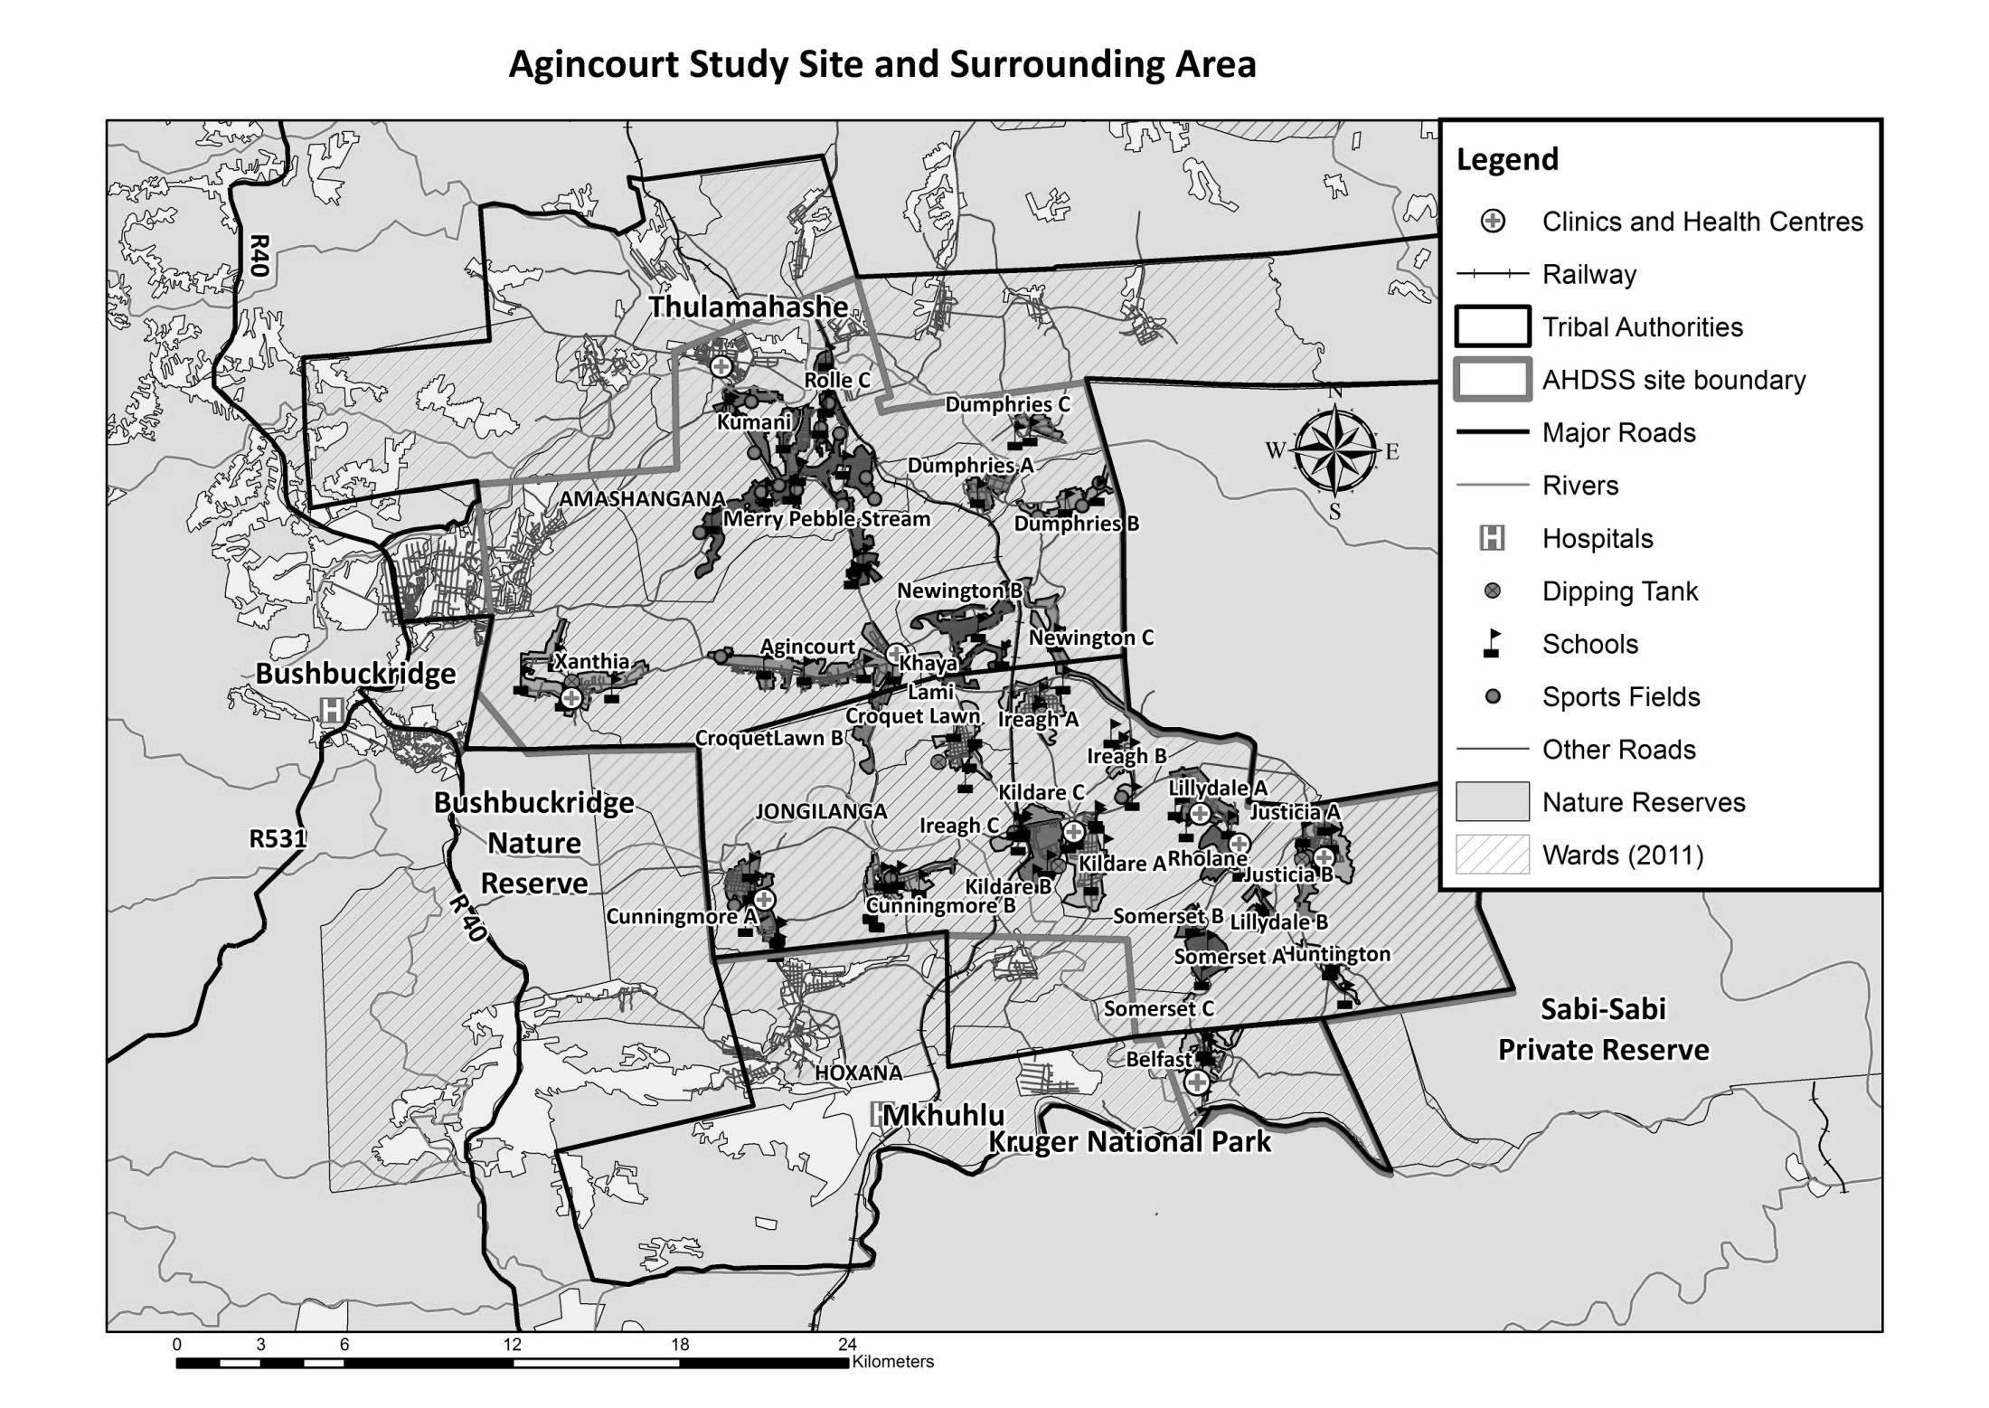
Dumphries B

Village Growth and Population over the Period 2008 – 2016
The numbers shown below are calculated according to numbers for the end of June 2016. The numbers are known as mid-year population figures.

Mid-year Figures of Dumphries B, 2008 and 2016
 |  |  | 2008 | 2016
Households |  |  | 366 | 459
Population |  |  | 2 265 | 2 516
Male |  |  | 1 083 | 1 220
Female |  |  | 1 182 | 1 296
Children under 5 |  |  | 315 | 257
Children of school-going age (5-19) |  |  | 864 | 887

Below you can see how many people were living in Dumphries B village of different ages in June 2016.

Mid-Year Population of Dumphries B village, 2016
Age Group | 2016
 | Male | Female | Total
0-4 | 125 | 132 | 257
5-9 | 156 | 168 | 324
10-14 | 156 | 145 | 301
15-19 | 124 | 138 | 262
20-24 | 132 | 125 | 257
25-29 | 126 | 126 | 252
30-34 | 112 | 94 | 206
35-39 | 82 | 78 | 160
40-44 | 55 | 82 | 137
45-49 | 52 | 45 | 97
50-54 | 28 | 40 | 68
55-59 | 17 | 25 | 42
60-64 | 19 | 16 | 35
65-69 | 10 | 20 | 30
70-74 | 5 | 20 | 25
75-79 | 6 | 16 | 22
80-84 | 8 | 7 | 15
85-89 | 6 | 13 | 19
90-94 | 0 | 4 | 4
95+ | 1 | 2 | 3
Total | 1 220 | 1 296 | 2 516

You can compare the population structure between Dumphries B village and the Agincourt HDSS research site (2008 and 2016) by looking at the population pyramids below.

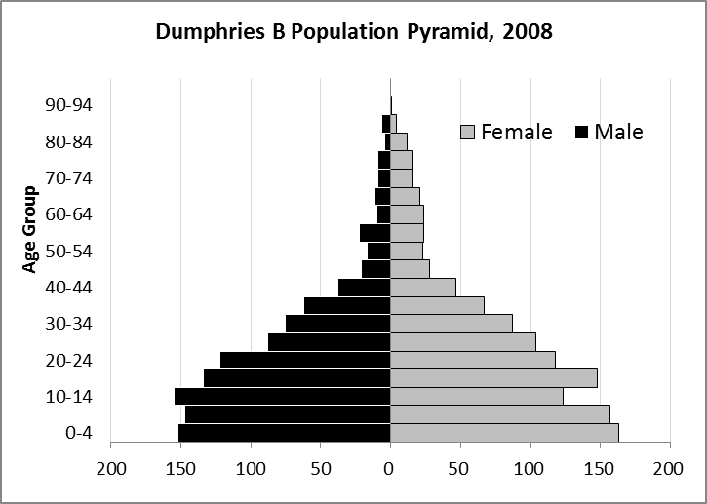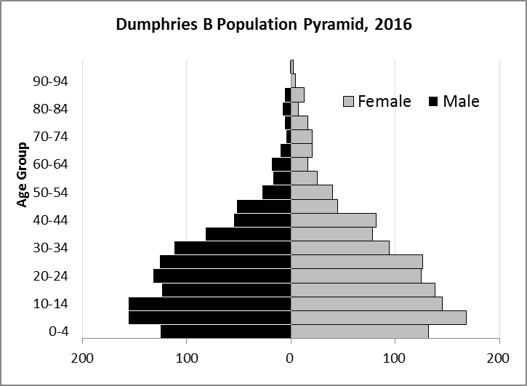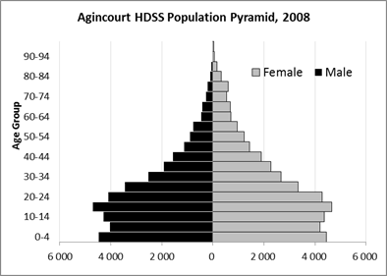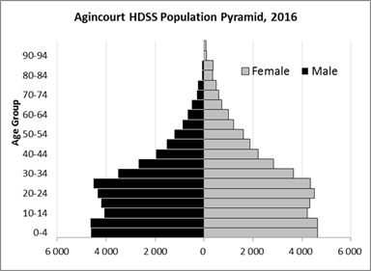

Take home message: The number of households in Dumphries B village has increased since 2008. The population has also grown between the years of 2008 and 2016. The population structure of Dumphries B village strongly follows the structure of the Agincourt HDSS research site.

Births

Number of Births by Sex
The number of births recorded in Dumphries B village are shown below. We can only provide data to the end of 2015.

Births by Sex in Dumphries B Village, 2008 and 2015
 | 2008 | 2015
Male Births | 43 | 21
Female Births | 35 | 22
Total Births | 78 | 43

The numbers of births show a downward trend in Dumphries B village. In 2015 there was a decrease in the number of births.

Crude Birth Rate (how many babies born for every one thousand people)
We compared the birth trends in Dumphries B village with the rest of the Agincourt HDSS research site in the graphs below.

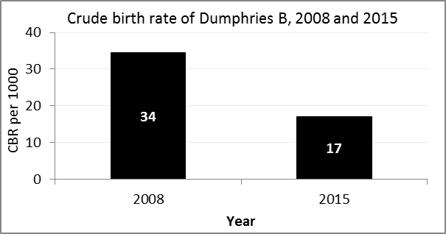
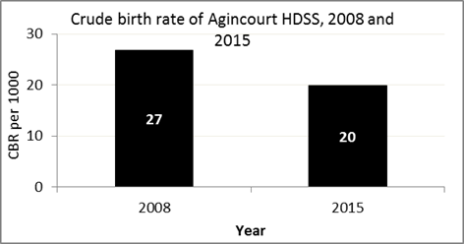

The crude birth rate is found by comparing the number of babies born to the total population. For example, above, for every 1000 people living in Dumphries B village in the year 2015, 17 babies were born.
When you compare the crude birth rates in Dumphries B village with the crude birth rate for the whole of the Agincourt HDSS research site, they are relatively similar. One difference is that Dumphries B had a greater decrease in births in 2015 than Agincourt HDSS.

Births by Mother’s Age and Age Specific Fertility Rates
Research within the Agincourt HDSS research site continues to look closely at fertility. Below you can see the number of babies born to mothers of different ages in Dumphries B village.

Births by Age group in Dumphries B, 2008 and 2015
Age Groups | 2008 | 2015
10-14 | 2 | 0
15 -19 | 22 | 9
20-24 | 16 | 14
25-29 | 15 | 8
30-34 | 15 | 10
35-39 | 6 | 1
40-44 | 1 | 1
45-49 | 1 | 0
Total Births | 78 | 43

We can also look at trends across the whole site and compare them with Dumphries B village.

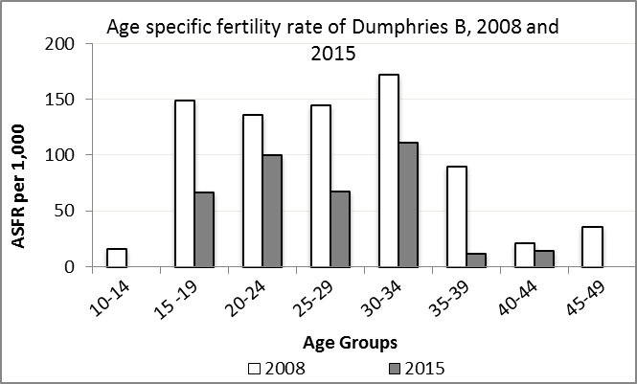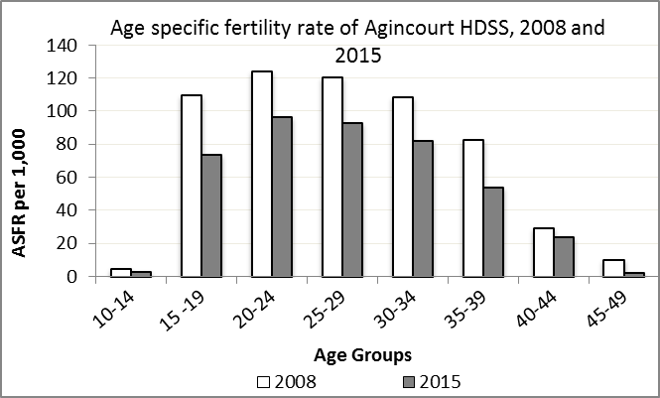

We find the age specific fertility rate by looking at how many women in a certain age group have had babies in a certain year. For example, we can see that in the year 2015 in Dumphries B village, for every 1 000 women ages 15-19, about 66 of them gave birth.

Take home message: 2015 saw decreases in fertility across all age groups, and fertility rates were lower than on average than Agincourt HDSS.

Deaths

Deaths

The MRC/Wits Agincourt Unit only gives numbers of deaths for each age group in each village, not the cause of death. The number of deaths occurring is low and if the cause of death is given, then a person’s confidentiality may be broken. Below you can see the total number of deaths that occurred in Dumphries B village in 2008 and in 2015.

Deaths by Sex in Dumphries B, 2008 and 2015
 | 2008 | 2015
Male Deaths | 14 | 4
Female Deaths | 12 | 7
Total Deaths | 26 | 11

Below you can compare the crude death rates over the same period in Dumphries B village and across the Agincourt HDSS research site.

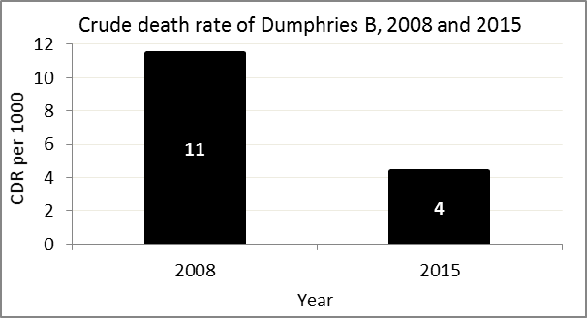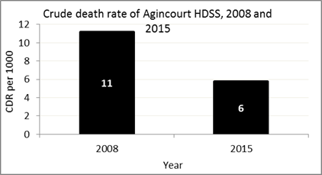
The crude death rate is found by looking at how many people died for every 1 000 people living in the population. For example, in 2015, for every 1 000 people in the population of Dumphries B village, 4 died.

The data shows that the crude death rate has decreased from the levels seen in 2008. In addition, the death rate across the whole population of the Agincourt HDSS research site is closer to the death rate before HIV became prominent in South Africa.

MIGRATION

Permanent migration patterns

Below you can see how many people have moved into Dumphries B village permanently and out of Dumphries B village permanently.

Out-Migrants by Sex in Dumphries B village, 2008 and 2015
 | 2008 | 2015
Male Out-Migrants | 64 | 43
Female Out-Migrants | 114 | 74
Total Out-Migrants | 178 | 117

In-Migrants by Sex in Dumphries B village, 2008 and 2015
 | 2008 | 2015
Male In-Migrants | 62 | 23
Female In-Migrants | 101 | 62
Total | 163 | 85

Take home message: The number of people permanently moving into and out of Dumphries B village is decreasing.

