CUNNINGMORE A VILLAGE FACT SHEET 2017

This “Fact Sheet” provides basic information on population changes and demographics for Cunningmore A village. Whenever you use this information, please reference it as being obtained from MRC/Wits Rural Public Health and Health Transitions Research Unit (Agincourt).

Villages in the Agincourt Health and Socio-Demographic Surveillance (HDSS) System Research Site in 2017 include:
Agincourt, Belfast, Croquet Lawn, Croquet Lawn B, Cunningmore A, Cunningmore B, Dumphries A, Dumphries B, Dumphries C, Huntington, Ireagh A, Ireagh B, Ireagh C, Justicia, Khaya Lami, Kildare A, Kildare B, Kumani, Lillydale A, Lillydale B, Makaringe, MP Stream, Newington B, Newington C, Rolle C, Somerset, Somerset C, and Xanthia.

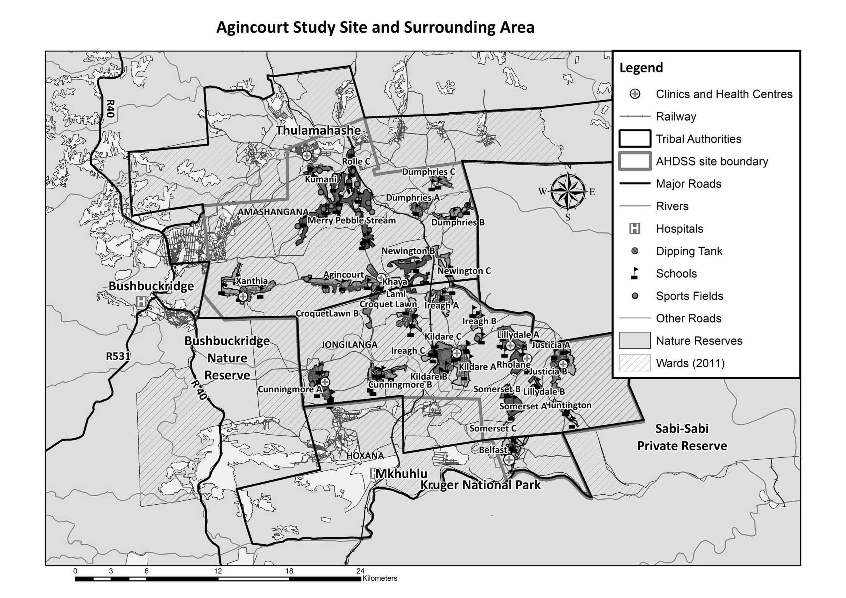
Cunningmore A

Village Growth and Population over the Period 1994 – 2016
The numbers shown below are calculated according to numbers for the end of June 2016. The numbers are known as mid-year population figures.

Mid-year Figures of Cunningmore A village, 1994 and 2016
 |  |  | 1994 | 2016
Households |  |  | 758 | 1 245
Population |  |  | 5 285 | 6 453
Male |  |  | 2 529 | 3 114
Female |  |  | 2 756 | 3 339
Children under 5 |  |  | 733 | 693
Children of school-going age (5-19) |  |  | 2 185 | 1 993

Below you can see how many people were living in Cunningmore A village of different ages in June 2016.

Mid-Year Population of Cunningmore A village, 2016
Age Group | 2016
 | Male | Female | Total
0-4 | 309 | 384 | 693
5-9 | 369 | 325 | 694
10-14 | 321 | 300 | 621
15-19 | 323 | 355 | 678
20-24 | 324 | 311 | 635
25-29 | 353 | 312 | 665
30-34 | 287 | 286 | 573
35-39 | 210 | 244 | 454
40-44 | 168 | 167 | 335
45-49 | 119 | 148 | 267
50-54 | 99 | 123 | 222
55-59 | 73 | 89 | 162
60-64 | 65 | 79 | 144
65-69 | 38 | 56 | 94
70-74 | 25 | 50 | 75
75-79 | 19 | 51 | 70
80-84 | 3 | 15 | 18
85-89 | 5 | 31 | 36
90-94 | 0 | 6 | 6
95+ | 4 | 7 | 11
Total | 3 114 | 3 339 | 6 453

You can compare the population structure between Cunningmore A village and the Agincourt HDSS research site (1994 and 2016) by looking at the population pyramids below.

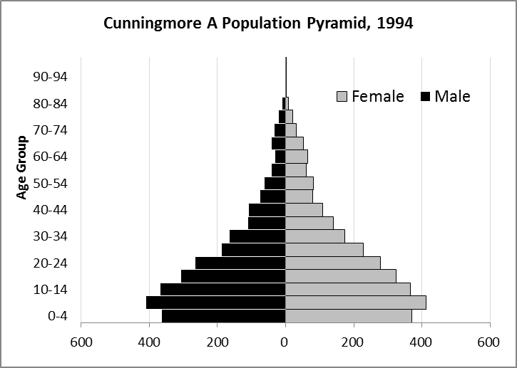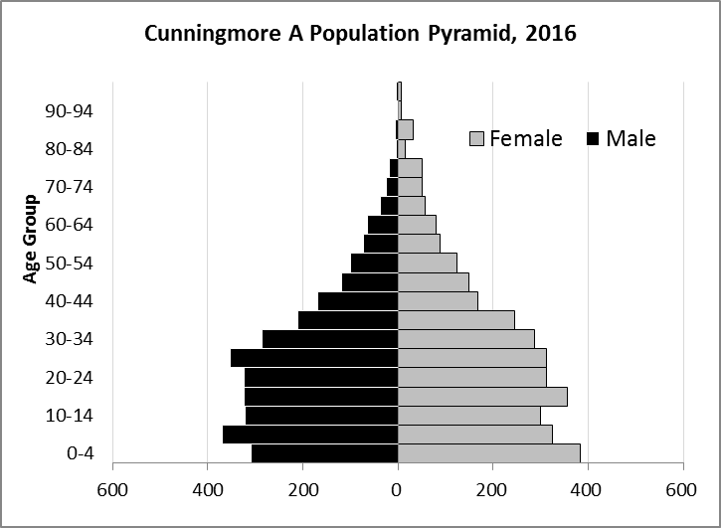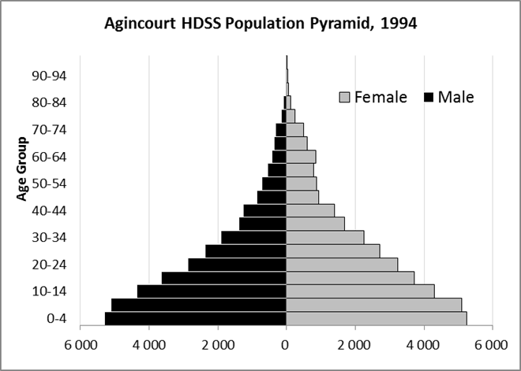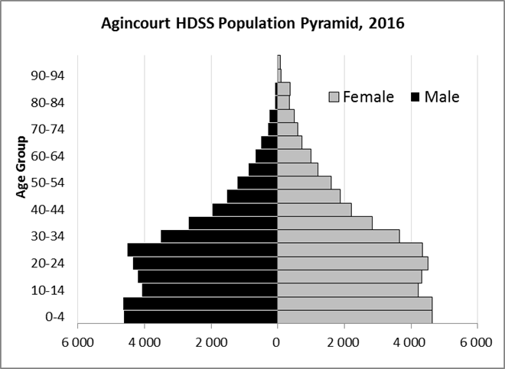

Take home message: The number of households in Cunningmore A village has increased since 1994. The population has also grown between the years of 1994 and 2016. The population structure of Cunningmore A village strongly follows the structure of the Agincourt HDSS research site.

Births

Number of Births by Sex
The number of births recorded in Cunningmore A village are shown below. We can only provide data to the end of 2015. We compared the birth trends in Cunningmore A village with the rest of the Agincourt HDSS research site in the following graphs.
Births by Sex in Cunningmore A village, 1994 and 2015
 | 1994 | 2015
Male Births | 64 | 57
Female Births | 49 | 70
Total Births | 113 | 127

The numbers of births show an upward trend in Cunningmore A village. In 2015 there was an increase in the number of births.

Crude Birth Rate (how many babies born for every one thousand people)
We compared the birth trends in Cunningmore A village with the rest of the Agincourt HDSS research site in the graphs below.

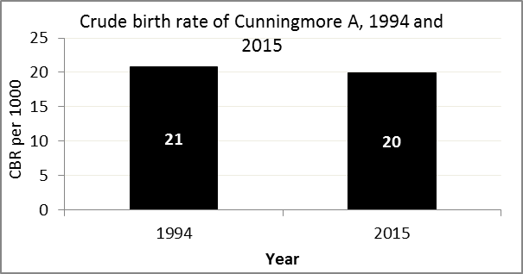
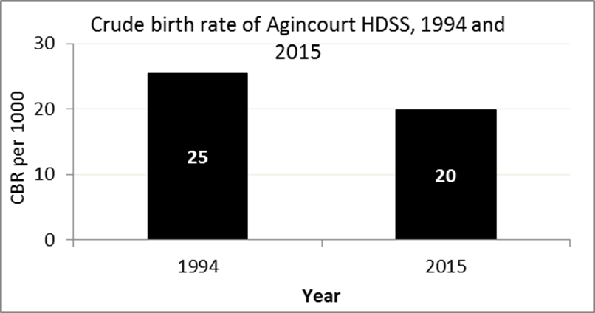

The crude birth rate is found by comparing the number of babies born to the total population. For example, above, for every 1 000 people living in Cunningmore A village in the year 2015, 20 babies were born.
When you compare the crude birth rates in Cunningmore A village with the crude birth rate for the whole of the Agincourt HDSS research site, they are relatively similar. One difference is that Cunningmore A had a smaller decrease in births in 2015 compared to Agincourt HDSS.
Births by Mother’s Age and Age Specific Fertility Rates
Research within the Agincourt HDSS research site continues to look closely at fertility. Below you can see the number of babies born to mothers of different ages in Cunningmore A village.

Births by Age group in Cunningmore A ,1994, 2015
Age Groups | 1994 | 2015
10-14 | 1 | 0
15 -19 | 23 | 19
20-24 | 21 | 27
25-29 | 25 | 35
30-34 | 28 | 29
35-39 | 9 | 15
40-44 | 5 | 2
45-49 | 1 | 0
Total Births | 113 | 127

We can also look at trends across the whole site and compare them with Cunningmore A village.

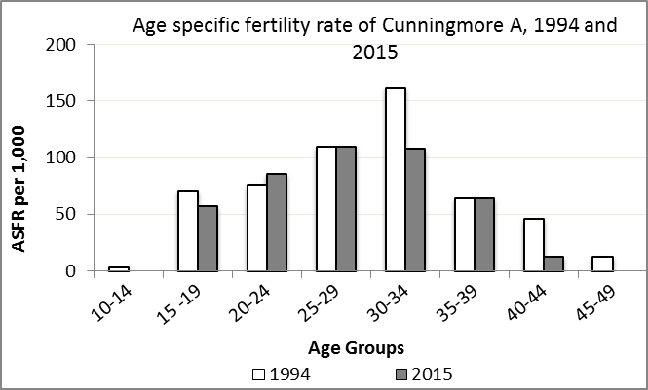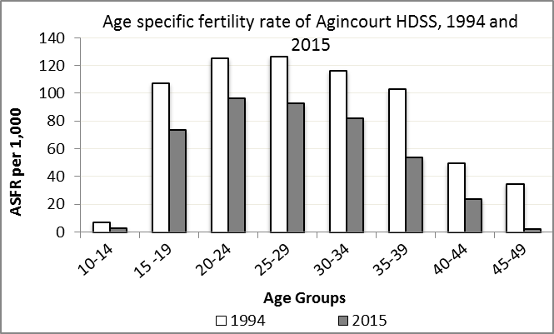

We find the age specific fertility rate by looking at how many women in a certain age group have had babies in a certain year. For example, we can see that in the year 2015 in Cunningmore A village, for every 1 000 women ages 15-19, about 57 of them gave birth.

Take home message: 2015 saw decreases in fertility throughout all age groups except for ages 15-19 and 35-39.

Deaths

Deaths

The MRC/Wits Agincourt Unit only gives numbers of deaths for each age group in each village, not the cause of death. The number of deaths occurring is low and if the cause of death is given, then a person’s confidentiality may be broken. Below you can see the total number of deaths that occurred in Cunningmore A village in 1994 and in 2015.

Deaths by Sex in Cunningmore A, 1994, 2015
 | 1994 | 2015
Male Deaths | 14 | 26
Female Deaths | 9 | 30
Total Deaths | 23 | 56

Below you can compare the crude death rates over the same period in Cunningmore A village and across the Agincourt HDSS research site.

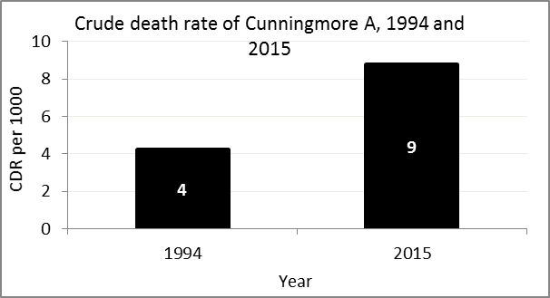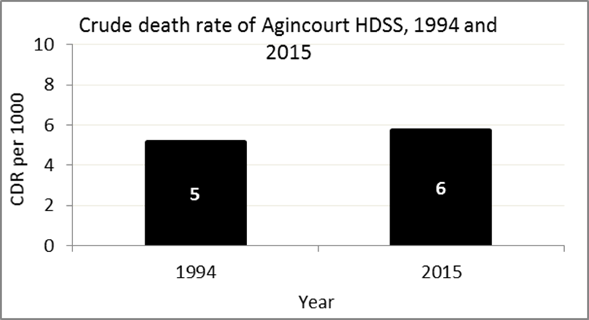
The crude death rate is found by looking at how many people died for every 1 000 people living in the population. For example, in 2015, for every 1 000 people in the population of Cunningmore A village, 9 died.

The data shows that the crude death rate has increased from the levels seen in 1994. However, the good news is that the death rate across the whole population of the Agincourt HDSS research site is closer to the death rate before HIV became prominent in South Africa.

MIGRATION

Permanent migration patterns

Below you can see how many people have moved into Cunningmore A village permanently and out of Cunningmore A village permanently.

Out-Migrants by Sex in Cunningmore A village, 2016
 | 1994 | 2015
Male Out-Migrants | 175 | 95
Female Out-Migrants | 228 | 135
Total Out-Migrants | 403 | 230

In-Migrants by Sex in Cunningmore A village, 2016
 | 1994 | 2015
Male In-Migrants | 89 | 92
Female In-Migrants | 132 | 145
Total | 221 | 237

Take home message: The number of people permanently moving into to Cunningmore A village is increasing, but the number of people permanently moving out of the village is decreasing.

