CROQUET LAWN B VILLAGE FACT SHEET 2017

This “Fact Sheet” provides basic information on population changes and demographics for Croquet Lawn B village. Whenever you use this information, please reference it as being obtained from MRC/Wits Rural Public Health and Health Transitions Research Unit (Agincourt).

Villages in the Agincourt Health and Socio-Demographic Surveillance (HDSS) System Research Site in 2017 include:
Agincourt, Belfast, Croquet Lawn, Croquet Lawn B, Cunningmore A, Cunningmore B, Dumphries A, Dumphries B, Dumphries C, Huntington, Ireagh A, Ireagh B, Ireagh C, Justicia, Khaya Lami, Kildare A, Kildare B, Kumani, Lillydale A, Lillydale B, Makaringe, MP Stream, Newington B, Newington C, Rolle C, Somerset, Somerset C, and Xanthia.

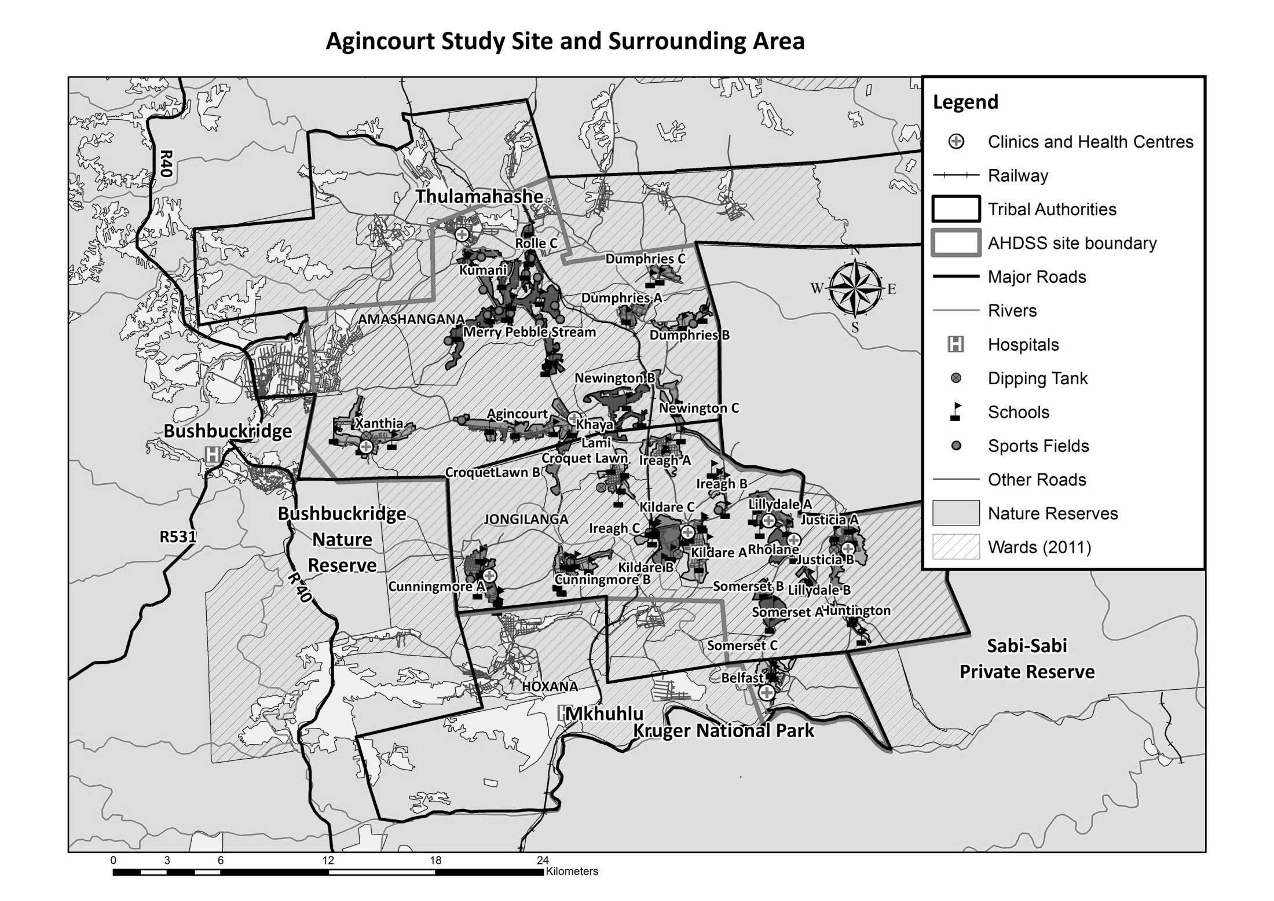
Croquet Lawn B

Village Growth and Population over the Period 1994 – 2016
The numbers shown below are calculated according to numbers for the end of June 2016. The numbers are known as mid-year population figures.

Mid-year Figures of Croquet Lawn B, 1994 and 2016
 |  |  | 1994 | 2016
Households |  |  | 80 | 132
Population |  |  | 489 | 799
Male |  |  | 218 | 371
Female |  |  | 271 | 428
Children under 5 |  |  | 89 | 94
Children of school-going age (5-19) |  |  | 196 | 267

Below you can see how many people were living in Croquet Lawn B village of different ages in June 2016.

Mid-Year Population of Croquet Lawn B village, 2016
Age Group | 2016
 | Male | Female | Total
0-4 | 43 | 51 | 94
5-9 | 38 | 48 | 86
10-14 | 47 | 52 | 99
15-19 | 44 | 38 | 82
20-24 | 51 | 49 | 100
25-29 | 41 | 39 | 80
30-34 | 27 | 20 | 47
35-39 | 20 | 25 | 45
40-44 | 18 | 21 | 39
45-49 | 12 | 22 | 34
50-54 | 1 | 14 | 15
55-59 | 5 | 9 | 14
60-64 | 7 | 6 | 13
65-69 | 7 | 8 | 15
70-74 | 3 | 10 | 13
75-79 | 2 | 3 | 5
80-84 | 3 | 4 | 7
85-89 | 2 | 6 | 8
90-94 | 0 | 2 | 2
95+ | 0 | 1 | 1
Total | 371 | 428 | 799

You can compare the population structure between Croquet Lawn B village and the Agincourt HDSS research site (1994 and 2016) by looking at the population pyramids below.

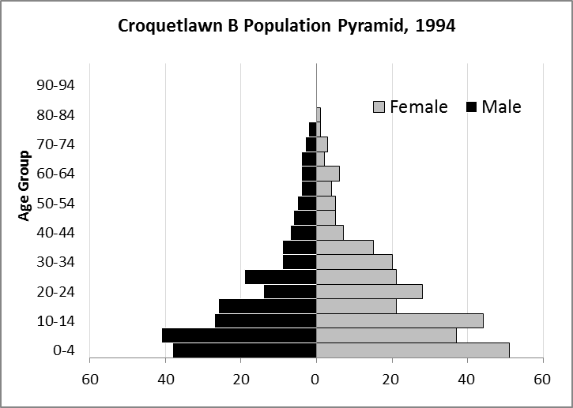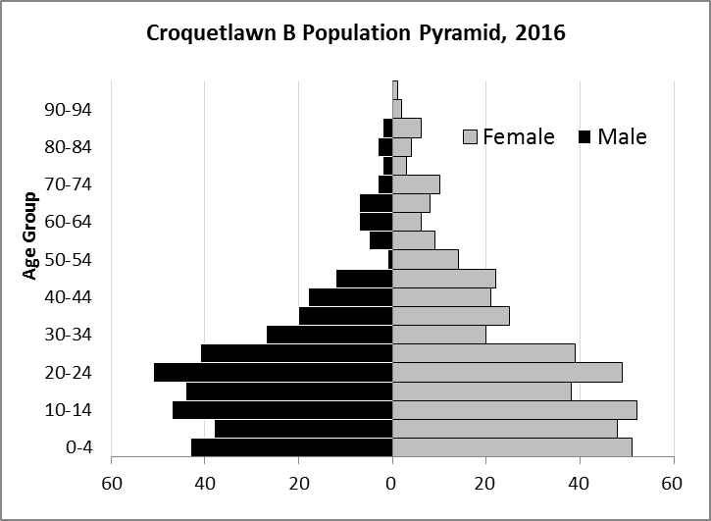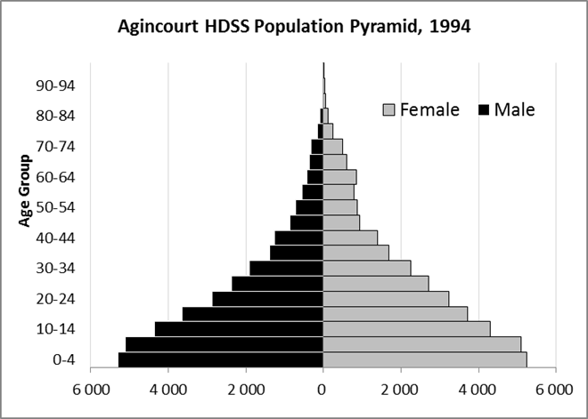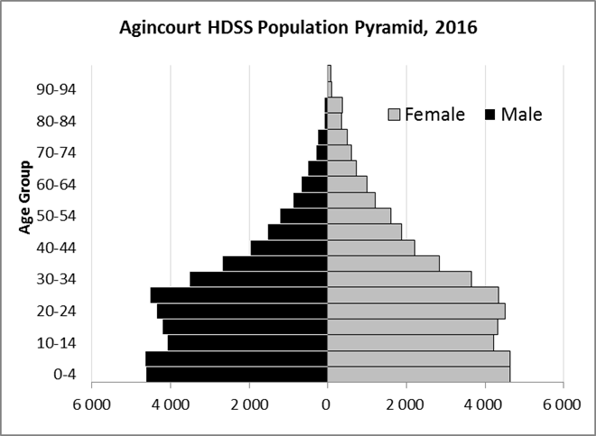

Take home message: The number of households in Croquet Lawn B village has increased since 1994. The population has also grown between the years of 1994 and 2016. The population structure of Croquet Lawn B village strongly follows the structure of the Agincourt HDSS research site.

Births

Number of Births by Sex
The number of births recorded in Croquet Lawn B village is shown below. We can only provide data to the end of 2015. We compared the birth trends in Croquet Lawn B village with the rest of the Agincourt HDSS research site below.

Births by Sex in Croquet Lawn B Village, 1994 and 2015
 | 1994 | 2015
Male Births | 4 | 4
Female Births | 11 | 14
Total Births | 15 | 18

The numbers of births show an upward trend in Croquet Lawn B village. In 2015 there was an increase in the number of births.

Crude Birth Rate (how many babies born for every one thousand people)
We can show the crude birth rate in Croque Lawn B village from 1994 to 2015. We show the crude birth rates in the Agincourt HDSS research site from 1994 to 2015.

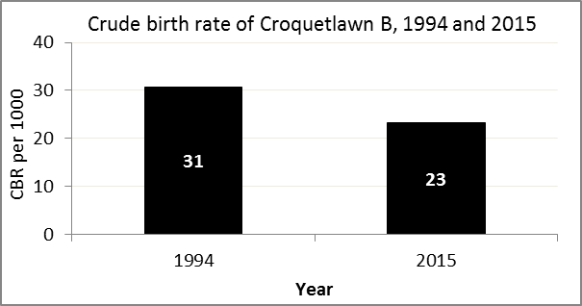
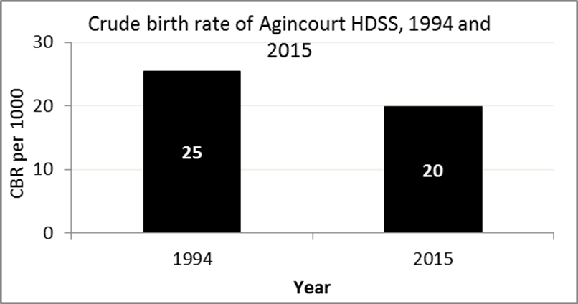

The crude birth rate is found by comparing the number of babies born to the total population. For example, in graph above, for every 1 000 people living in Croquet Lawn B village in the year 2015, 23 babies were born.
When you compare the crude birth rates in Croquet Lawn B village with the crude birth rate for the whole of the Agincourt HDSS research site, they are relatively similar. One difference is that Croquet Lawn B had more births in 2015 than the Agincourt HDSS.

Births by Mother’s Age and Age Specific Fertility Rates
Research within the Agincourt HDSS research site continues to look closely at fertility. Below we show you the number of babies born to mothers of different ages in Croquet Lawn B village.
Births by Age group in Croquet Lawn B 1994 and 2015
Age Groups | 1994 | 2015
10-14 | 0 | 0
15 -19 | 2 | 2
20-24 | 4 | 7
25-29 | 4 | 2
30-34 | 2 | 4
35-39 | 2 | 2
40-44 | 0 | 1
45-49 | 0 | 0
Total Births | 14 | 18

We can also look at trends across the whole site and compare them with Croquet Lawn B village below.

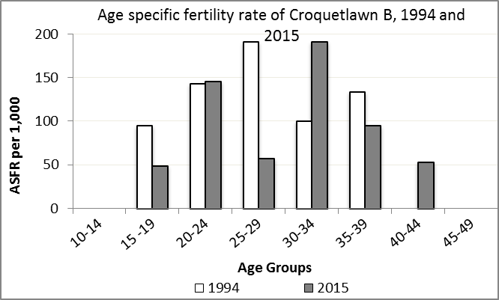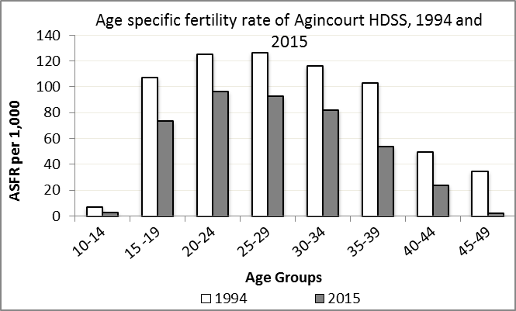

We find the age specific fertility rate by looking at how many women in a certain age group have had babies in a certain year. For example, if we look at the graph above, we can see that in the year 2015 in Croquet Lawn B village, for every 1 000 women ages 15-19, about 49 of them gave birth.

Take home message: 2015 saw a mix of increase and decreases across age groups. Ages 15-19, 25-29, and 35-39 saw decreases in fertility, while ages 20-24, 30-34, and 40-44 saw increases in fertility.

Deaths

Deaths

The MRC/Wits Agincourt Unit only gives numbers of deaths for each age group in each village, not the cause of death. The number of deaths occurring is low and if the cause of death is given, then a person’s confidentiality may be broken. Below we show you the total number of deaths that occurred in Croquet Lawn B village in 1994 and in 2015.

Deaths by Sex in Croquet Lawn B, 1994 and 2015
 | 1994 | 2015
Male Deaths | 1 | 8
Female Deaths | 1 | 1
Total Deaths | 2 | 9

Below you can compare the crude death rates over the same period in Croquet Lawn B village and across the Agincourt HDSS research site.

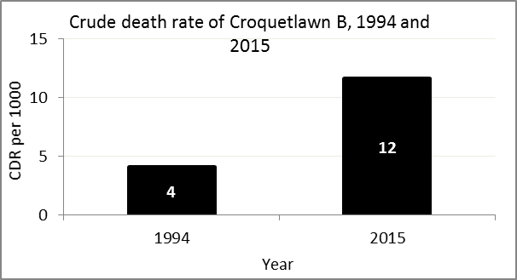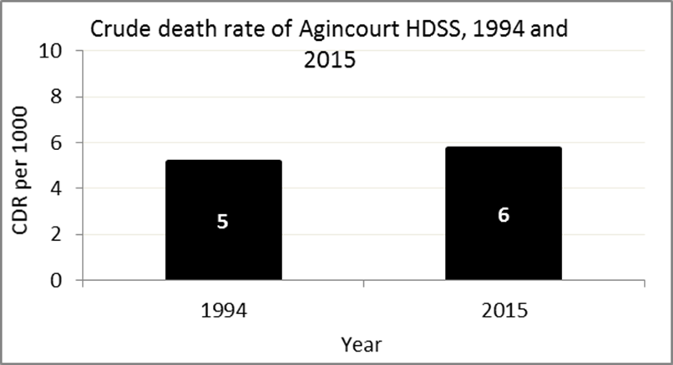
The crude death rate is found by looking at how many people died for every 1 000 people living in the population. For example, in 2015, for every 1 000 people in the population of Croquet Lawn B village, 12 died.

The data shows that the crude death rate has increased from the levels seen in 1994. However, the good news is that the death rate across the whole population of the Agincourt HDSS research site is closer to the death rate before HIV became prominent in South Africa.

MIGRATION

Permanent migration patterns

The table below has the numbers of how many people have moved into Croquet Lawn B village permanently and out of Croquet Lawn B village permanently.

In-Migrants by Sex in Croquet Lawn B village, 1994 and 2015
 | 1994 | 2015
Male In-Migrants | 30 | 12
Female In-Migrants | 40 | 14
Total | 70 | 26

Out-Migrants by Sex in Croquet Lawn B village,1994 and 2015
 | 1994 | 2015
Male Out-Migrants | 11 | 8
Female Out-Migrants | 20 | 17
Total Out-Migrants | 31 | 25

Take home message: The number of people permanently moving into and out of Croquet Lawn B village is decreasing.

