BELFAST VILLAGE FACT SHEET 2017

This “Fact Sheet” provides basic information on population changes and demographics for Belfast village. Whenever you use this information, please reference it as being obtained from MRC/Wits Rural Public Health and Health Transitions Research Unit (Agincourt).

Villages in the Agincourt Health and Socio-Demographic Surveillance (HDSS) System Research Site in 2017 include:
Agincourt, Belfast, Croquet Lawn, Croquet Lawn B, Cunningmore A, Cunningmore B, Dumphries A, Dumphries B, Dumphries C, Huntington, Ireagh A, Ireagh B, Ireagh C, Justicia, Khaya Lami, Kildare A, Kildare B, Kumani, Lillydale A, Lillydale B, Makaringe, MP Stream, Newington B, Newington C, Rolle C, Somerset, Somerset C, and Xanthia.

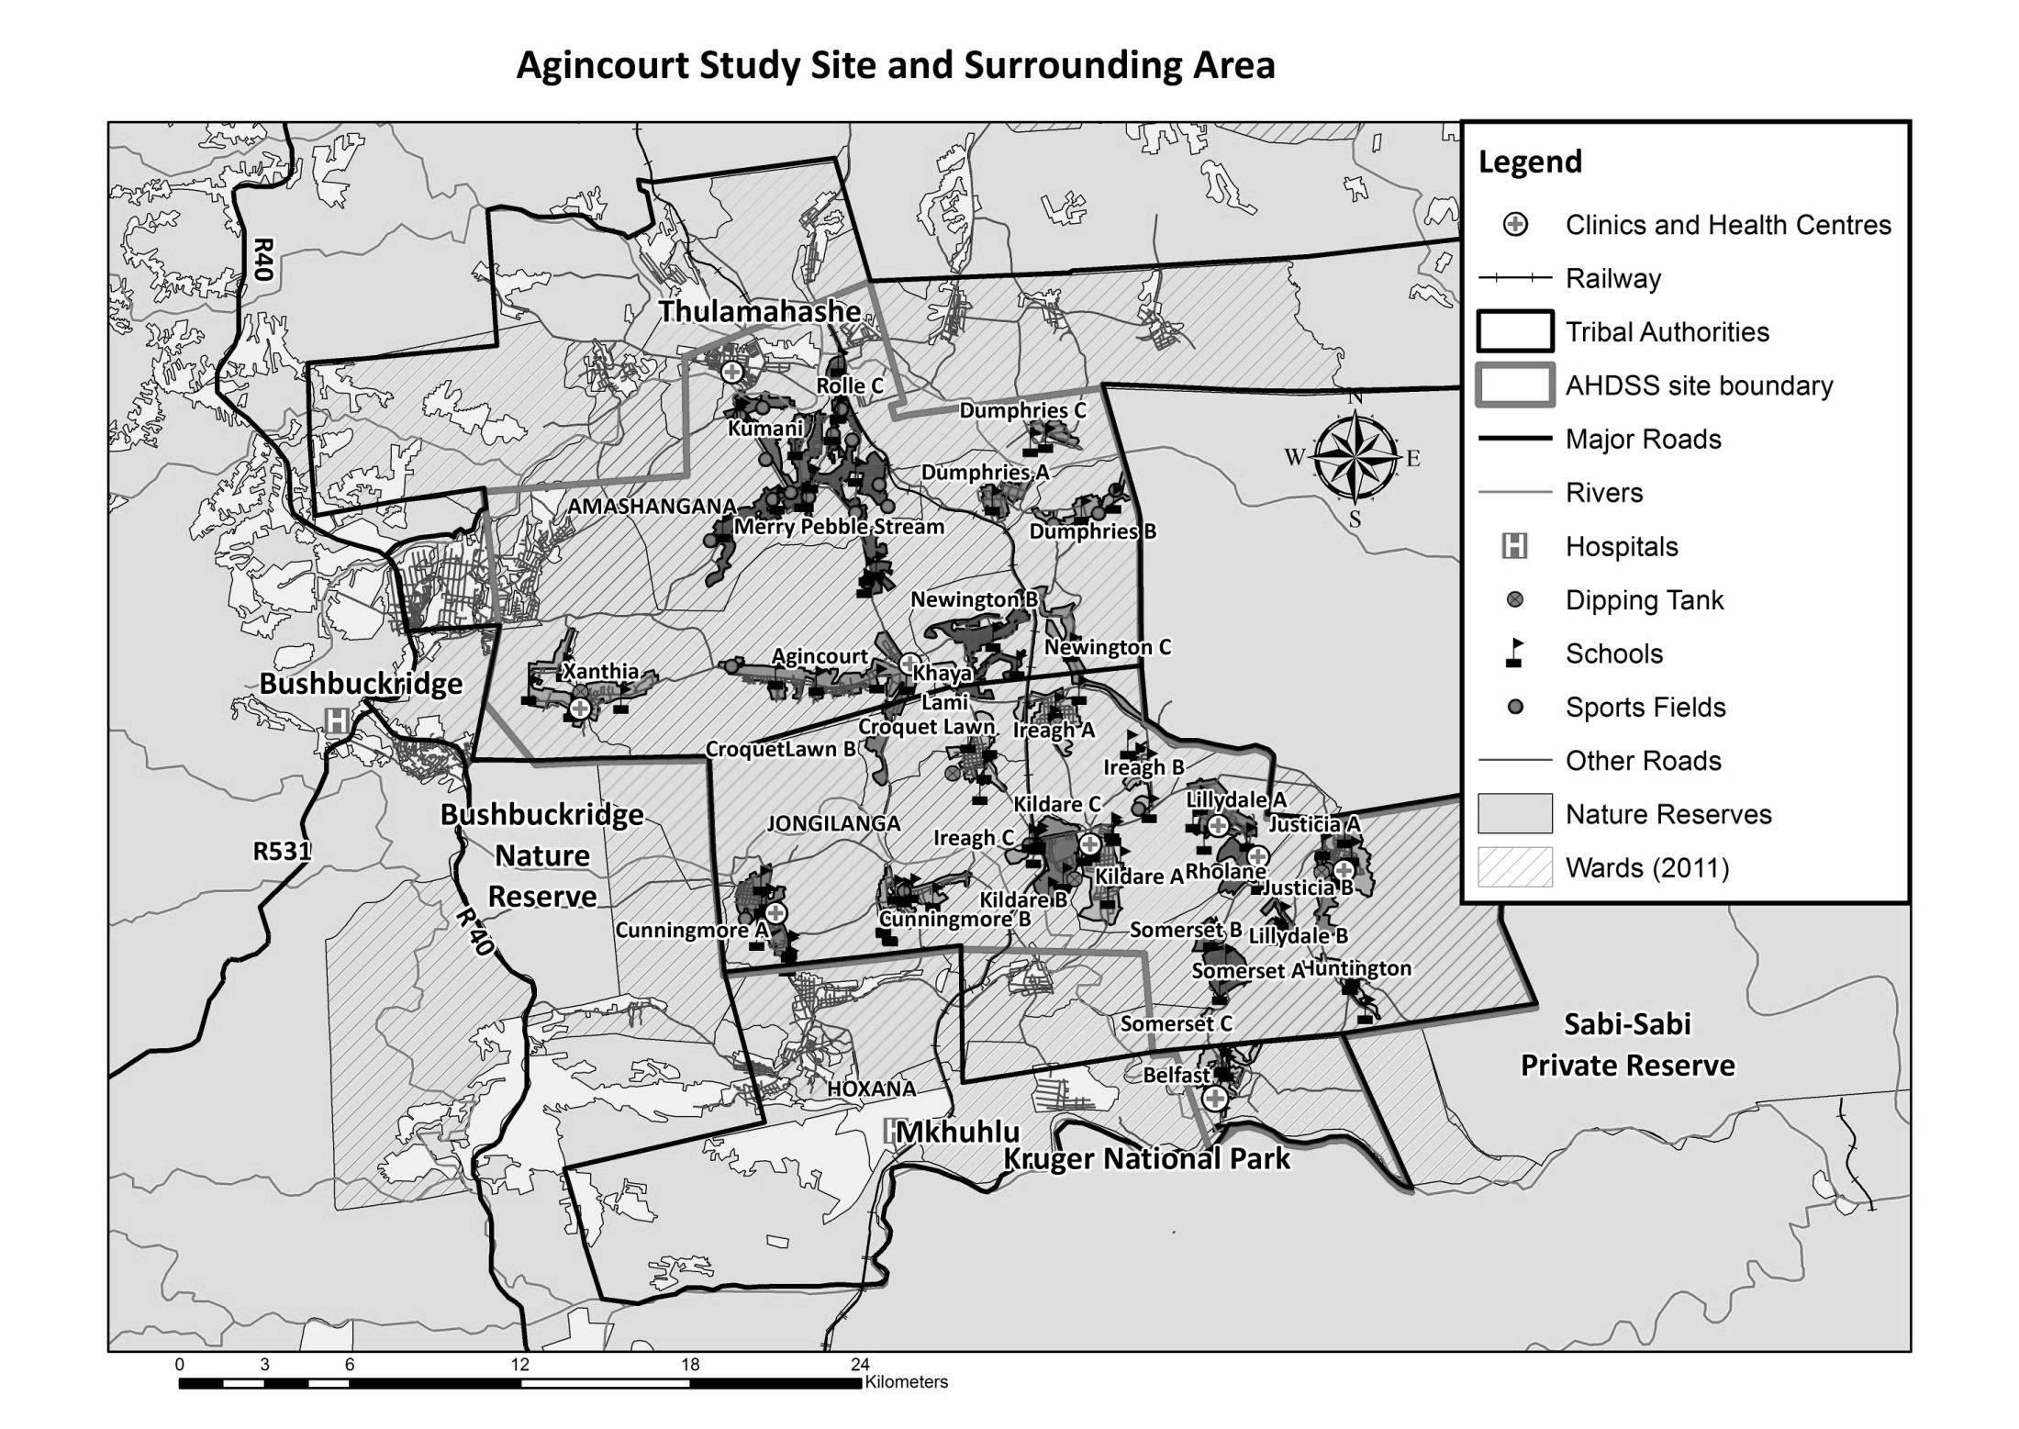
Belfast

Village Growth and Population over the Period 2008– 2016
The numbers shown below are calculated according to numbers for the end of June 2016. The numbers are known as mid-year population figures.

Mid-year Figures of Belfast village, 2008 and 2016
 |  |  | 2008 | 2016
Households |  |  | 1 132 | 1 265
Population |  |  | 6 411 | 7 018
Male |  |  | 3 130 | 3 392
Female |  |  | 3 281 | 3 626
Children under 5 |  |  | 746 | 817
Children of school-going age (5-19) |  |  | 2 431 | 2 204

Below you can see how many people were living in Belfast village of different ages in June 2016.

Mid-Year Population of Belfast village, 2016
Age Group | 2016
 | Male | Female | Total
0-4 | 409 | 408 | 817
5-9 | 358 | 342 | 700
10-14 | 329 | 379 | 708
15-19 | 388 | 408 | 796
20-24 | 384 | 417 | 801
25-29 | 422 | 359 | 781
30-34 | 256 | 278 | 534
35-39 | 209 | 225 | 434
40-44 | 182 | 170 | 352
45-49 | 138 | 168 | 306
50-54 | 90 | 112 | 202
55-59 | 61 | 100 | 161
60-64 | 69 | 67 | 136
65-69 | 38 | 45 | 83
70-74 | 17 | 38 | 55
75-79 | 20 | 42 | 62
80-84 | 13 | 30 | 43
85-89 | 7 | 27 | 34
90-94 | 2 | 5 | 7
95+ | 0 | 6 | 6
Total | 3 392 | 3 626 | 7 018

You can compare the population structure between Belfast village and the Agincourt HDSS research site (2008 and 2016) by looking at the population pyramids below.

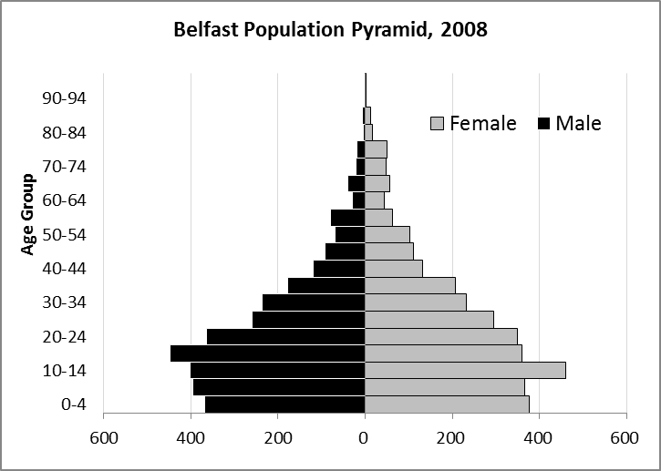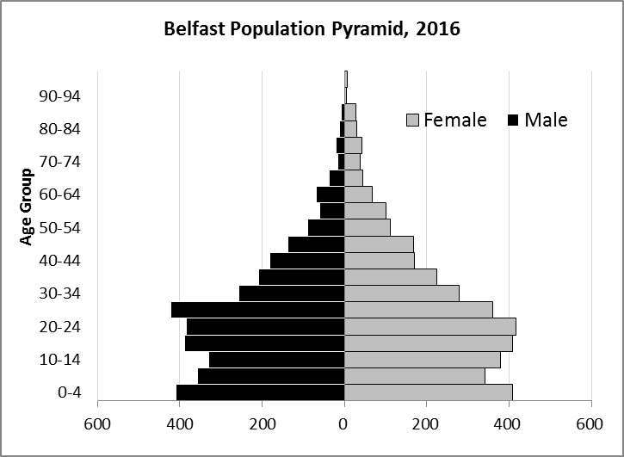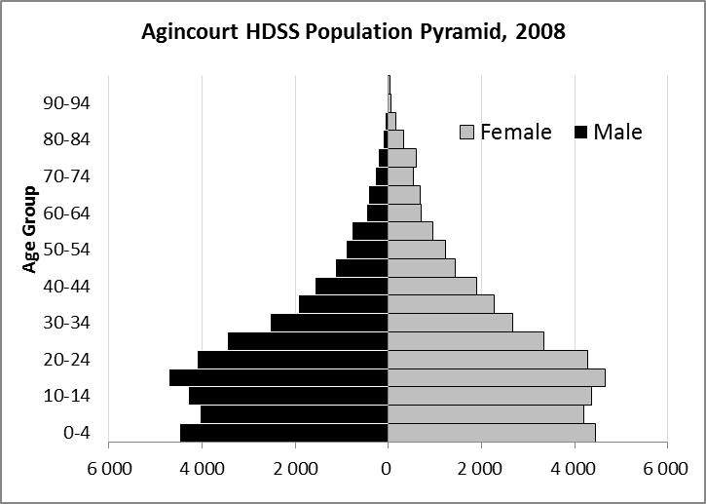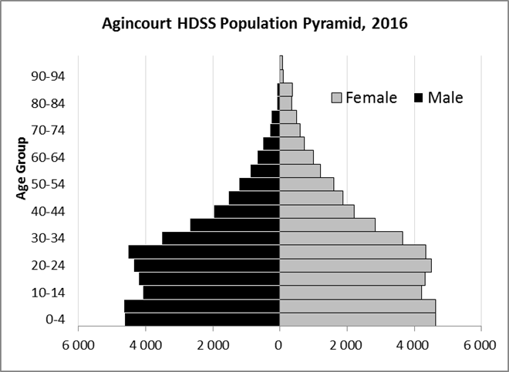

Take home message: The number of households in Belfast village has increased since 2008. The population has also grown between the years of 2008 and 2016. The population structure Belfast village strongly follows the structure of the Agincourt HDSS research site.

Births

Number of Births by Sex
The number of births recorded Belfast village are shown below. We can only provide data to the end of 2015.
Births by Sex in Belfast village, 2008 and 2015
 | 2008 | 2015
Male Births | 70 | 67
Female Births | 56 | 70
Total Births | 126 | 137

The numbers of births show an upward trend in Belfast village. In 2015 there was an increase in the number of births.

Crude Birth Rate (how many babies born for every one thousand people)
We compared the birth trends in Belfast village with the rest of the Agincourt HDSS research site in the graphs below.

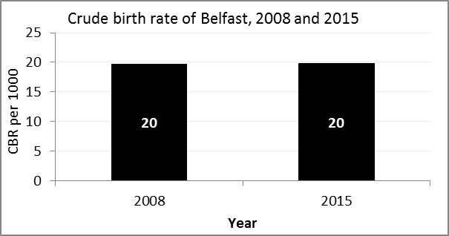
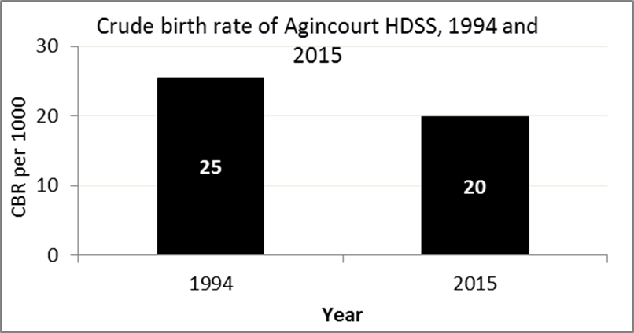

The crude birth rate is found by comparing the number of babies born to the total population. For example, for every 1 000 people (all ages and both male and female) living in Belfast village in the year 2015, 20 babies were born.
When you compare the birth rates in Belfast village with the birth rate for the whole of the Agincourt HDSS research site, they are relatively similar. One difference is that Belfast had the same birth rate in 2008 and 2015, while Agincourt HDSS did not.

Births by Mother’s Age and Age Specific Fertility Rates
Research within the Agincourt HDSS research site continues to look closely at fertility. You can see the number of babies born to mothers of different ages in Belfast village below.

Births by Age group in Belfast, 2008 and 2015
Age Groups | 2008 | 2015
10-14 | 2 | 0
15 -19 | 36 | 28
20-24 | 28 | 35
25-29 | 25 | 36
30-34 | 22 | 25
35-39 | 10 | 10
40-44 | 2 | 3
45-49 | 1 | 0
Total Births | 126 | 137

We can also look at trends in birth rates in different age groups across the whole site and compare them with Belfast village.

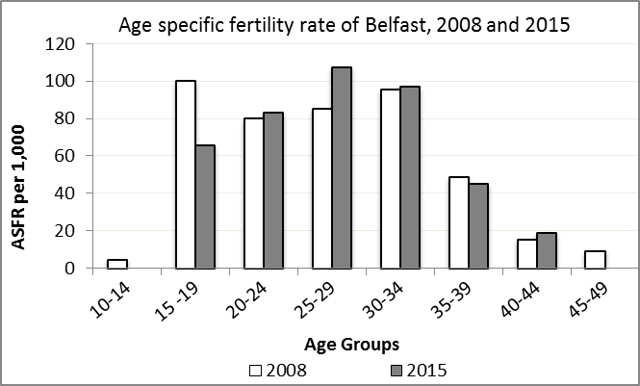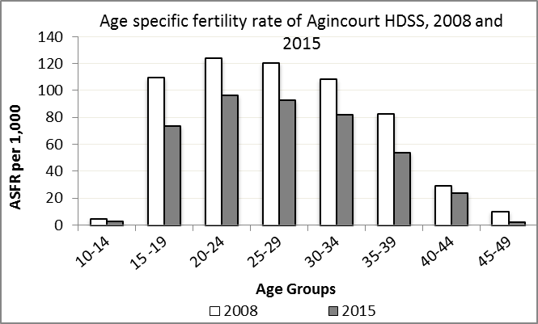

We find the age specific fertility rate by looking at how many women in a certain age group have had babies in a certain year. We can see that in the year 2015 in Belfast village, for every 1 000 women ages 15-19, about 66 of them gave birth.

Take home message: 2015 saw increases in fertility in age 20-34 and 40-44, but decreases across ages 10-14, 15-19, 35-39 and 45-49. The birth rates in Belfast are mostly higher than the average across all the villages in the Agincourt HDSS.

Deaths

Deaths

The MRC/Wits Agincourt Unit only gives numbers of deaths for each age group in each village, not the cause of death. The number of deaths occurring is low and if the cause of death is given, then a person’s confidentiality may be broken. Below you can see the total number of deaths that occurred in Belfast village in 2008 and in 2015.

Deaths by Sex in Belfast, 2008 and 2015
 | 2008 | 2015
Male Deaths | 31 | 25
Female Deaths | 31 | 30
Total Deaths | 62 | 55

Below you can compare the crude death rates over the same period in Belfast village and across the Agincourt HDSS research site.

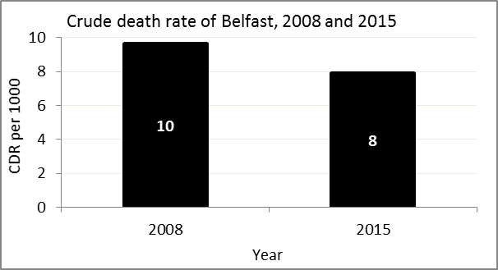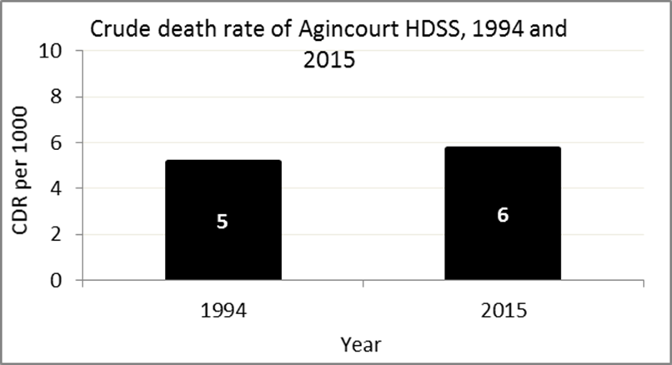
The crude death rate is found by looking at how many people died for every 1 000 people living in the population. For example, in 2015, for every 1 000 people in the population of Belfast village, 8 died.

The data shows that the crude death rate has decreased from the levels seen in 2008. In addition, the death rate across the whole population of the Agincourt HDSS research site is closer to the death rate before HIV became prominent in South Africa.

MIGRATION

Permanent migration patterns

Below you can see how many people have moved into and out of Belfast village permanently.

In-Migrants by Sex into Belfast village
 | 2008 | 2015
Male In-Migrants | 153 | 78
Female In-Migrants | 237 | 145
Total | 390 | 223

Out-Migrants by Sex out of Belfast village
 | 2008 | 2015
Male Out-Migrants | 182 | 103
Female Out-Migrants | 281 | 151
Total Out-Migrants | 463 | 254

Take home message: The number of people permanently moving both into and out of Belfast village is decreasing.

