AGINCOURT VILLAGE FACT SHEET 2017

This “Fact Sheet” provides basic information on population changes and demographics for Agincourt village. Whenever you use this information, please reference it as being obtained from MRC/Wits Rural Public Health and Health Transitions Research Unit (Agincourt).

Villages in the Agincourt Health and Socio-Demographic Surveillance (HDSS) System Research Site in 2017 include:
Agincourt, Belfast, Croquet Lawn, Croquet Lawn B, Cunningmore A, Cunningmore B, Dumphries A, Dumphries B, Dumphries C, Huntington, Ireagh A, Ireagh B, Ireagh C, Justicia, Khaya Lami, Kildare A, Kildare B, Kumani, Lillydale A, Lillydale B, Makaringe, MP Stream, Newington B, Newington C, Rolle C, Somerset, Somerset C, and Xanthia.

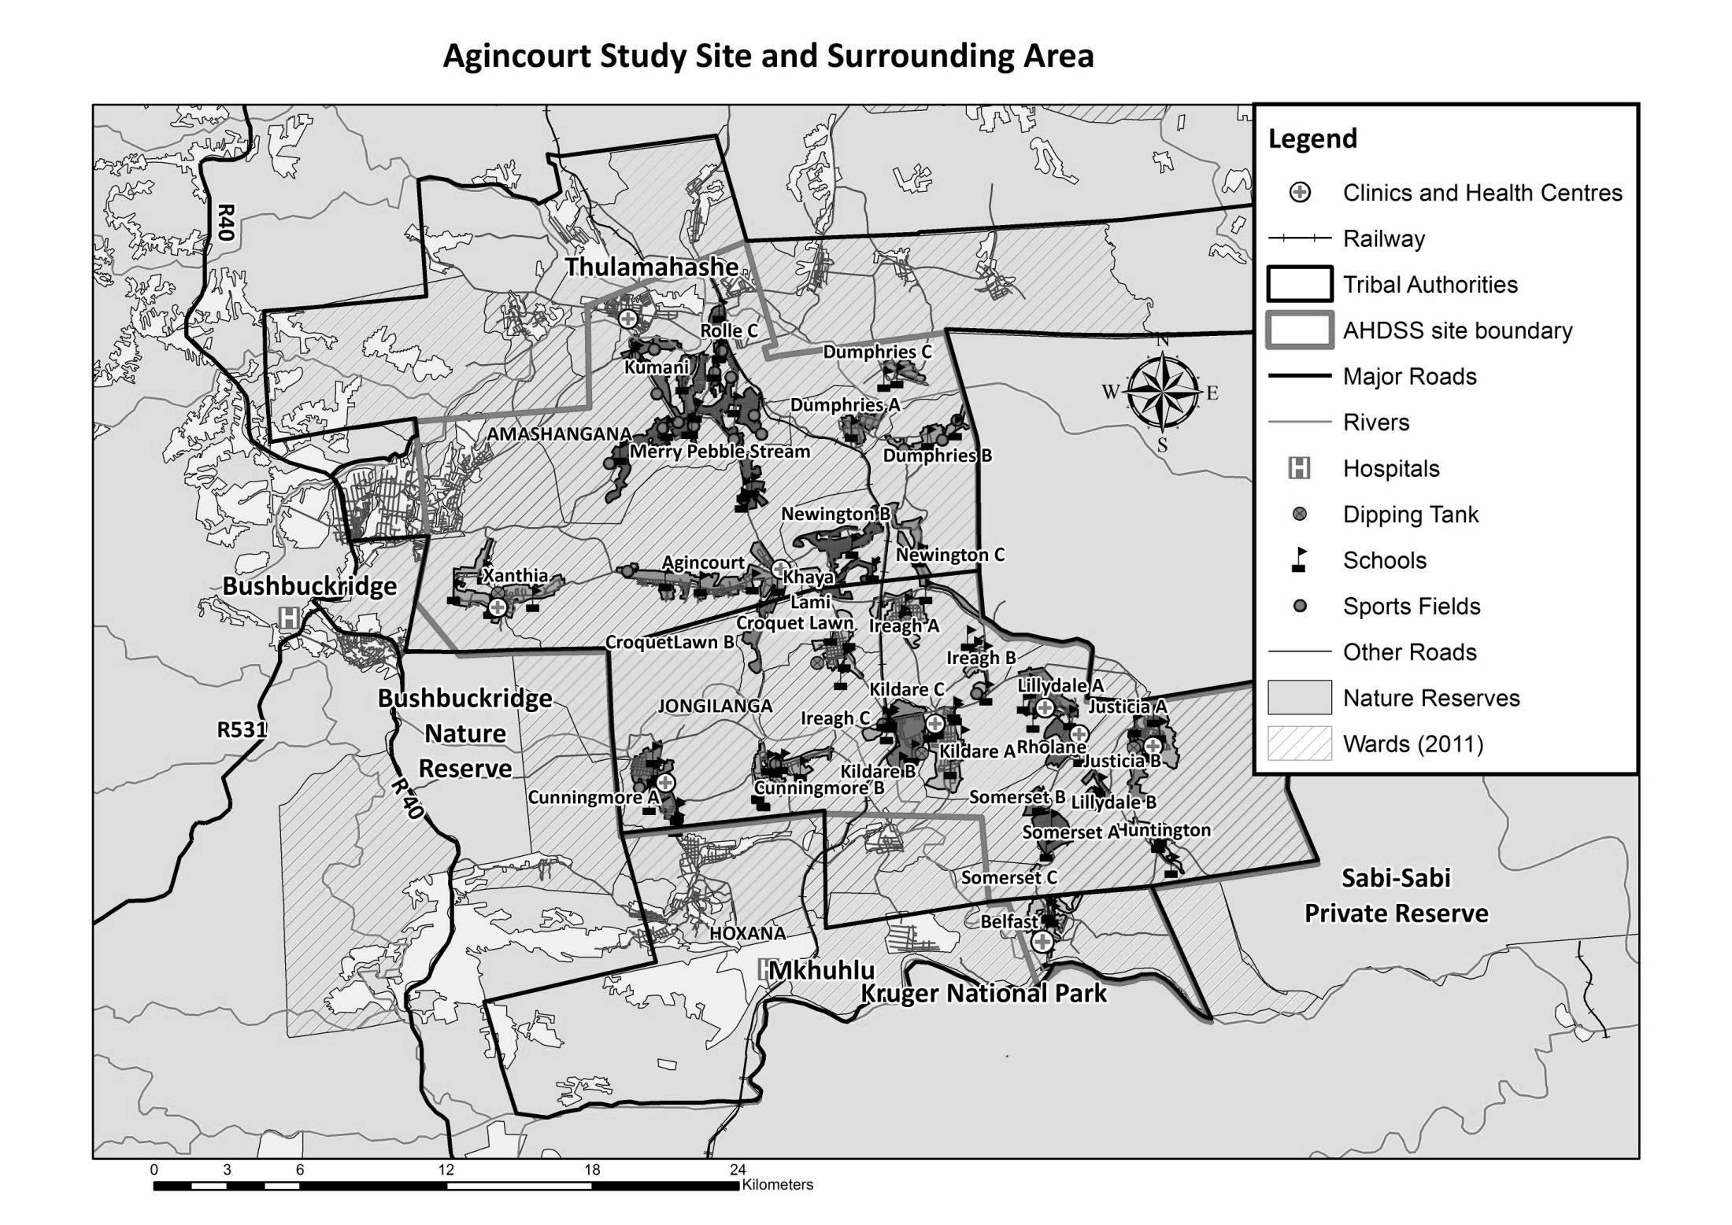
Agincourt

Village Growth and Population over the Period 1994 – 2016
The numbers shown below are calculated according to numbers for the end of June 2016. The numbers are known as mid-year population figures.

Mid-year Figures of Agincourt village, 1994 and 2016
 |  |  | 1994 | 2016
Households |  |  | 981 | 1 232
Population |  |  | 6 508 | 7 035
Male |  |  | 3 153 | 3 404
Female |  |  | 3 355 | 3 631
Children under 5 |  |  | 985 | 682
Children of school-going age (5-19) |  |  | 2 584 | 2 100

Below you can see how many people were living in Agincourt village of different ages in June 2016.

Mid-Year Population Agincourt village, 2016
Age Group | 2016
 | Male | Female | Total
0-4 | 339 | 343 | 682
5-9 | 365 | 383 | 748
10-14 | 340 | 351 | 691
15-19 | 312 | 349 | 661
20-24 | 361 | 343 | 704
25-29 | 397 | 388 | 785
30-34 | 334 | 297 | 631
35-39 | 246 | 222 | 468
40-44 | 181 | 188 | 369
45-49 | 120 | 152 | 272
50-54 | 120 | 138 | 258
55-59 | 87 | 129 | 216
60-64 | 72 | 96 | 168
65-69 | 44 | 64 | 108
70-74 | 30 | 56 | 86
75-79 | 34 | 42 | 76
80-84 | 8 | 18 | 26
85-89 | 9 | 52 | 61
90-94 | 2 | 16 | 18
95+ | 3 | 4 | 7
Total | 3 404 | 3 631 | 7 035

You can compare the population structure between Agincourt village and the Agincourt HDSS research site (1994 and 2016) by looking at the population pyramids below.

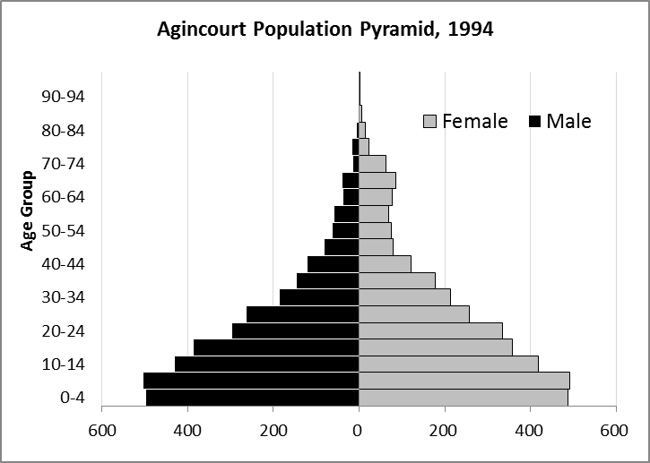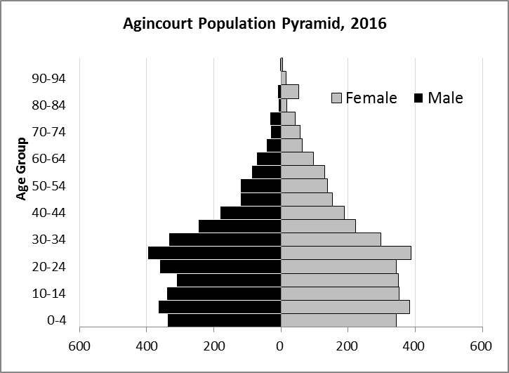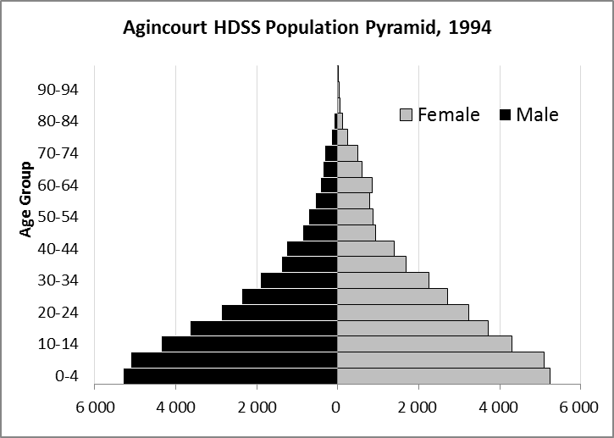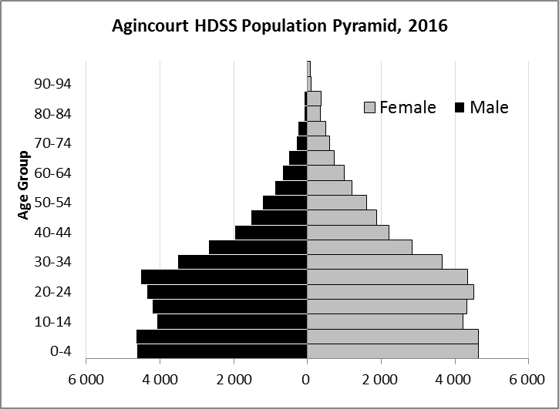

Take home message: The number of households in Agincourt village has increased since 1994. The population has also grown between the years of 1994 and 2016. The population structure of Agincourt village strongly follows the structure of the Agincourt HDSS research site.

Births

Number of Births by Sex
The number of births recorded Agincourt village are shown below. We can only provide data to the end of 2015. We compared the birth trends in Agincourt village with the rest of the Agincourt HDSS research site in the following graphs.
Births by Sex in Agincourt village, 1994 and 2015
 | 1994 | 2015
Male Births | 72 | 60
Female Births | 79 | 73
Total Births | 151 | 133

The numbers of births show a downward trend in Agincourt village. In 2015 there was a decrease in the number of births.

Crude Birth Rate
We compared the birth trends in Agincourt village with the rest of the Agincourt HDSS research site in the graphs below.

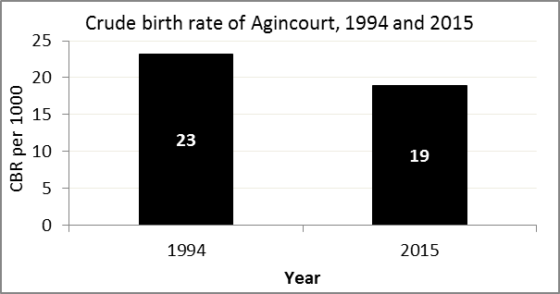
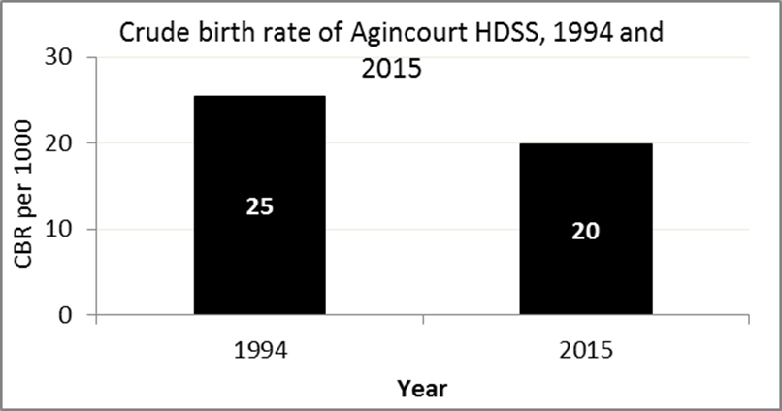

The crude birth rate is found by comparing the number of babies born to the total population. For example, above, for every 1 000 people living in Agincourt village in the year 2015, 19 babies were born.
When you compare the crude birth rates in Agincourt village with the crude birth rate for the whole of the Agincourt HDSS research site, they are relatively similar.

Births by Mother’s Age and Age Specific Fertility Rates
Research within the Agincourt HDSS research site continues to look closely at fertility. Below you can see the number of babies born to mothers of different ages in Agincourt village.
Births by Age group in Agincourt,1994 and 2015
Age Groups | 1994 | 2015
10-14 | 3 | 0
15 -19 | 29 | 28
20-24 | 39 | 37
25-29 | 30 | 31
30-34 | 31 | 22
35-39 | 14 | 10
40-44 | 3 | 4
45-49 | 2 | 1
Total Births | 151 | 133

We can also look at trends across the whole site and compare them with Agincourt village.

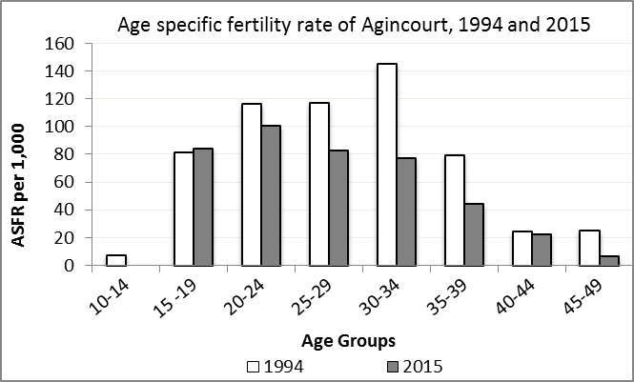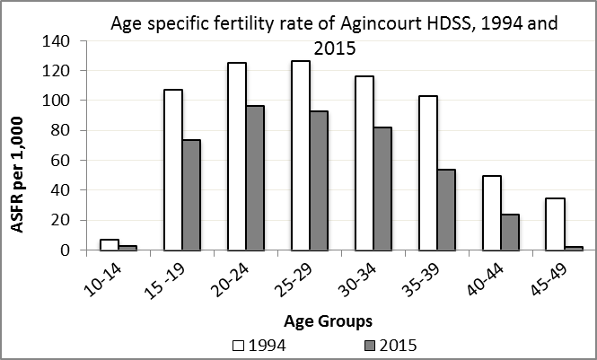

We find the age specific fertility rate by looking at how many women in a certain age group have had babies in a certain year. For example, we can see that in the year 2015 in Agincourt village, for every 1 000 women ages 15-19, about 84 of them gave birth.

Take home message: 2015 saw an increase in fertility among ages 15-19. All other age groups experienced a decrease in fertility.

Deaths

Deaths

The MRC/Wits Agincourt Unit only gives numbers of deaths for each age group in each village, not the cause of death. The number of deaths occurring is low and if the cause of death is given, then a person’s confidentiality may be broken. Below you can see the total number of deaths that occurred in Agincourt village in 1994 and in 2015.

Deaths by Sex in Agincourt, 1994 and 2015
 | 1994 | 2015
Male Deaths | 13 | 37
Female Deaths | 16 | 29
Total Deaths | 29 | 66

Below you can compare the crude death rates over the same period in Agincourt village and across the Agincourt HDSS research site.

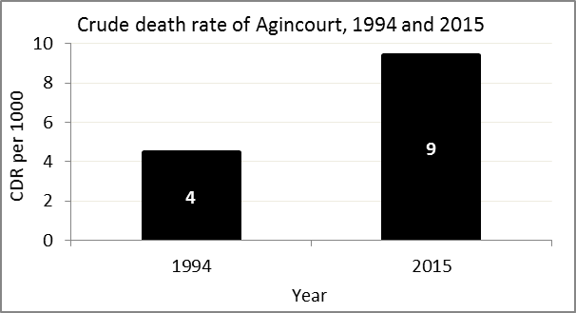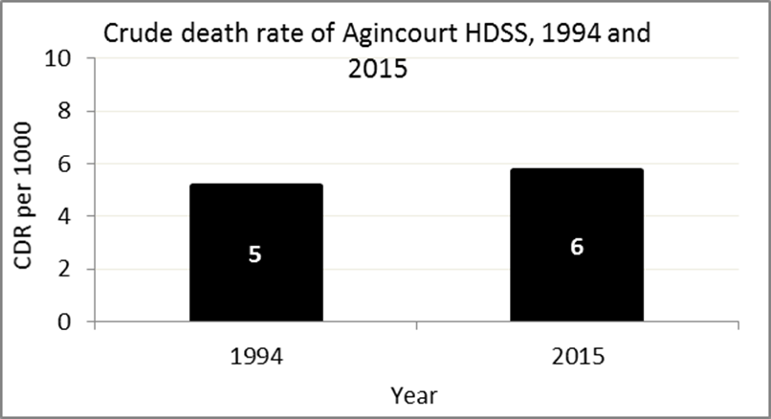
The crude death rate is found by looking at how many people died for every 1 000 people living in the population. For example, in 2015, for every 1 000 people in the population of Agincourt village, 9 died.

The data shows that the crude death rate has increased from the levels seen in 1994. However, the good news is that the death rate across the whole population of the Agincourt HDSS research site is closer to the death rate before HIV became prominent in South Africa.

MIGRATION

Permanent migration patterns

Below you can see how many people have moved into Agincourt village permanently and out of Agincourt village permanently.

Out-Migrants by Sex in Agincourt village, 1994 and 2015
 | 1994 | 2015
Male Out-Migrants | 157 | 102
Female Out-Migrants | 212 | 140
Total Out-Migrants | 369 | 242

In-Migrants by Sex in Agincourt village, 1994 and 2015
 | 1994 | 2015
Male In-Migrants | 101 | 90
Female In-Migrants | 180 | 128
Total | 281 | 218

Take home message: The number of people permanently moving into and out of Agincourt village is decreasing.

